E2 Flash Development Testing
2020-05-14 – 2020-05-31
Tyler Gerritsen

Table of Contents
Series 1 – Baseline Testing and Improvements 4
Overview: 4
Results: 4
Test Data: 4
Series 2 – TC4452 Gate Driver Output 48
Overview: 48
Results: 48
Test Data: 48
Series 3 – IPP60R190P6 Current Testing 68
Overview: 68
Test Data: 68
Series 4 – IRFB4332 MOSFET Gate Circuit Development 103
Overview: 103
Test Data: 103
Series 5 – LED Repetitive Strobe Testing #1 143
Overview: 143
Results: 143
Test Data: 144
Series 6 – LED Repetitive Strobe Testing #2 145
Overview: 145
Results: 145
Test Data: 145
Series 7 – LED Repetitive Strobe Testing #3 146
Overview: 146
Test Data: 147
Series 8 – LED Current Testing 148
Overview: 148
Results: 148
Test Data: 148
Series 9 – Multi-Strobe Testing 185
Overview: 185
Test Data: 185
Series 10 – IGBT Testing 186
Overview: 186
Results: 186
Test Data: 186
Series 11 – Flyback Converter Testing 198
Overview: 198
Results: 198
Test Data: 198
Series 12 – Bank Testing 200
Overview: 200
Results: 200
Test Data: 200

Series 1 – Baseline Testing and Improvements

Overview:
Purpose: To improve the MOSFET gate circuit such that rise time, fall time, and ringing are better controlled.
Equipment:
- E2 Prototype with four banks of LED’s in various states of damage
  - IPPR60 MOSFET’s

Results:
- The original flash design had the following characteristics:
  - The gate voltage rose rapidly (<100ns) with moderate overshoot (9.5V stabilized, >14V during overshoot period)
  - The gate voltage fell rapidly (<100ns) but the pause due to miller capacitance was significant (~100ns)
  - The following LED drive voltage (not including series resistor voltage drop) vs current relationship was established

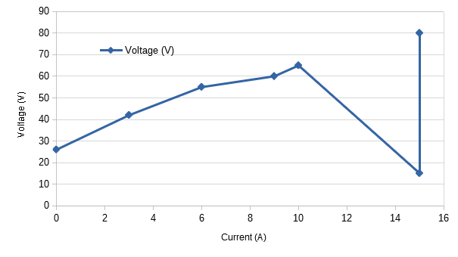
Test Data:

1 GATE: 10V? CAP ANODE: 120V SERIES RESISTOR: 2R DURATION: 1us
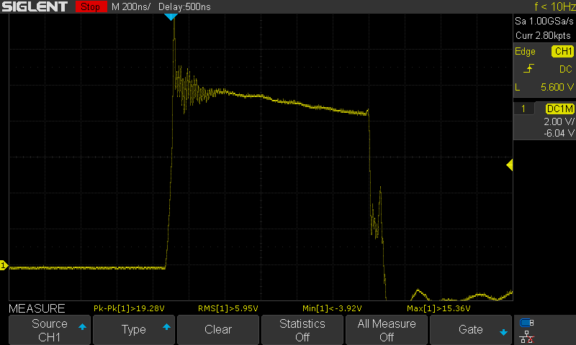
CH1 – Gate, Gnd – FET gnd
120V Cap Anode
Original circuit
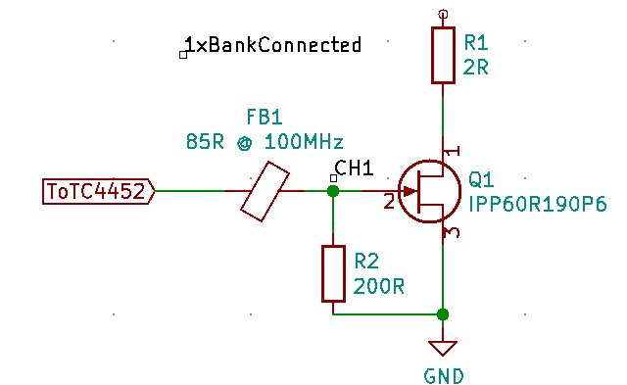
2 GATE: 10V? CAP ANODE: 120V SERIES RESISTOR: 2R DURATION: 1us
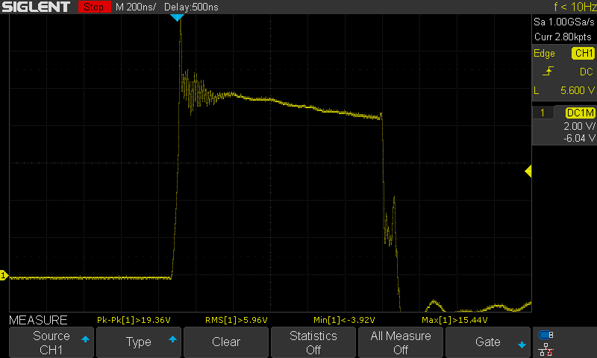
No Change
3 GATE: 10V? CAP ANODE: 45V SERIES RESISTOR: 2R DURATION: 1us
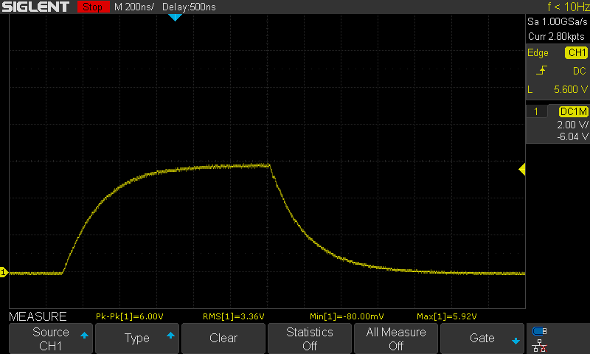
Capacitor Anode Voltage reduced to 45V
220R added between control board and Ferrite bead
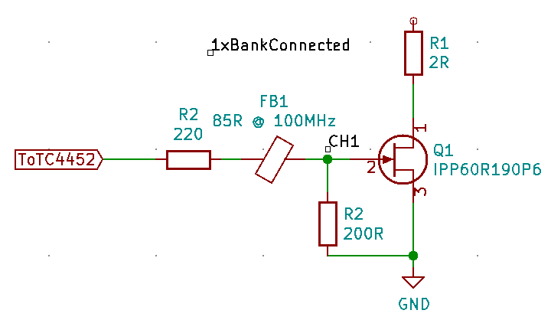
4 GATE: 10V? CAP ANODE: 45V SERIES RESISTOR: 2R DURATION: 1us
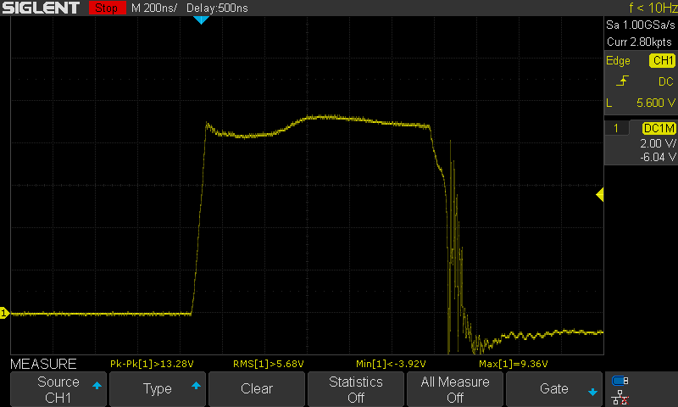
Replaced 220R Gate Resistor with 20R
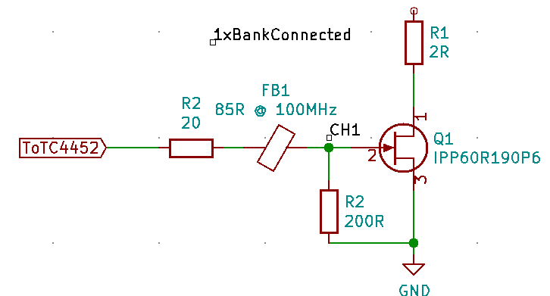
5 GATE: 10V? CAP ANODE: 45V SERIES RESISTOR: 2R DURATION: 1us
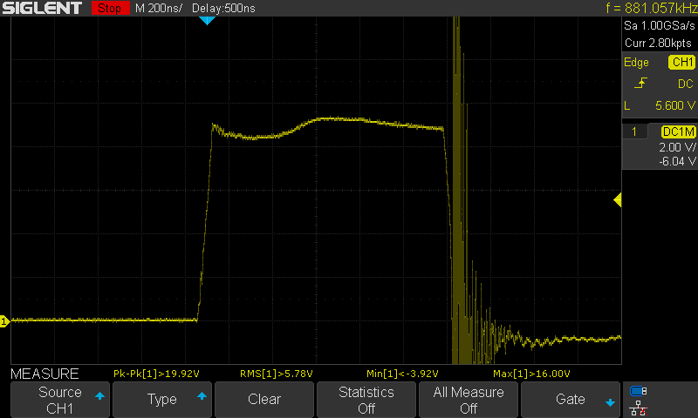
Added 1N5819 Schottky to decrease fall time
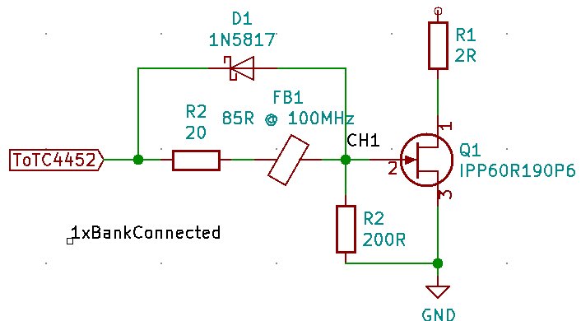

6 GATE: 10V? CAP ANODE: 45V SERIES RESISTOR: 2R DURATION: 1us
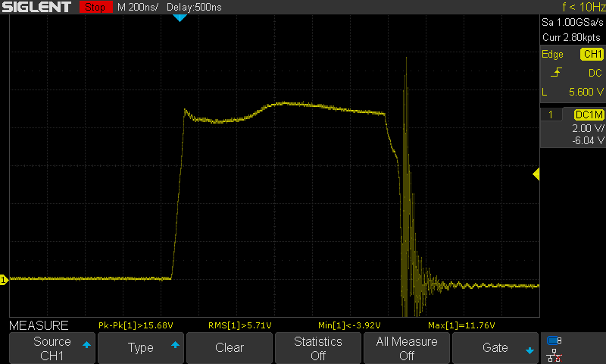
Moved schottky
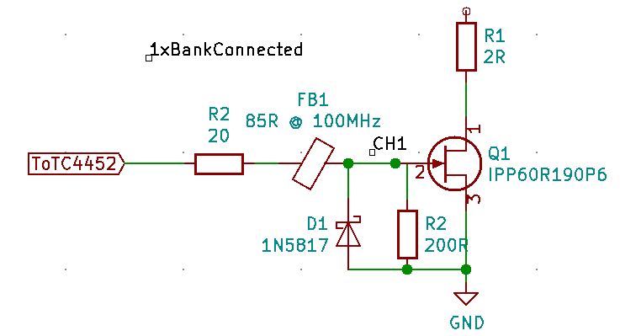

7 GATE: 10V? CAP ANODE: 45V SERIES RESISTOR: 2R DURATION: 1us
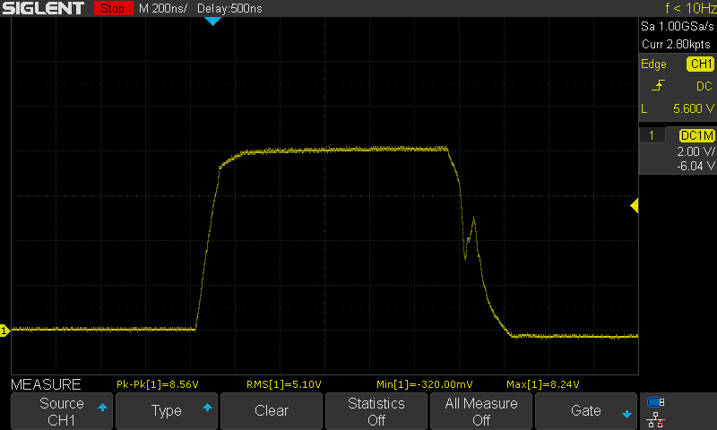
Changed gate resistor to 50R
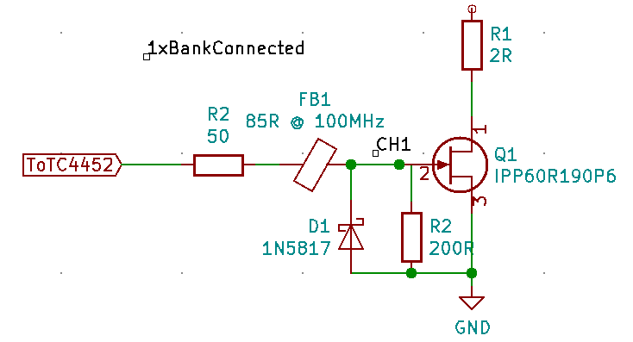

8 GATE: 10V? CAP ANODE: 90V SERIES RESISTOR: 2R DURATION: 1us
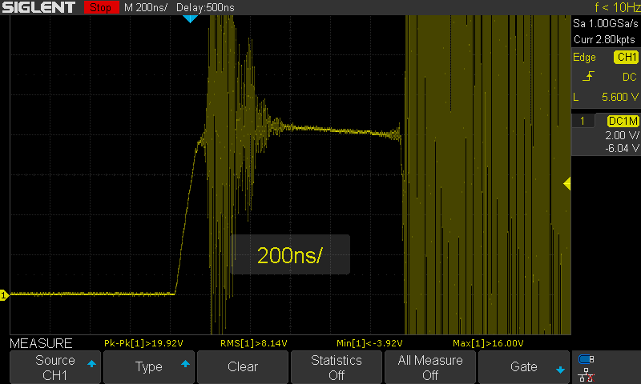
Increased Cap Anode to 90V

9 GATE: 10V? CAP ANODE: 90V SERIES RESISTOR: 2R DURATION: 1us
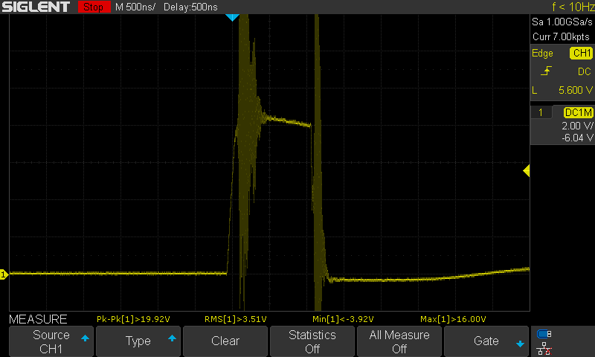
No Change
10 GATE: 10V? CAP ANODE: 90V SERIES RESISTOR: 2R DURATION: 1us
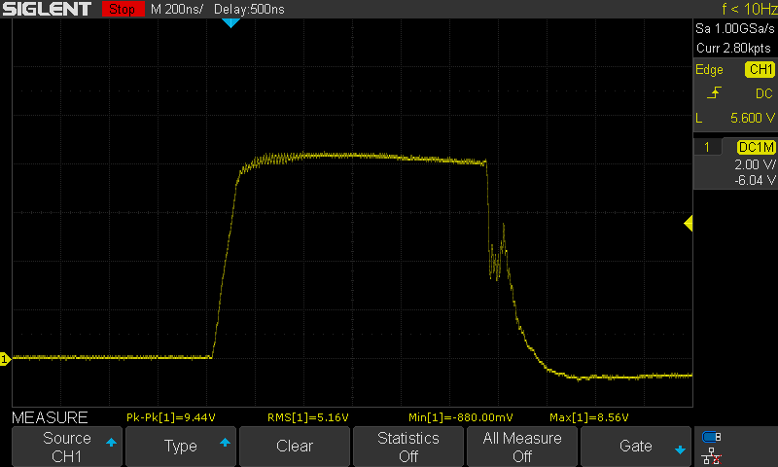
Removed Diode
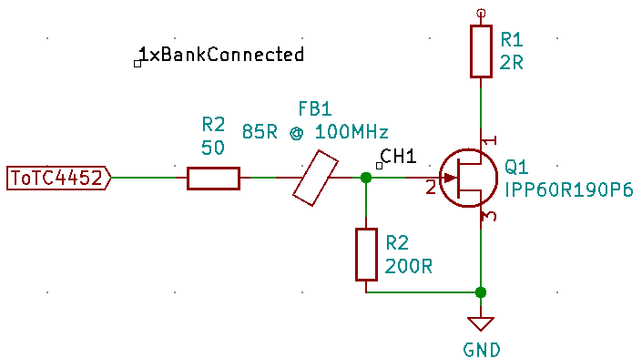
11, 12 (dup) GATE: 10V? CAP ANODE: 120V SERIES RESISTOR: 2R DURATION: 1us
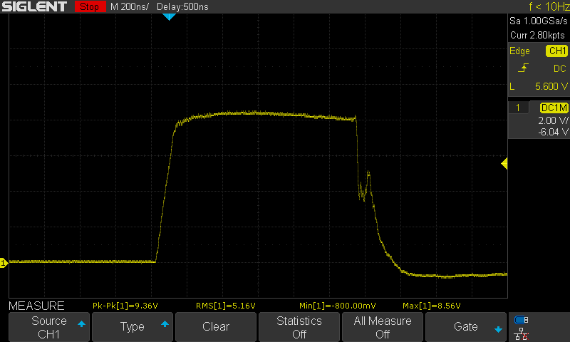
Increased Cap Anode to 120V
13 GATE: 10V? CAP ANODE: 120V SERIES RESISTOR: 2R DURATION: 1us
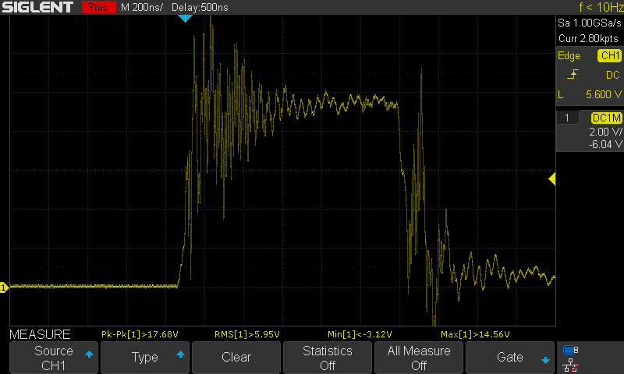
Connect all 4 LED Banks
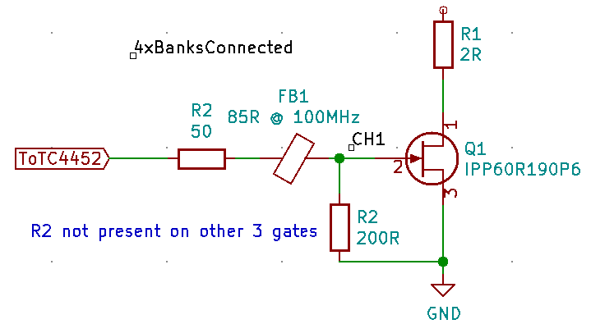
14 GATE: 10V? CAP ANODE: 120V SERIES RESISTOR: 2R DURATION: 1us
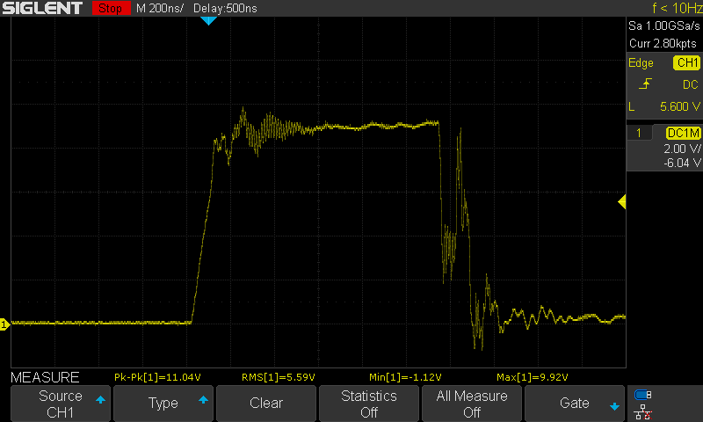
Added 50R gate resistor to all banks
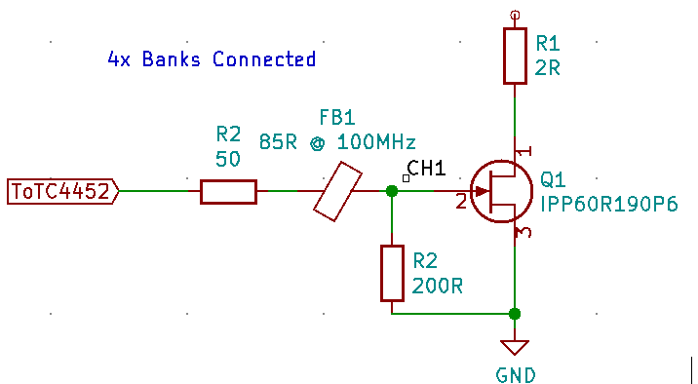
15 GATE: 10V? CAP ANODE: 120V SERIES RESISTOR: 2R DURATION: 1us
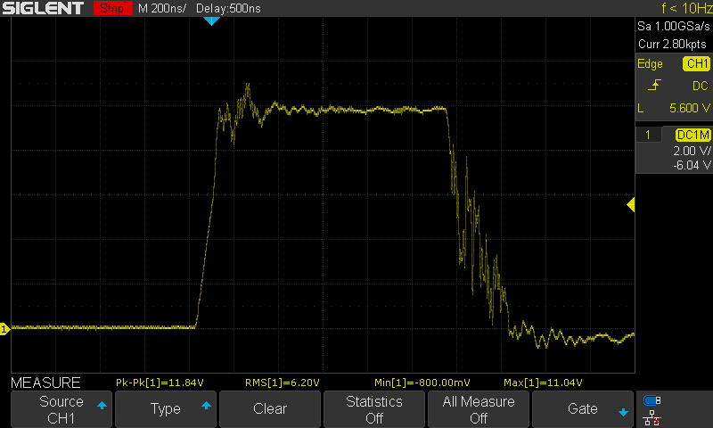
Removed 200R pull-down resistor
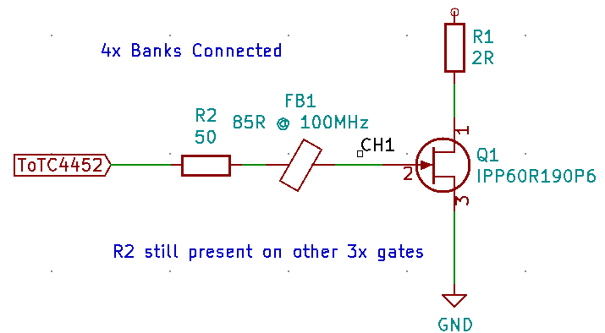
16 GATE: 10V? CAP ANODE: 120V SERIES RESISTOR: 2R DURATION: 1us
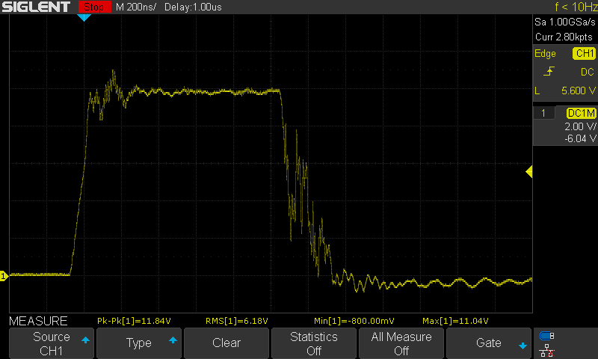
200R pull-down re-installed, 50R pull-down added in series (250R effective)
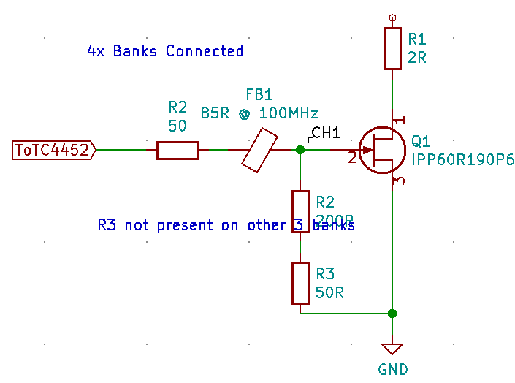

17 GATE: 10V? CAP ANODE: 120V SERIES RESISTOR: 2R DURATION: 1us
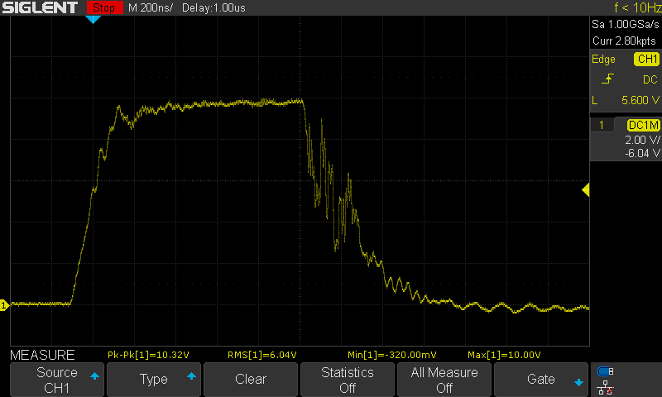
Pull-Down removed
50R gate resistor replaced with 100R
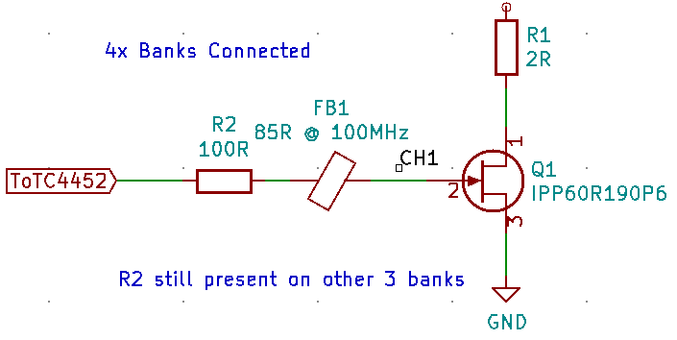

18 GATE: 10V? CAP ANODE: 120V SERIES RESISTOR: 2R DURATION: 1us
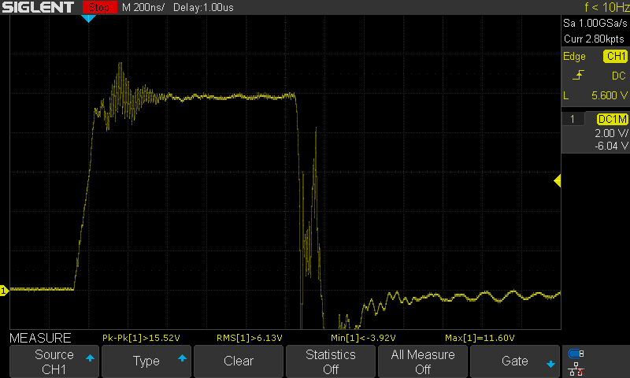
Diode added to gate with series resistor
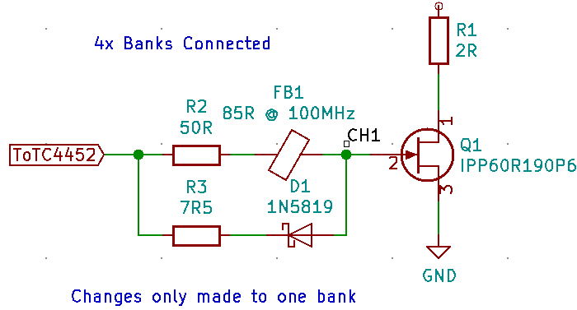

19 & 20 (dup) GATE: 10V? CAP ANODE: 120V SERIES RESISTOR: 2R DURATION: 1us
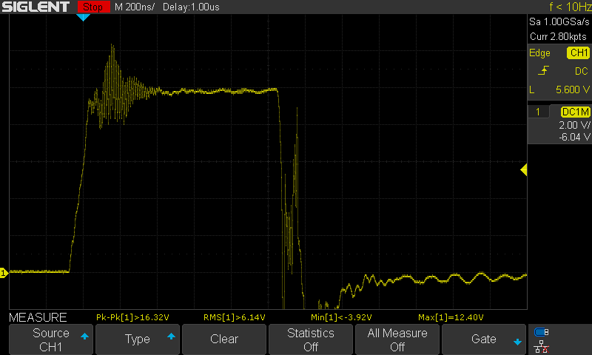
Replace 5819 with 5817
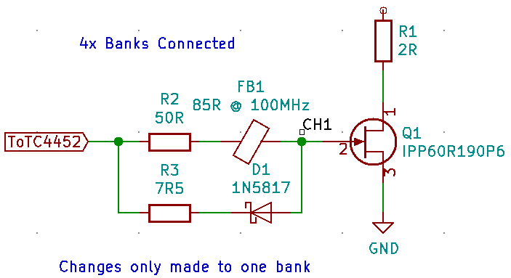

21 GATE: 10V? CAP ANODE: 120V SERIES RESISTOR: 2R DURATION: 1us
Removed Ferrite Bead
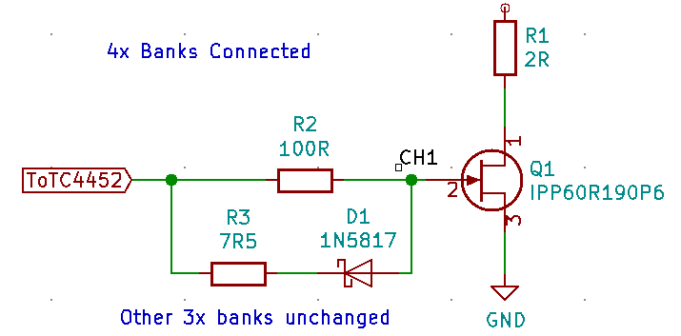

22 GATE: 10V? CAP ANODE: 120V SERIES RESISTOR: 2R DURATION: 1us
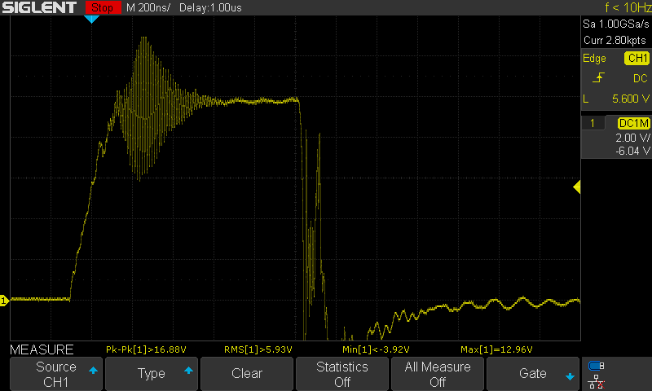
Moved ferrite bead to series with diode and 100R
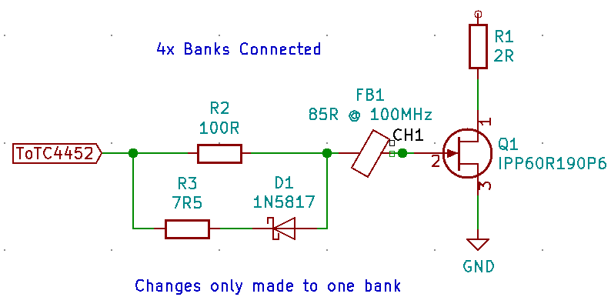

23 GATE: 10V? CAP ANODE: 120V SERIES RESISTOR: 2R DURATION: 1us
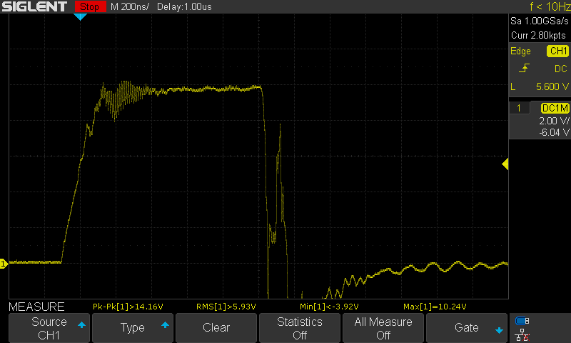
Apply circuit to ALL banks
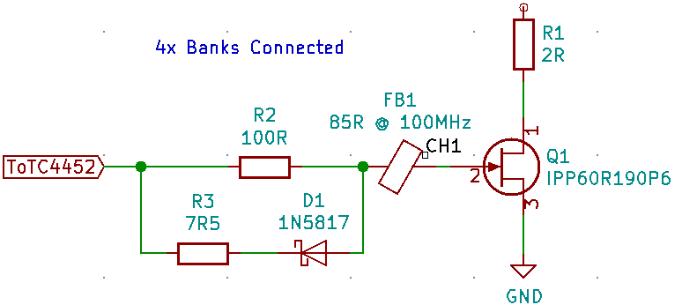

24 GATE: 10V? CAP ANODE: 120V SERIES RESISTOR: 2R DURATION: 1us
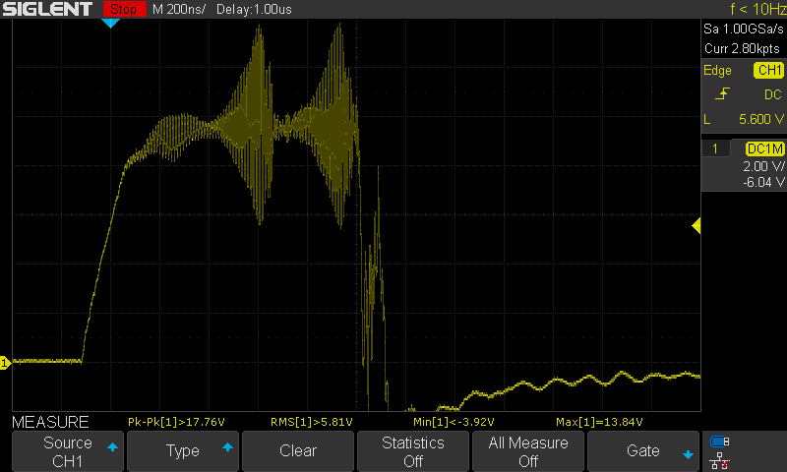
Removed errant capacitor in circuit...
25, 26 (dup) GATE: 10V? CAP ANODE: 120V SERIES RESISTOR: 2R DURATION: 1us
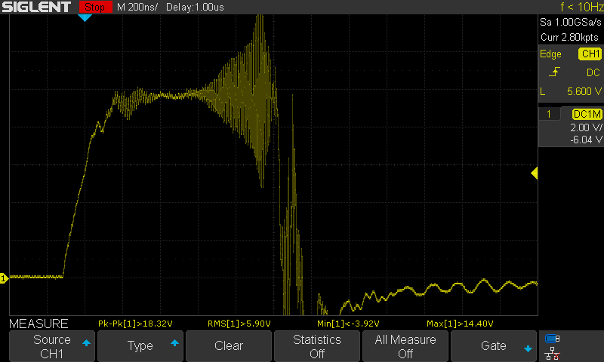
No Change
26 GATE: 10V? CAP ANODE: 120V SERIES RESISTOR: 2R DURATION: 2us
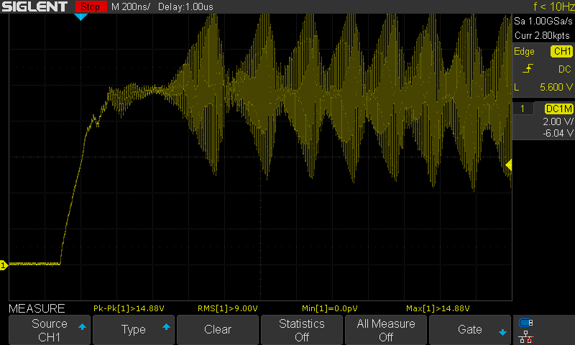
2microsecond Strobe
27 GATE: 10V? CAP ANODE: 120V SERIES RESISTOR: 2R DURATION: 1us
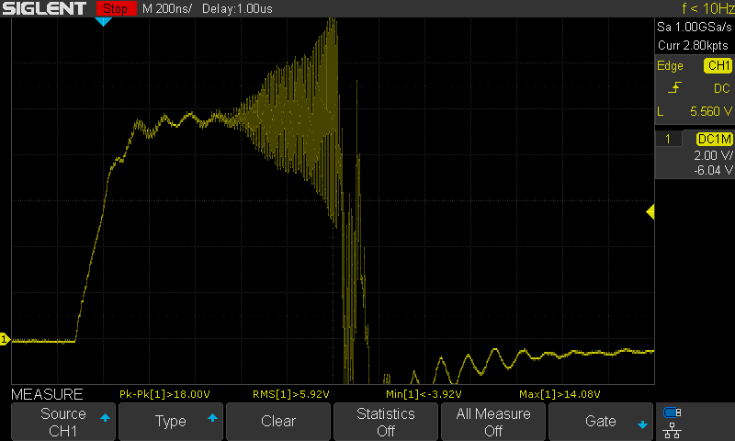
Replaced ferrite bead with 135R @ 100MHz
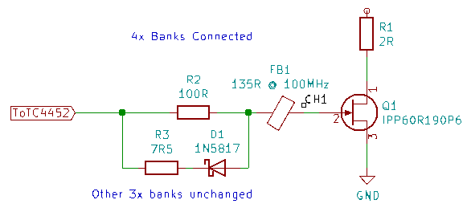

28 GATE: 10V? CAP ANODE: 120V SERIES RESISTOR: 2R DURATION: 1us
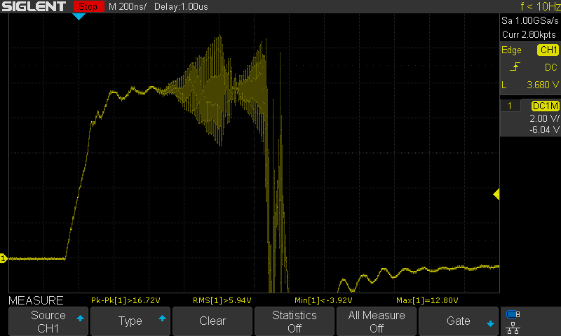
Added second ferrite beads, moved 135R ferrite bead
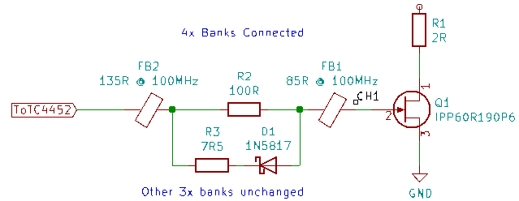

29 GATE: 10V? CAP ANODE: 120V SERIES RESISTOR: 2R DURATION: 1us
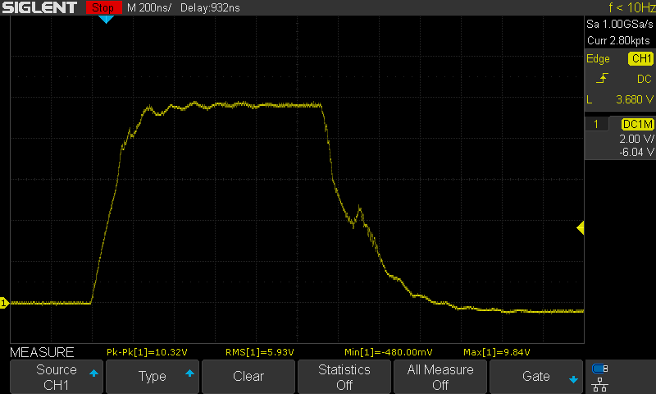
Removed diode-resistor circuit
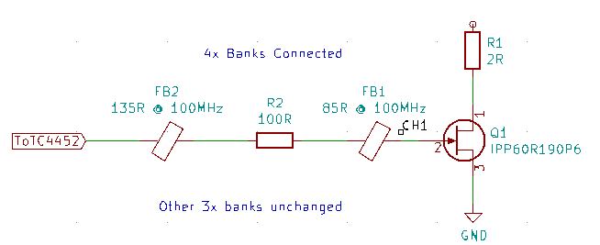

30 GATE: 10V? CAP ANODE: 120V SERIES RESISTOR: 2R DURATION: 1us
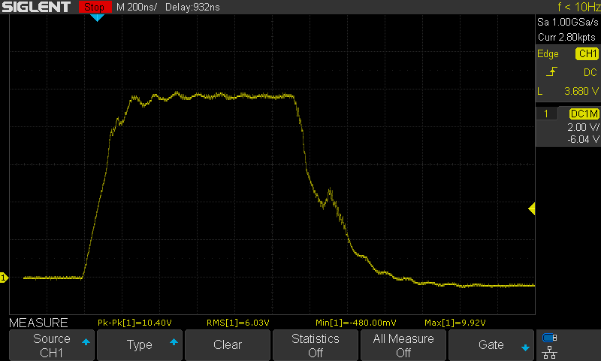
Removed 135R ferrite bead
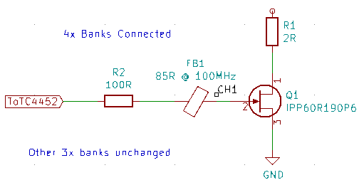
31 GATE: 10V? CAP ANODE: 120V SERIES RESISTOR: 2R DURATION: 1us
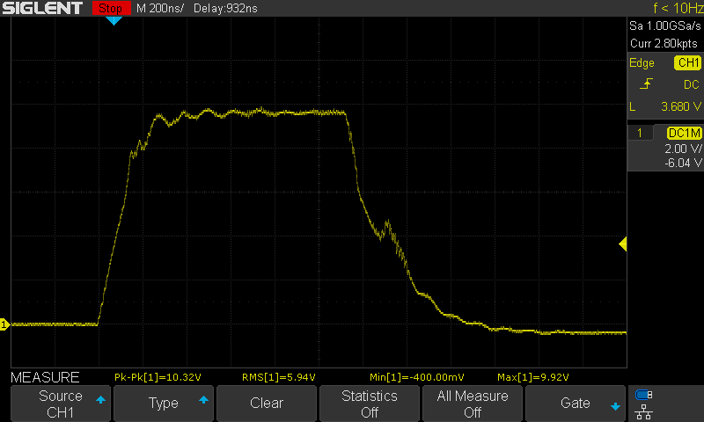
Trimmed leads
32 GATE: 10V? CAP ANODE: 120V SERIES RESISTOR: 2R DURATION: 1us
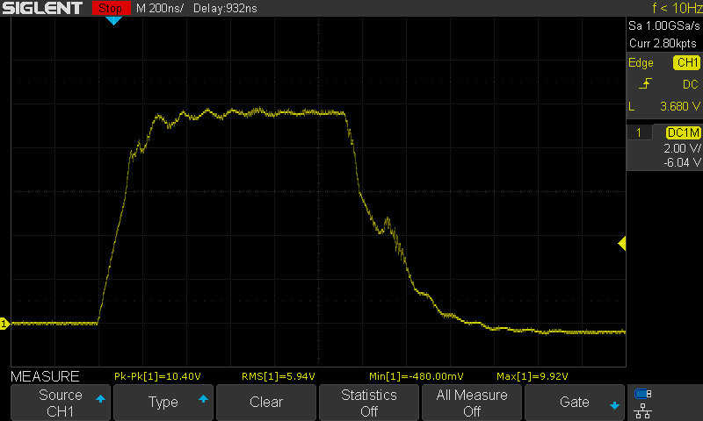
Replaced 85R ferrite bead with 135R ferrite bead
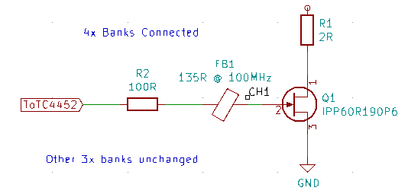
33 GATE: 10V? CAP ANODE: 120V SERIES RESISTOR: 2R DURATION: 1us
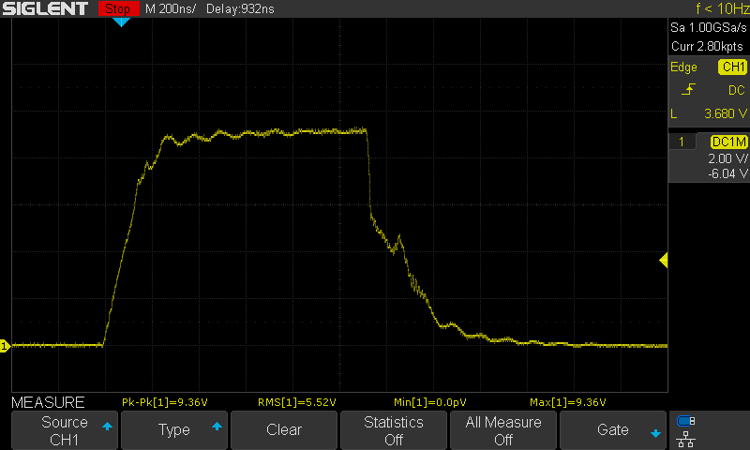
Added 200R pull-down resistor
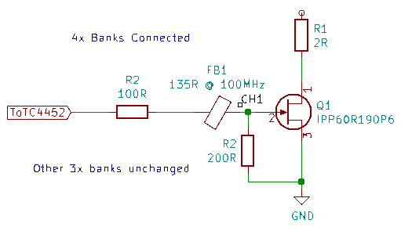
34, 35 (dup) GATE: 10V? CAP ANODE: 50V SERIES RESISTOR: 2R DURATION: 1us
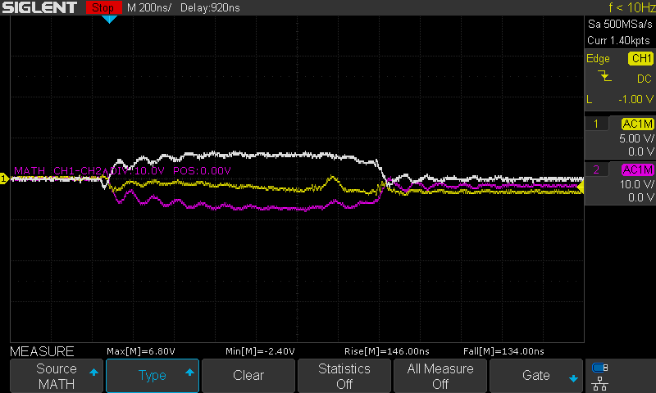
Measuring Current
50V Cap Anode
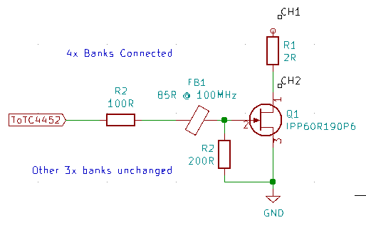
36 GATE: 10V? CAP ANODE: 70V SERIES RESISTOR: 2R DURATION: 1us
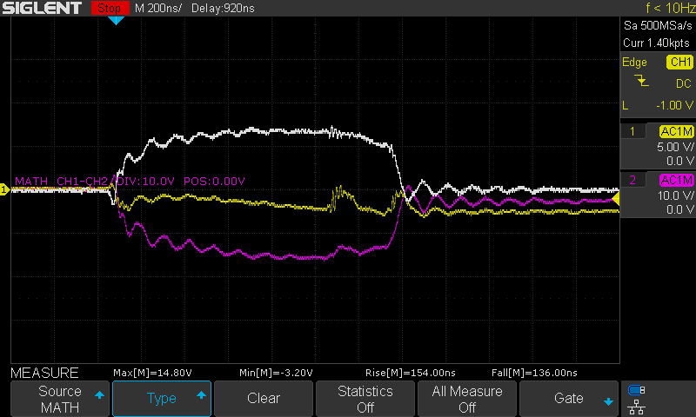
Measuring Current
70V Cap Anode

37 GATE: 10V? CAP ANODE: 80V SERIES RESISTOR: 2R DURATION: 1us
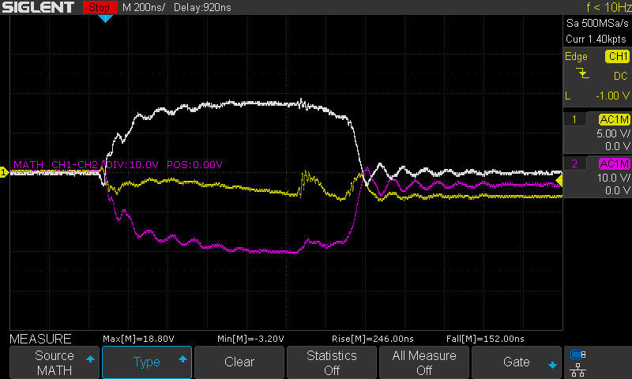
Measuring Current
80V Cap Anode

38 GATE: 10V? CAP ANODE: 90V SERIES RESISTOR: 2R DURATION: 1us
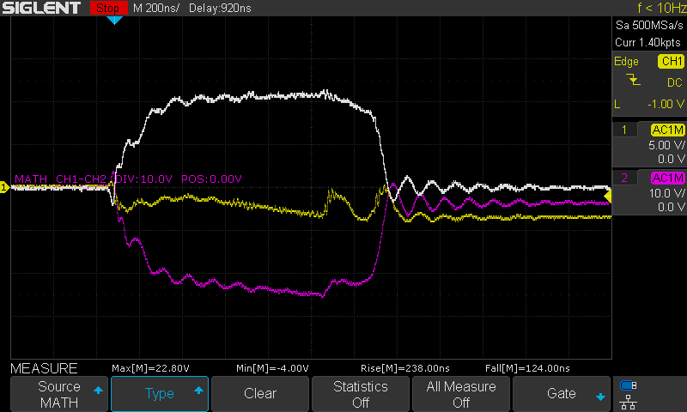
Measuring Current
90V Cap Anode

39, 40 (duplicate) GATE: 10V? CAP ANODE: 50V SERIES RESISTOR: 2R DURATION: 1us
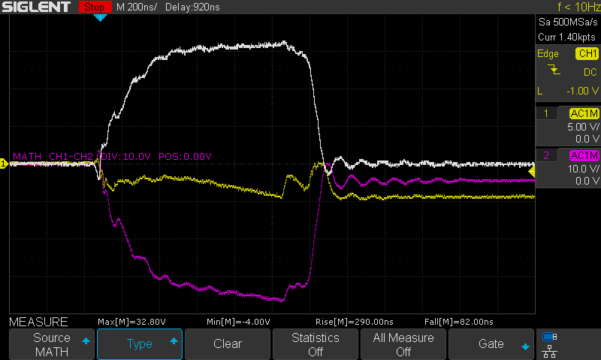
Measuring Current
50V Cap Anode

41 GATE: 10V? CAP ANODE: 120V SERIES RESISTOR: 2R DURATION: 1us
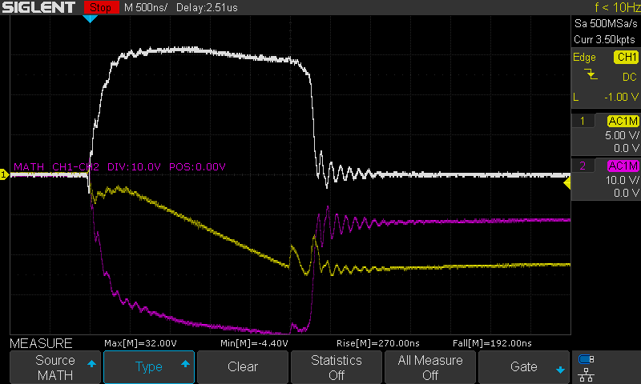
Measuring Current
120V Cap Anode

42, 43 (duplicate) GATE: 10V? CAP ANODE: 50V SERIES RESISTOR: 2R DURATION: 1us
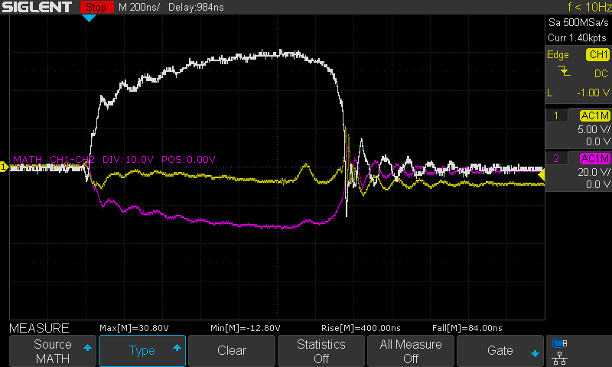
Measuring Current
50V Cap Anode
Changed ferrite bead and pull-down resistor changed

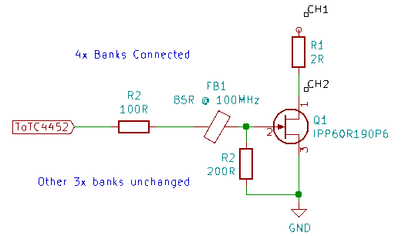
44 GATE: 10V? CAP ANODE: 70V SERIES RESISTOR: 2R DURATION: 1us
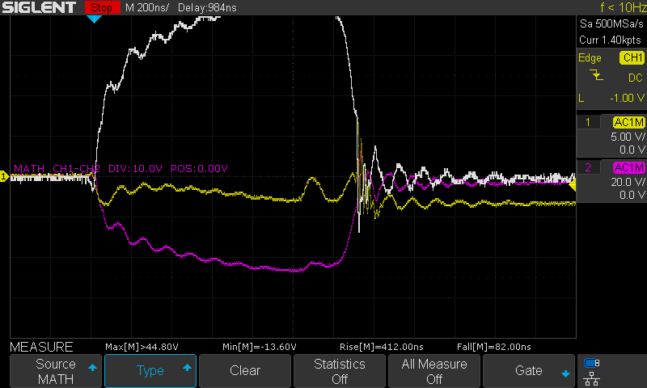
70V Cap Anode
45 GATE: 10V? CAP ANODE: 50V SERIES RESISTOR: 2R DURATION: 1us
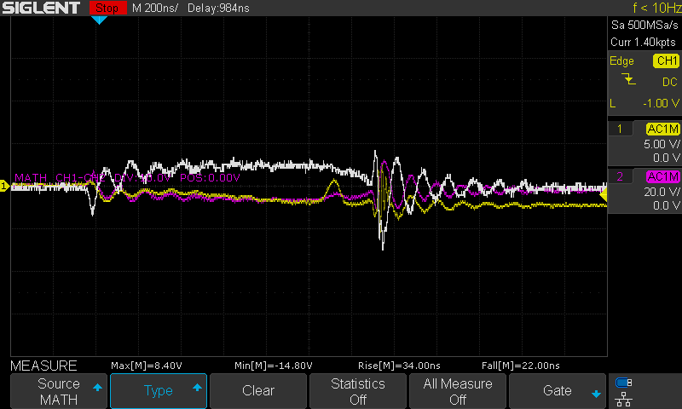
Measuring Current
50V Cap Anode
Changed ferrite bead and pull-down resistor changed
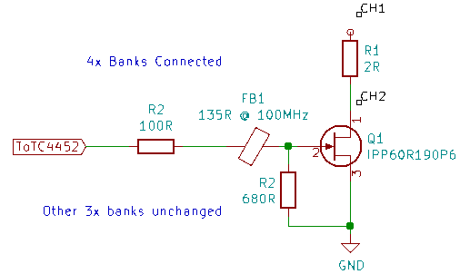
46, 47 (duplicate) GATE: 10V? CAP ANODE: 90V SERIES RESISTOR: 2R DURATION: 1us
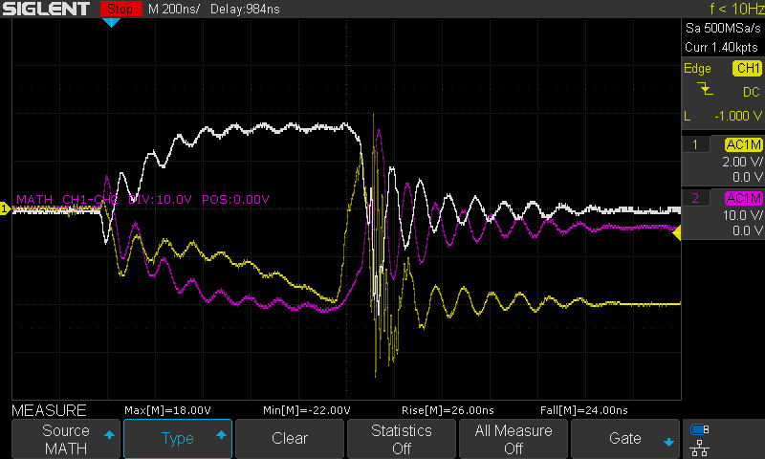
Measuring Current
90V Cap Anode

48 GATE: 10V? CAP ANODE: 120V SERIES RESISTOR: 2R DURATION: 1us
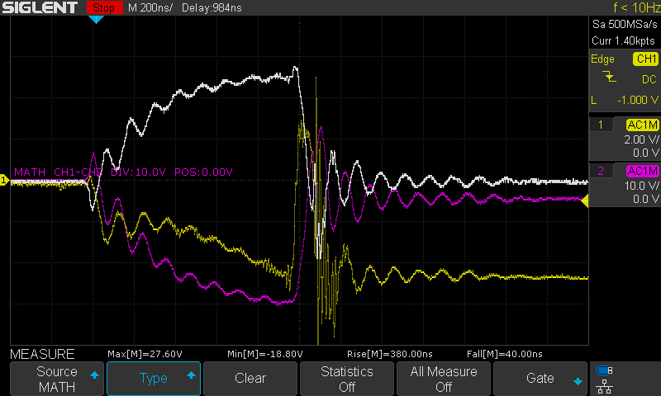
Measuring Current
120V Cap Anode

49 GATE: 10V? CAP ANODE: 120V SERIES RESISTOR: 2R DURATION: 1us
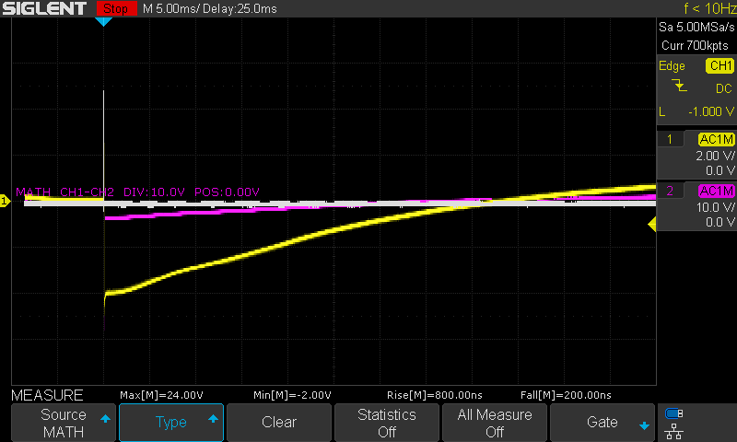
Measuring Current
120V Cap Anode

Series 2 – TC4452 Gate Driver Output

Overview:
Purpose: To improve the gate driver circuit
Equipment:
- E2 Prototype with four banks of LED’s in various states of damage
  - IPPR60 MOSFET’s

Results:
- Adding capacitance to the TC4452 output exacerbates the ringing
- Adding a 10R series resistor with 10nF capacitor to GND to the TC4452 output slows the gate rise and fall significantly (~400ns rise/fall time)
- Adding a 1R5 series resistor with 10nF capacitor to GND to the TC4452 output improves ringing, overshoot @ gates slightly without affecting rise/fall times

Test Data:
1 GATE: 10V? CAP ANODE: 120V SERIES RESISTOR: 2R DURATION: 1us
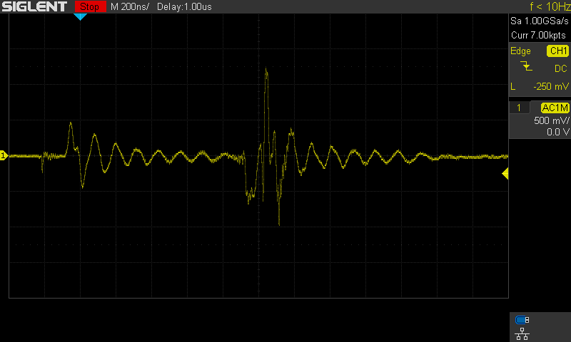
TC4452 Input Voltage
1us pulse, 4x gates connected
2x 10uF capacitors (ceramic) supplying
2 GATE: 10V? CAP ANODE: 120V SERIES RESISTOR: 2R DURATION: 1us
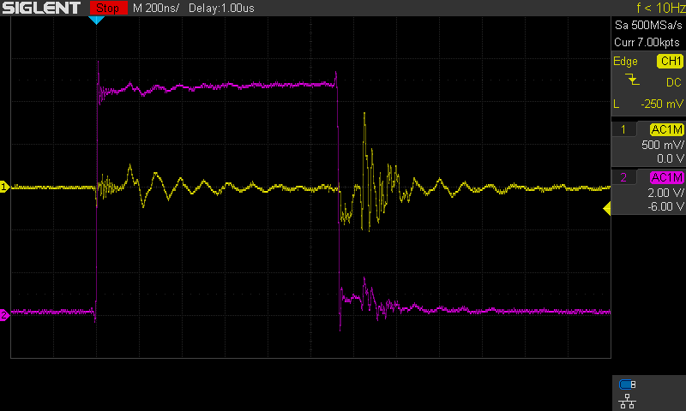
CH1 – TC4452 Input
CH2 – TC4452 Output
1us pulse
3 GATE: 10V? CAP ANODE: 120V SERIES RESISTOR: 2R DURATION: 1us
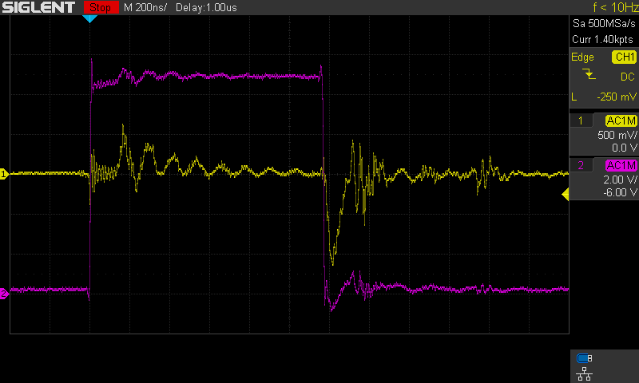
Added 10nF cap @ TC4452 input
4 GATE: 10V? CAP ANODE: 120V SERIES RESISTOR: 2R DURATION: 1us
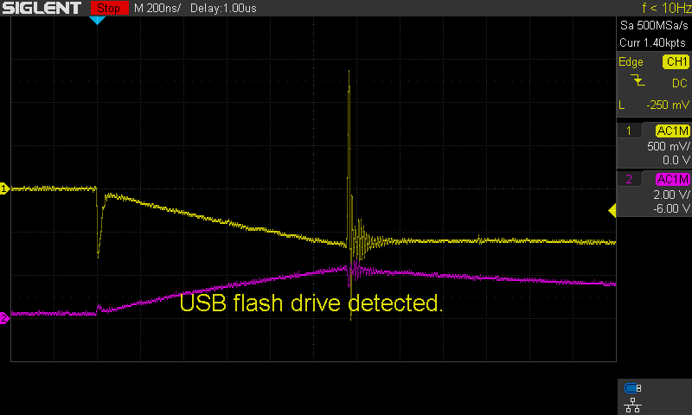
Added 2.2uF capacitor on TC4452 output
5, 6 (duplicate) GATE: 10V? CAP ANODE: 120V SERIES RESISTOR: 2R DURATION: 1us
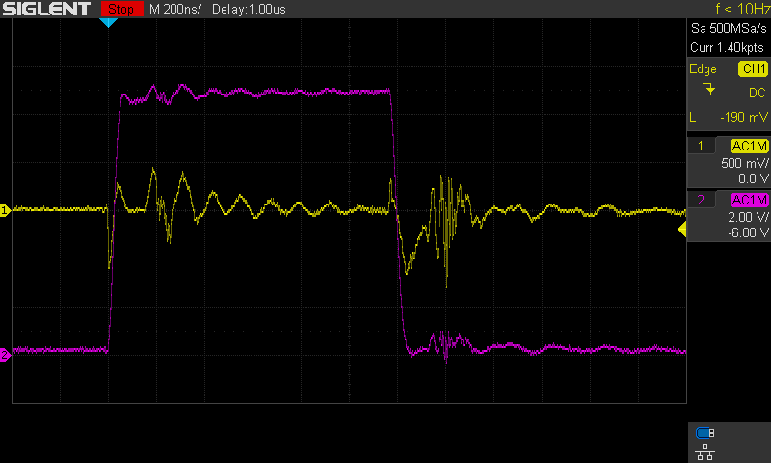
Replaced 2.2uF with 10nF on output
7 GATE: 10V? CAP ANODE: 120V SERIES RESISTOR: 2R DURATION: 1us
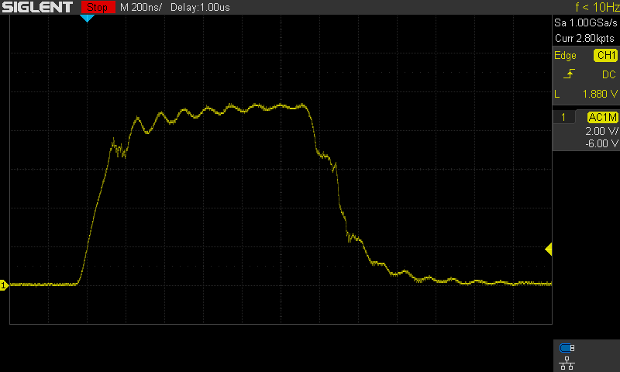
CH1 – MOSFET Gate
8 GATE: 10V? CAP ANODE: 120V SERIES RESISTOR: 2R DURATION: 1us
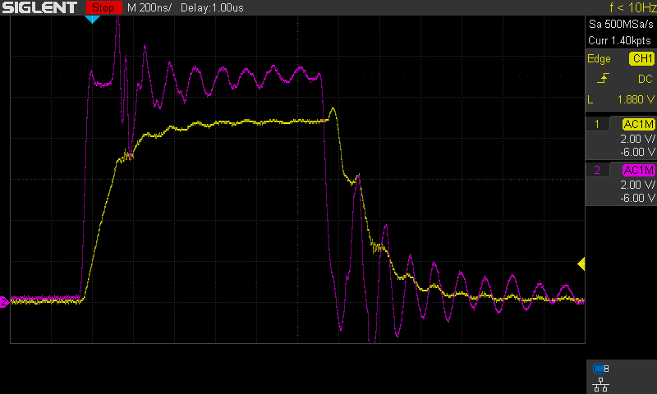
CH1 – MOSFET Gate voltage
CH2 -
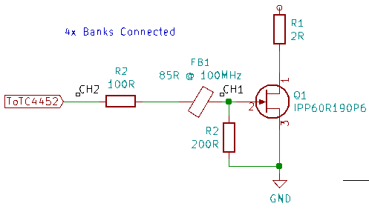

9 GATE: 10V? CAP ANODE: 120V SERIES RESISTOR: 2R DURATION: 1us
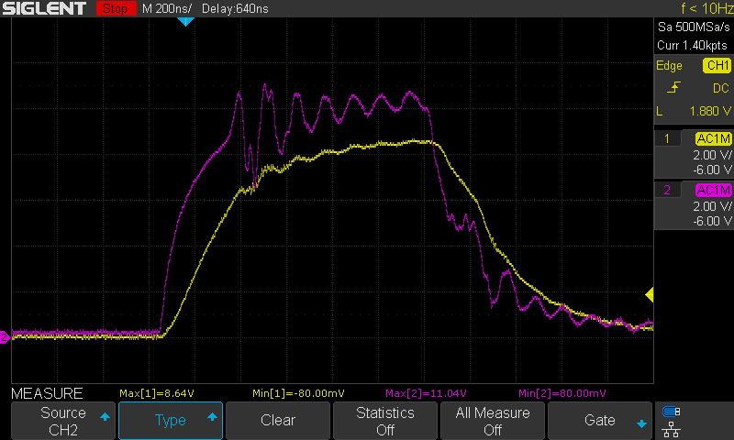
Added 10R resistor on TC4452 output
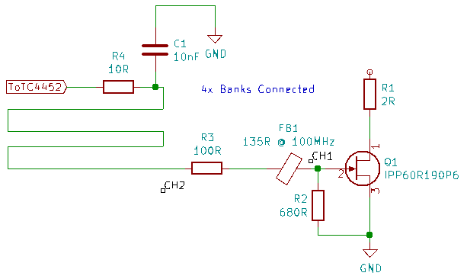

10 GATE: 10V? CAP ANODE: 120V SERIES RESISTOR: 2R DURATION: 1us
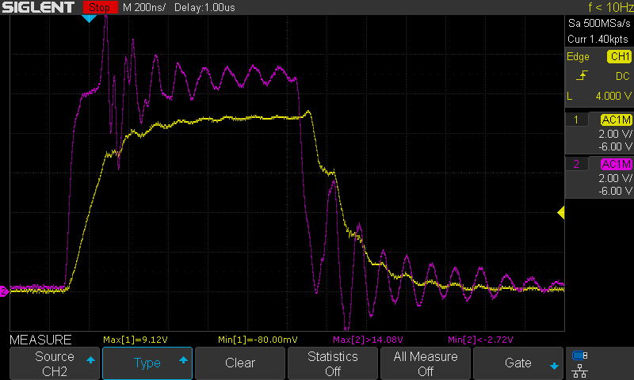
Changed TC4452 output resistor to 1R5
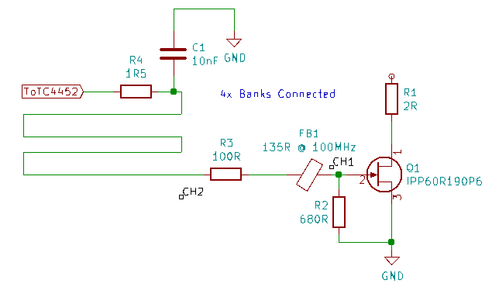

11 GATE: 10V? CAP ANODE: 120V SERIES RESISTOR: 2R DURATION: 1us
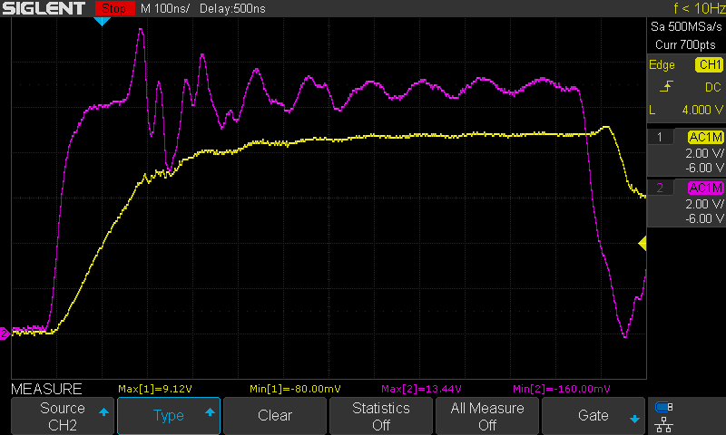
No Change
12 GATE: 10V? CAP ANODE: 120V SERIES RESISTOR: 2R DURATION: 1us
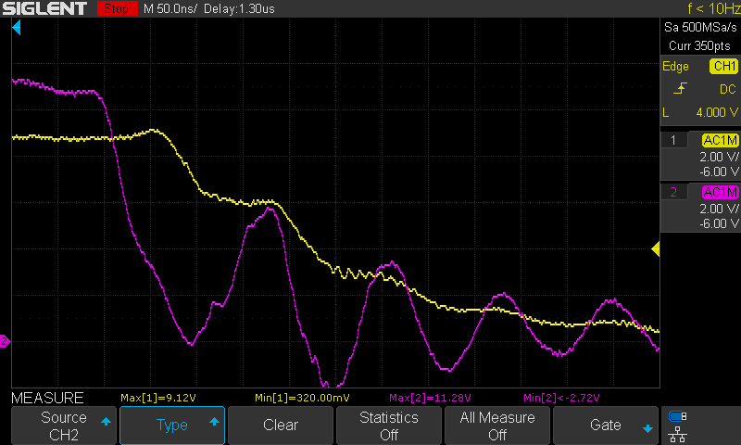
No Change
13 GATE: 10V? CAP ANODE: 120V SERIES RESISTOR: 2R DURATION: 1us
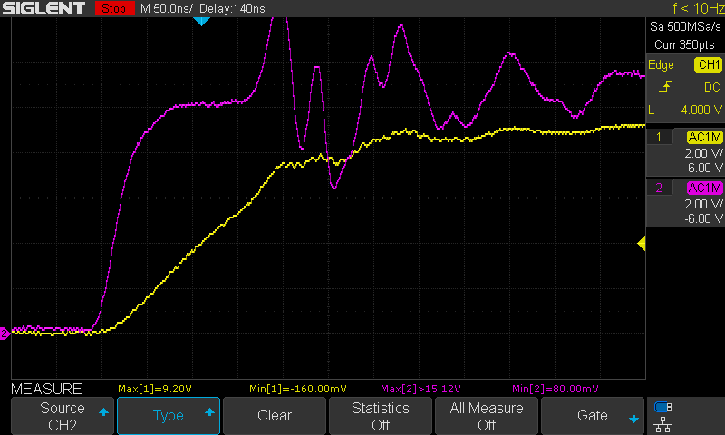
Moved probes to furthest gate (longest leads), was on nearest gate (shortest leads)
14 GATE: 10V? CAP ANODE: 120V SERIES RESISTOR: 2R DURATION: 1us
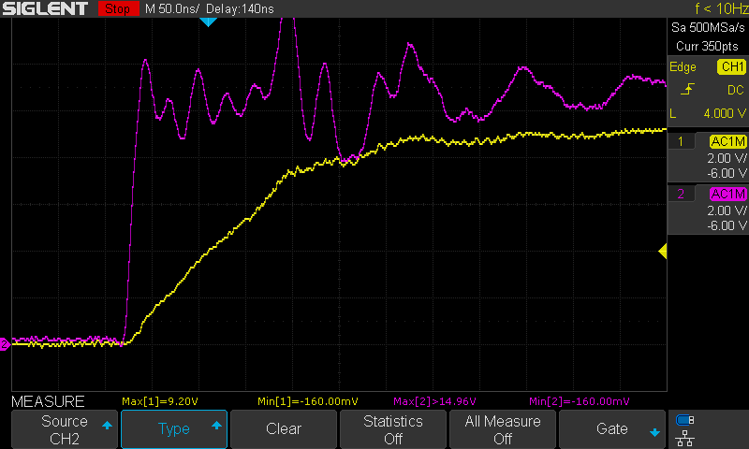
Removed capacitor @ TC4452
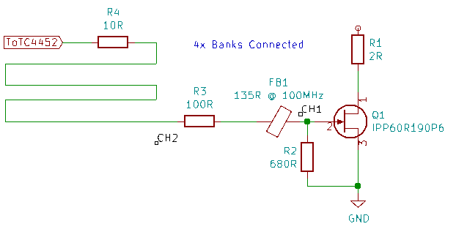
15 GATE: 10V? CAP ANODE: 120V SERIES RESISTOR: 2R DURATION: 1us
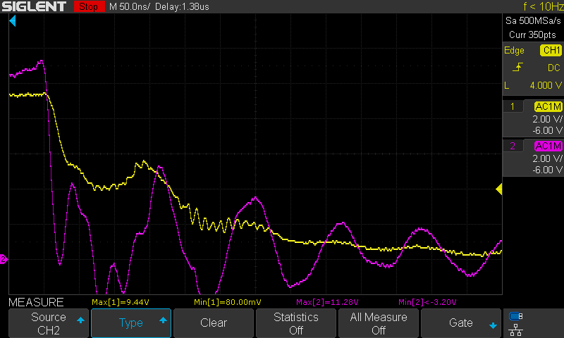
No Change
16 GATE: 10V? CAP ANODE: 120V SERIES RESISTOR: 2R DURATION: 1us
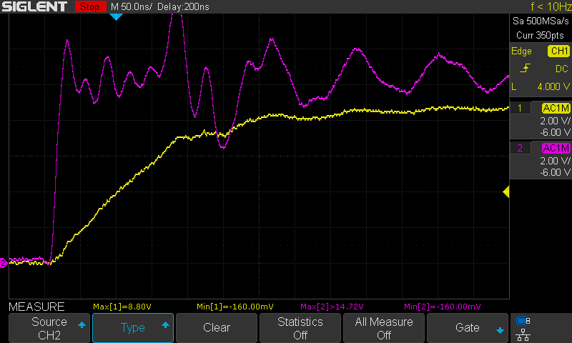
Moved probes to nearest bank
17 GATE: 10V? CAP ANODE: 120V SERIES RESISTOR: 2R DURATION: 1us
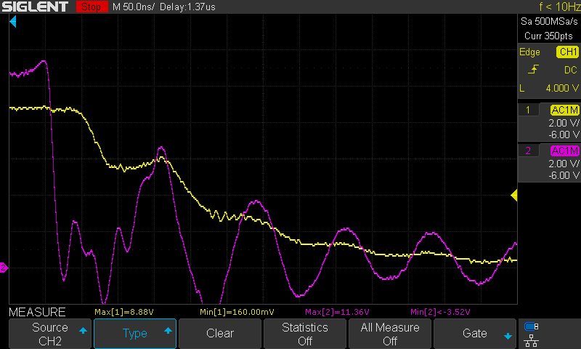
No Change
18, 19 (duplicate) GATE: 10V? CAP ANODE: 120V SERIES RESISTOR: 2R DURATION: 1us
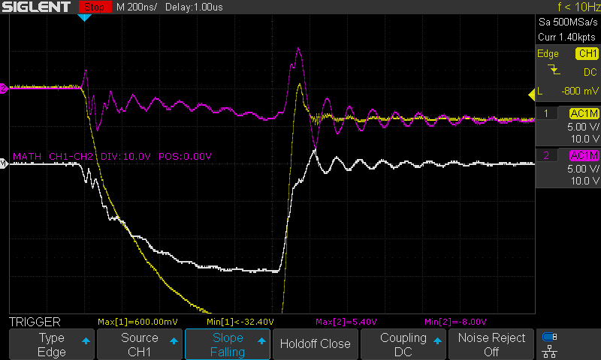
Measuring current across 2R LED resistor
20 GATE: 10V? CAP ANODE: 120V SERIES RESISTOR: 2R DURATION: 1us
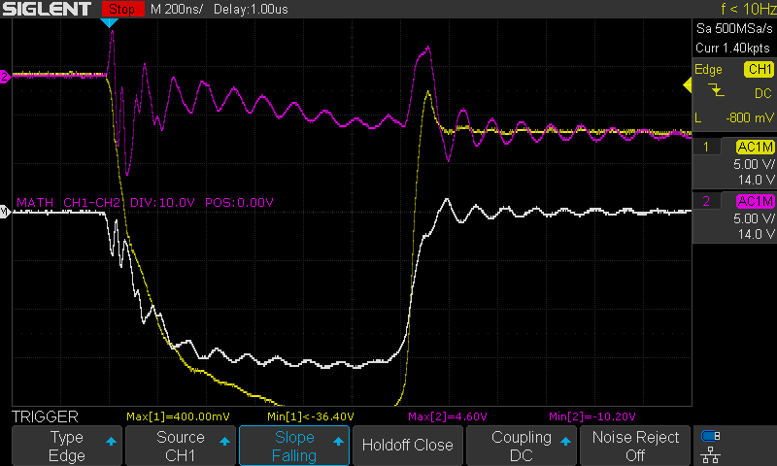
No Change
21 GATE: 11.4V CAP ANODE: 120V SERIES RESISTOR: 2R DURATION: 1us
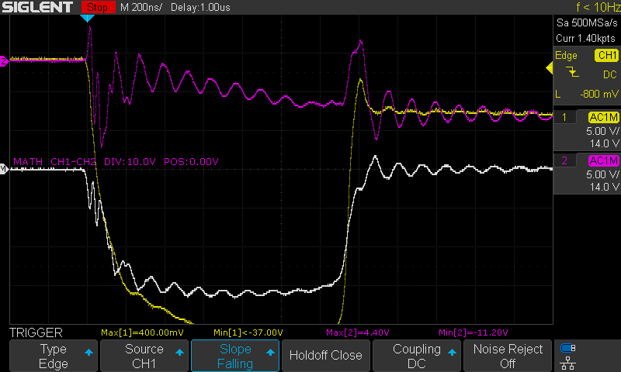
Changed TC4452 input voltage to 11.4V

Series 3 – IPP60R190P6 Current Testing

Overview:
Purpose: To test current capabilities of IPP60R190P6 MOSFET
Equipment:
- E2 Prototype with four banks of LED’s in various states of damage
  - IPPR60 MOSFET’s
2R Circuit:
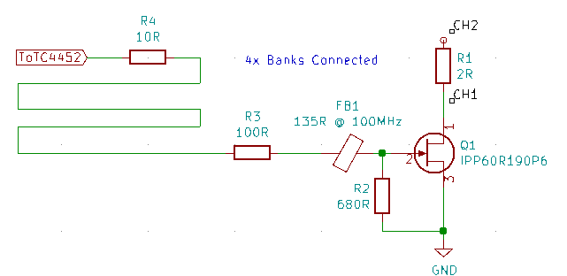
R25 Circuit:

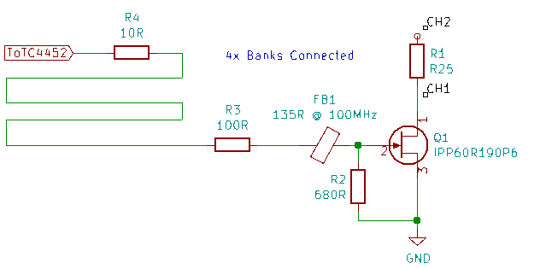
Test Data:
23 GATE: 9V CAP ANODE: 60V SERIES RESISTOR: 2R DURATION: 1us
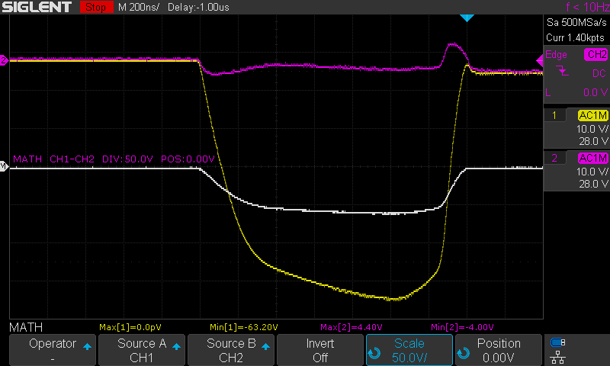
24 GATE: 9V CAP ANODE: 80V SERIES RESISTOR: 2R DURATION: 1us
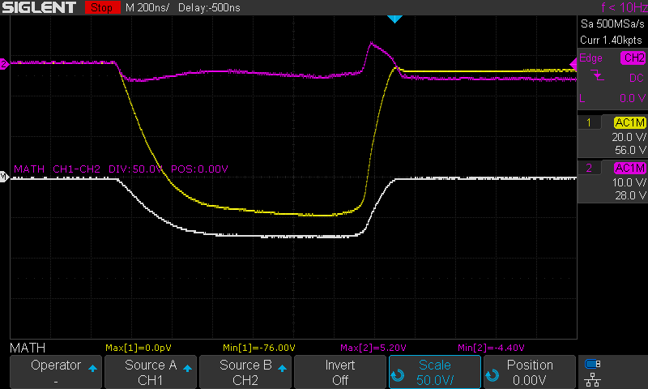
25, 26 (dup) GATE: 9V CAP ANODE: 100V SERIES RESISTOR: 2R DURATION: 1us
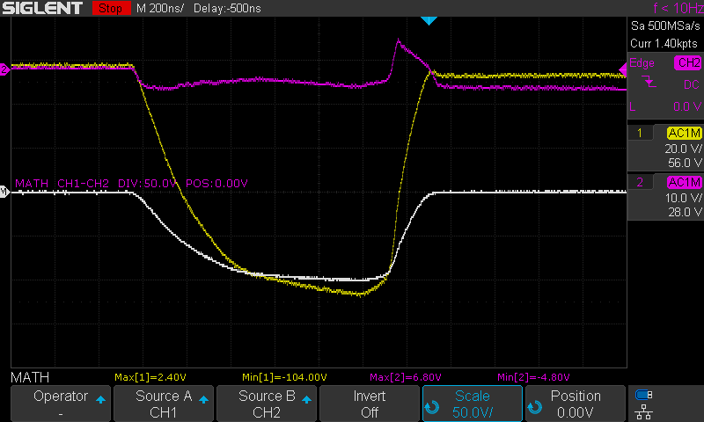
27 GATE: 9V CAP ANODE: 120V SERIES RESISTOR: 2R DURATION: 1us
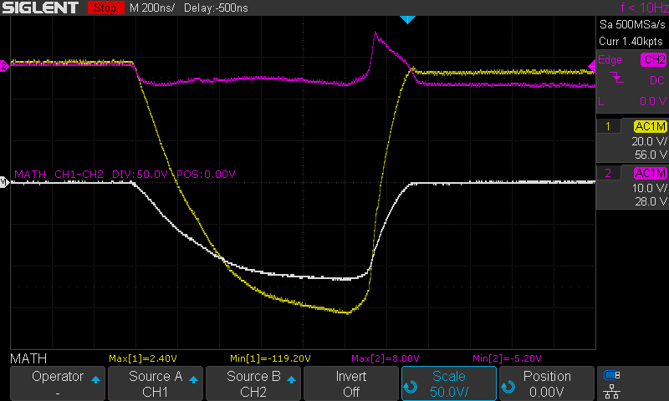
28 GATE: 10.5V CAP ANODE: 60V SERIES RESISTOR: 2R DURATION: 1us
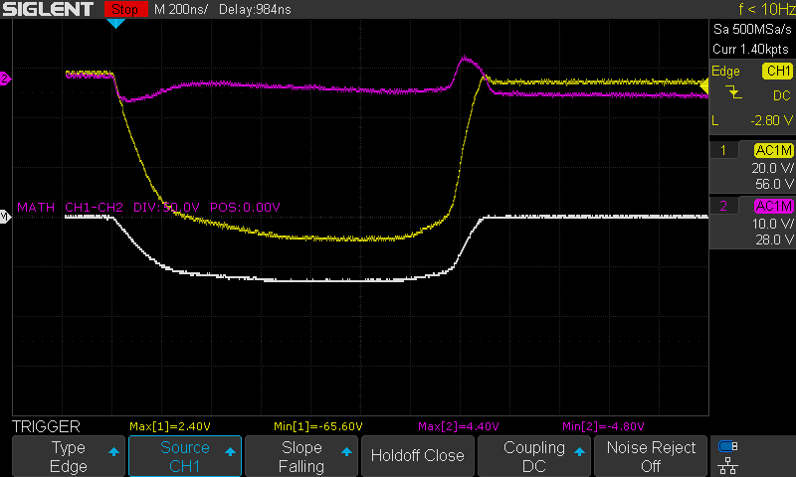
29 GATE: 10.5V CAP ANODE: 80V SERIES RESISTOR: 2R DURATION: 1us
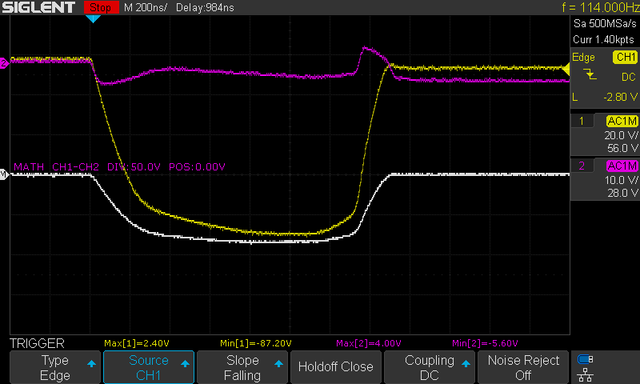
30 GATE: 10.5V CAP ANODE: 100V SERIES RESISTOR: 2R DURATION: 1us
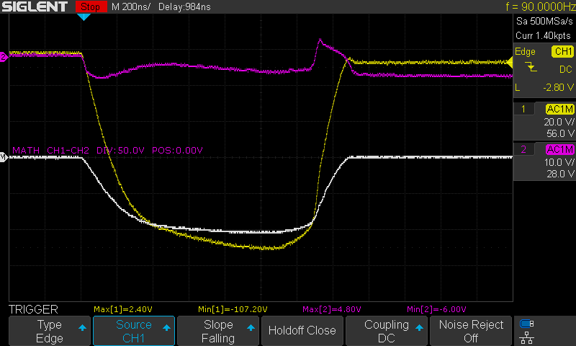
31, 32 (dup) GATE: 10.5V CAP ANODE: 120V SERIES RESISTOR: 2R DURATION: 1us
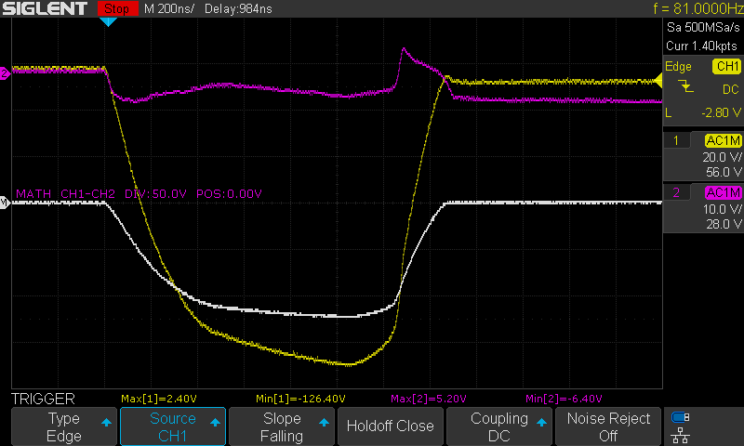
33 GATE: 12V CAP ANODE: 60V SERIES RESISTOR: 2R DURATION: 1us
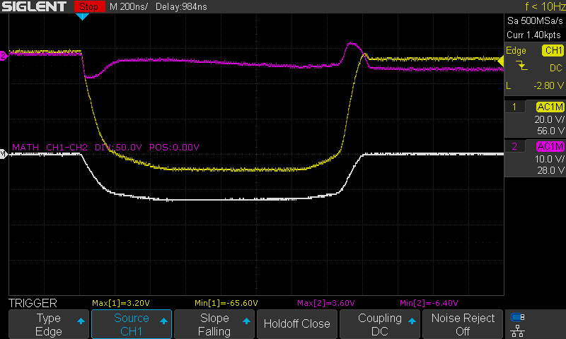
34 GATE: 12V CAP ANODE: 80V SERIES RESISTOR: 2R DURATION: 1us
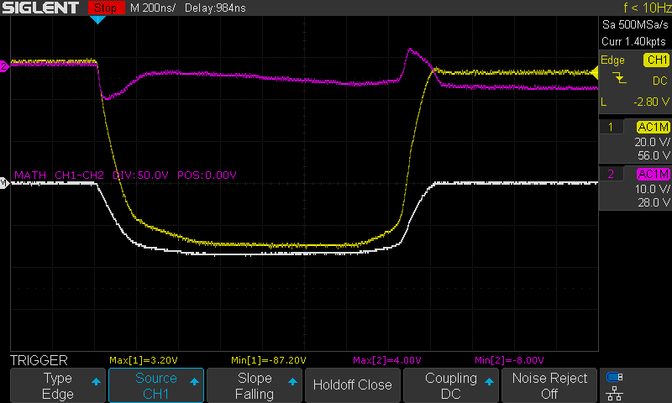
35 GATE: 12V CAP ANODE: 100V SERIES RESISTOR: 2R DURATION: 1us
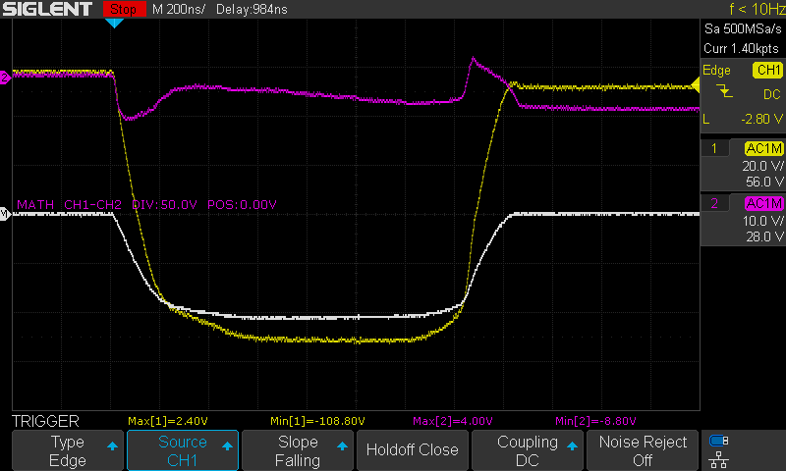
36 GATE: 12V CAP ANODE: 120V SERIES RESISTOR: 2R DURATION: 1us
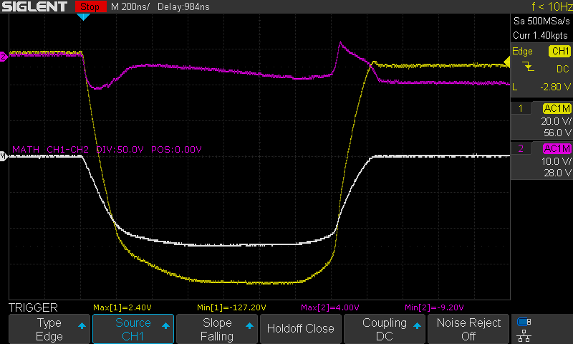
37 GATE: 9V CAP ANODE: 60V SERIES RESISTOR: R25 DURATION: 1us
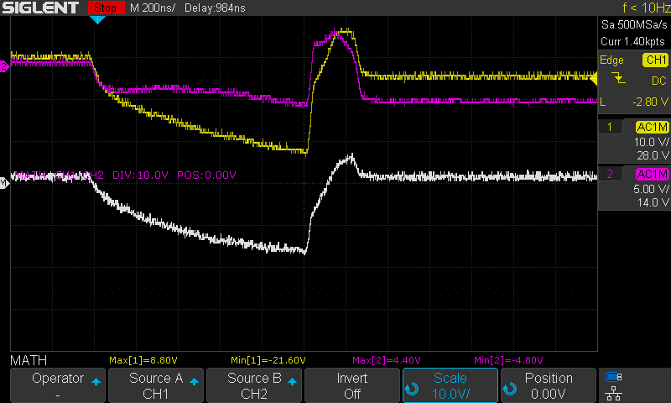
38 GATE: 9V CAP ANODE: 80V SERIES RESISTOR: R25 DURATION: 1us
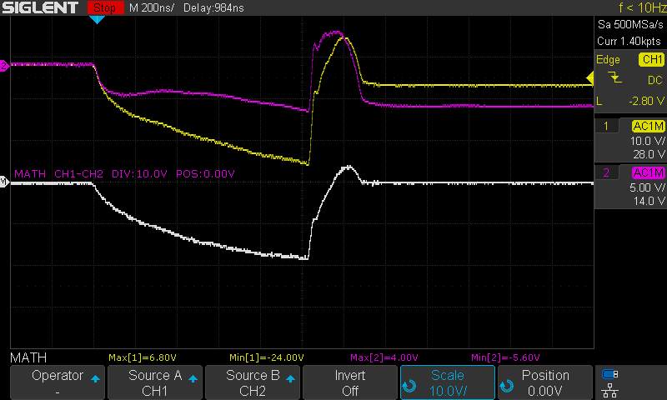
39 GATE: 9V CAP ANODE: 100V SERIES RESISTOR: R25 DURATION: 1us
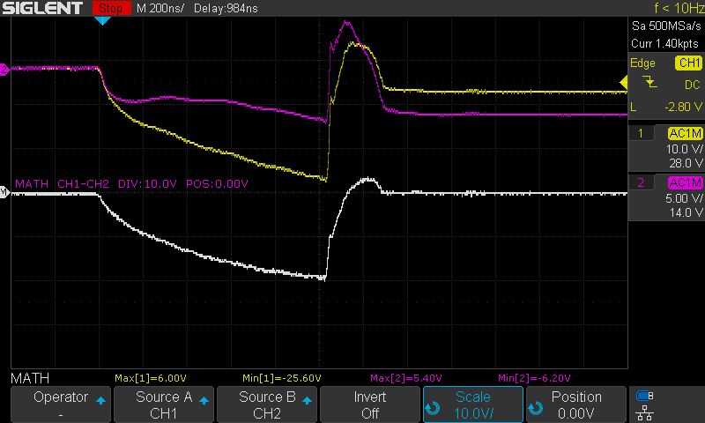
40 GATE: 9V CAP ANODE: 120V SERIES RESISTOR: R25 DURATION: 1us
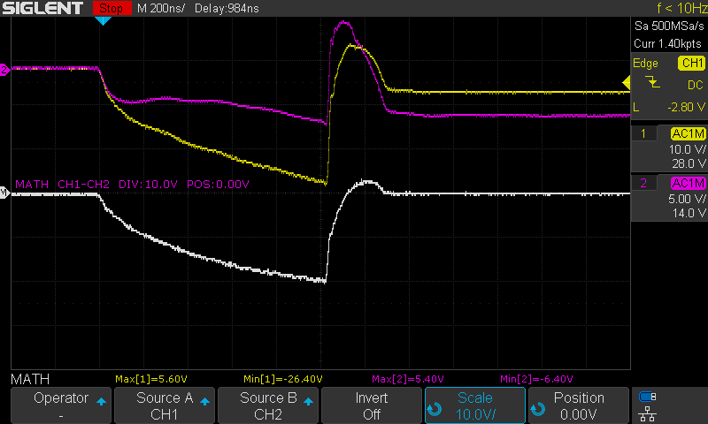
41 GATE: 10.5V CAP ANODE: 60V SERIES RESISTOR: R25 DURATION: 1us
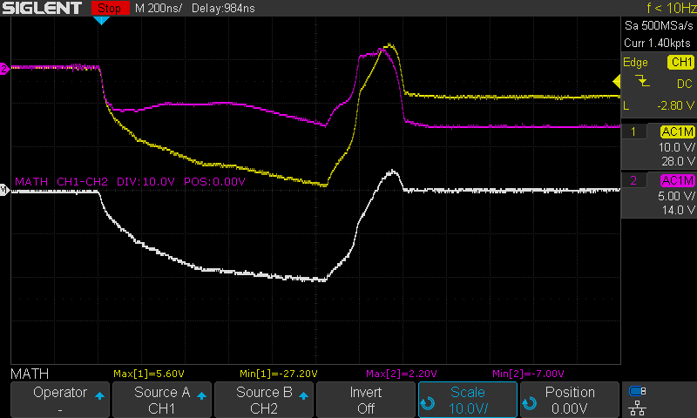
42 GATE: 10.5V CAP ANODE: 80V SERIES RESISTOR: R25 DURATION: 1us
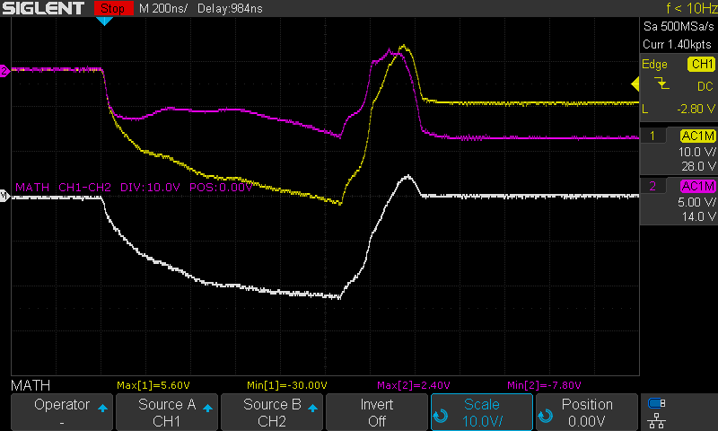
43 GATE: 10.5V CAP ANODE: 100V SERIES RESISTOR: R25 DURATION: 1us
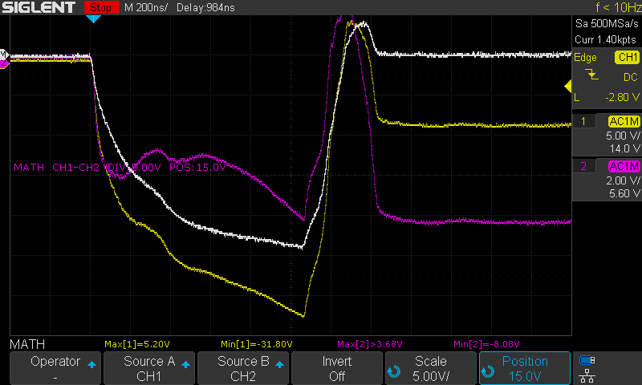

44, 45 (dup) GATE: 10.5V CAP ANODE: 120V SERIES RESISTOR: R25 DURATION: 1us
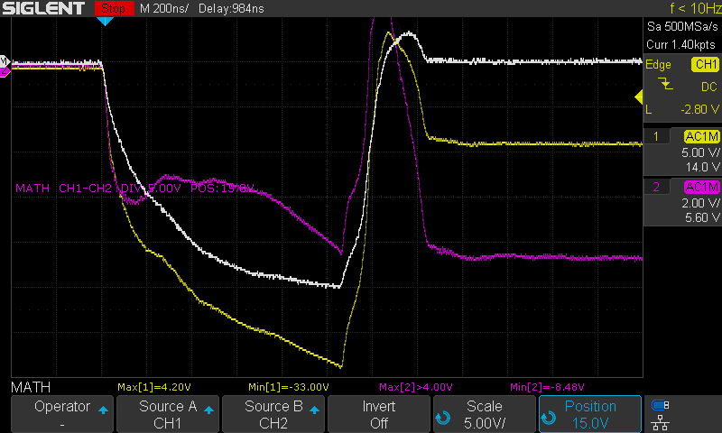
46 GATE: 12V CAP ANODE: 60V SERIES RESISTOR: R25 DURATION: 1us
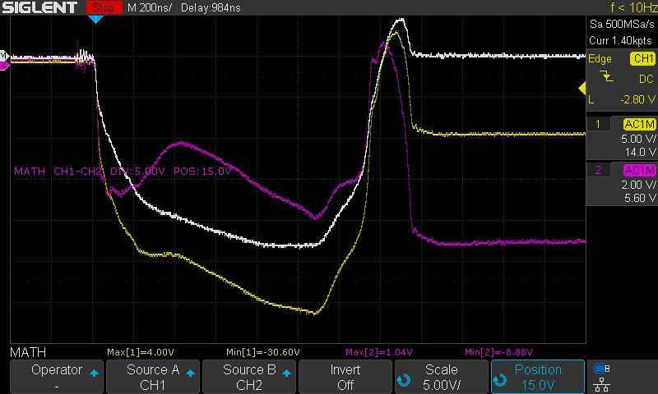
47 GATE: 12V CAP ANODE: 80V SERIES RESISTOR: R25 DURATION: 1us
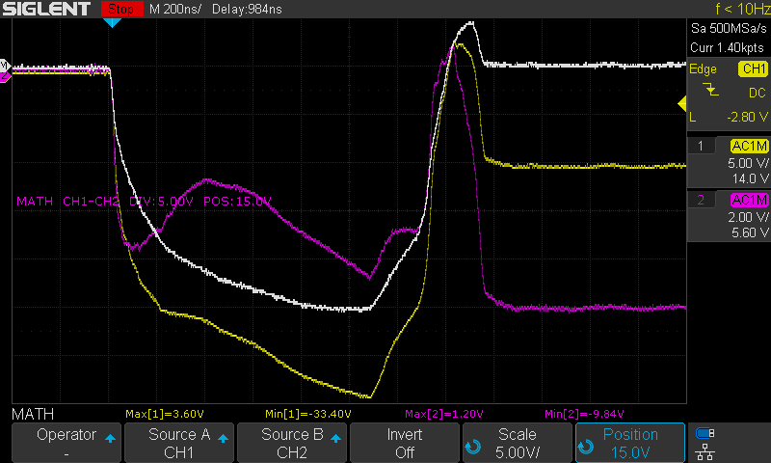
48 GATE: 12V CAP ANODE: 100V SERIES RESISTOR: R25 DURATION: 1us
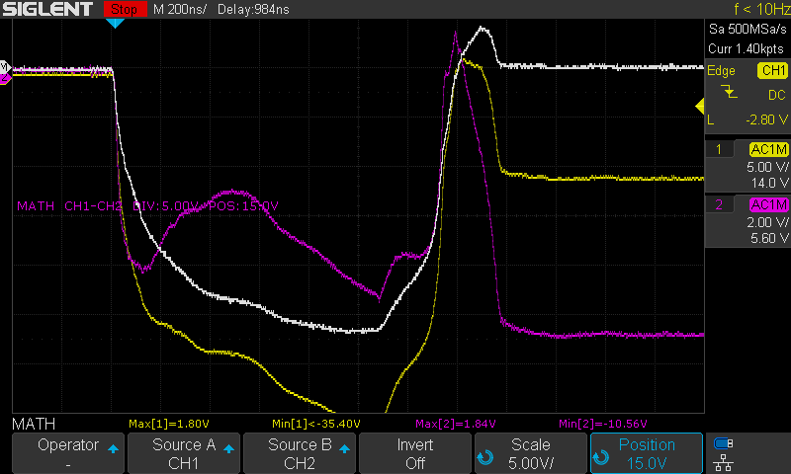
49 GATE: 12V CAP ANODE: 120V SERIES RESISTOR: R25 DURATION: 1us
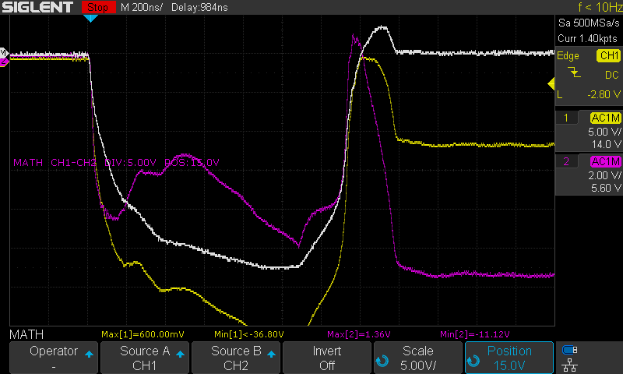
50, 51 (dup) GATE: 13.3V CAP ANODE: 120V SERIES RESISTOR: R25 DURATION: 1us
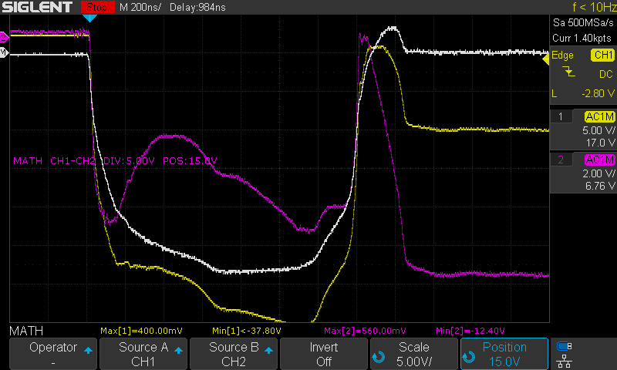
52, 53 (dup) GATE: 16.5V CAP ANODE: 120V SERIES RESISTOR: R25 DURATION: 1us
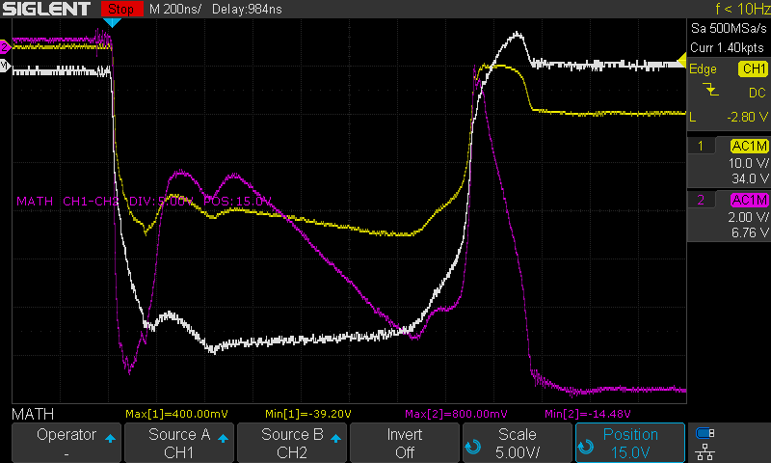
54, 55 (dup) GATE: 18.4V CAP ANODE: 120V SERIES RESISTOR: R25 DURATION: 1us
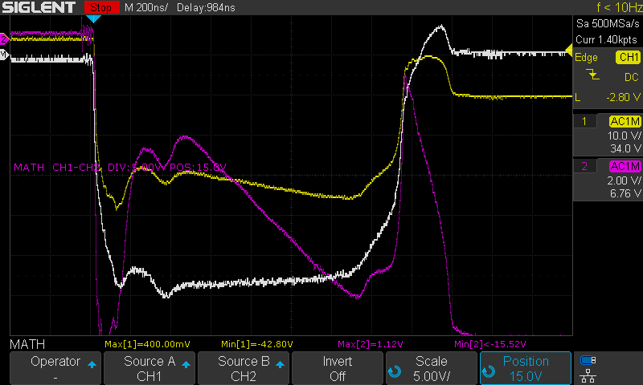
56 GATE: 18.4V CAP ANODE: 100V SERIES RESISTOR: R25 DURATION: 1us
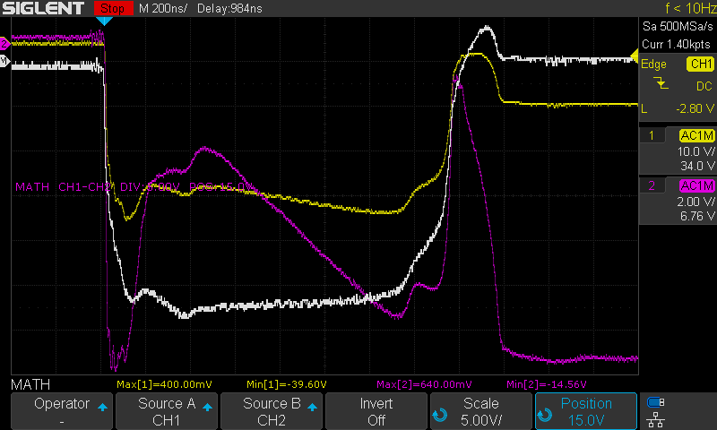
57 GATE: 18.4V CAP ANODE: 80V SERIES RESISTOR: R25 DURATION: 1us
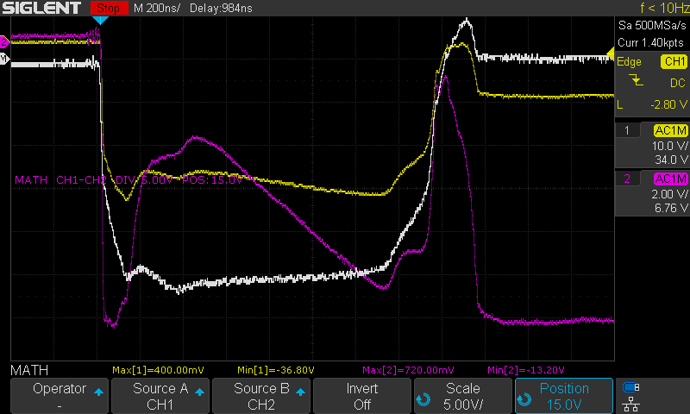
58 GATE: 18.4V CAP ANODE: 60V SERIES RESISTOR: R25 DURATION: 1us
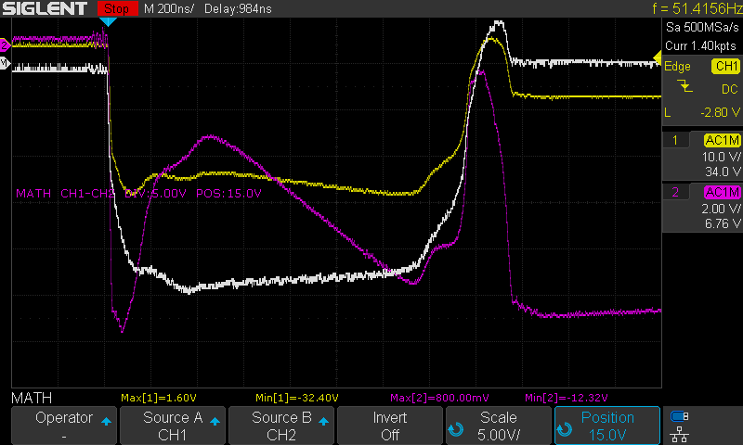
59 GATE: 18.4V CAP ANODE: 60V SERIES RESISTOR: R25 DURATION: 4us
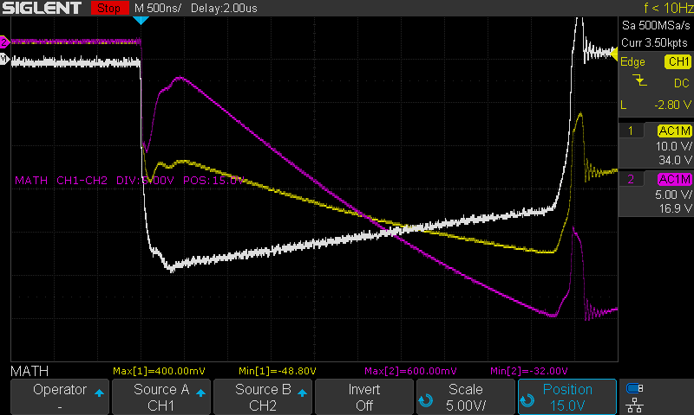
60 GATE: 18.4V CAP ANODE: 80V SERIES RESISTOR: R25 DURATION: 4us
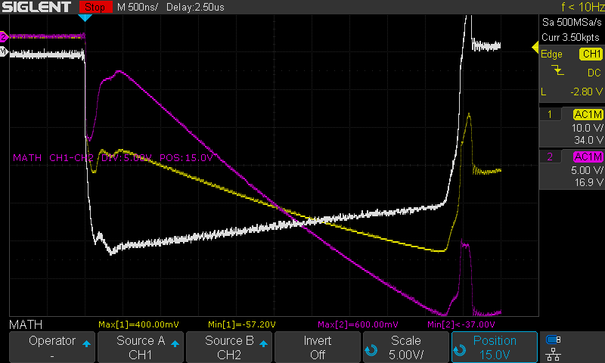
61 GATE: 18.4V CAP ANODE: 100V SERIES RESISTOR: R25 DURATION: 4us
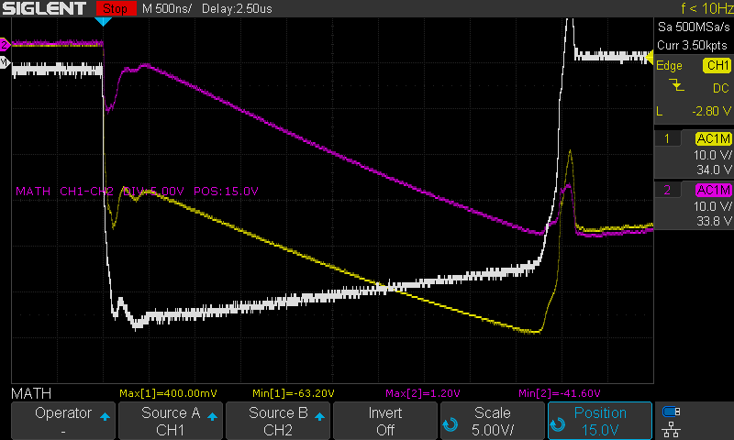
62, 63 (dup) GATE: 18.4V CAP ANODE: 120V SERIES RESISTOR: R25 DURATION: 4us
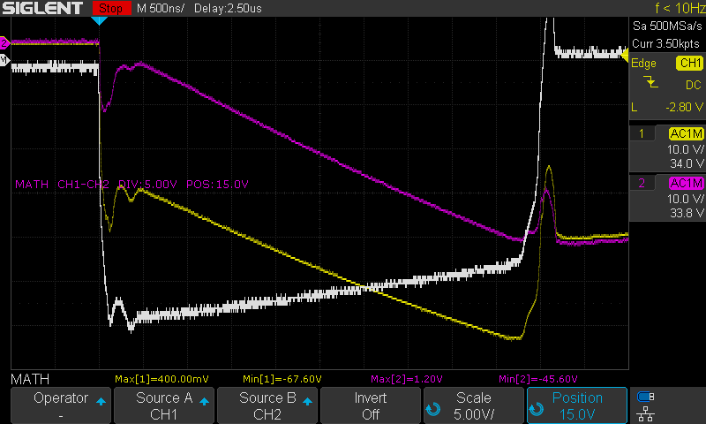

Series 4 – IRFB4332 MOSFET Gate Circuit Development
2020-05-16

Overview:
Purpose: To develop an effective gate driver circuit for the IRFB4332 MOSFET
Equipment:
- E2 Prototype with four banks of LED’s in various states of damage
  - IPPR60 MOSFET’s

Test Data:
64 GATE: 12V CAP ANODE: 60V SERIES RESISTOR: R25 DURATION: 1us
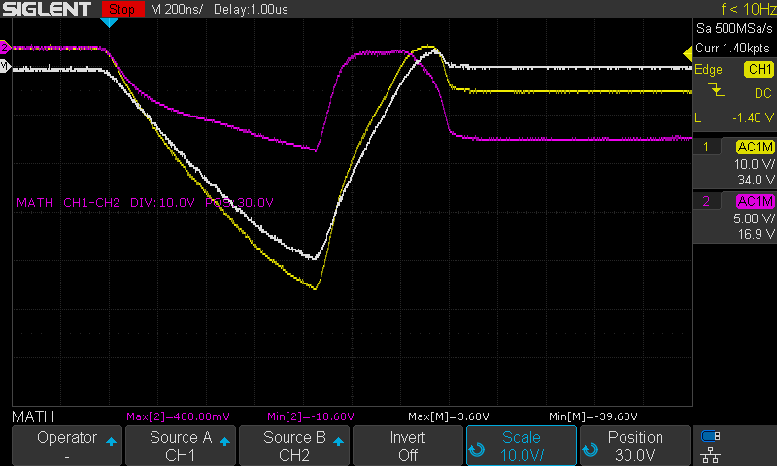
Measuring current through 0.25R resistor (R1)
No changes to gate circuit from IPP60R190P6 circuit
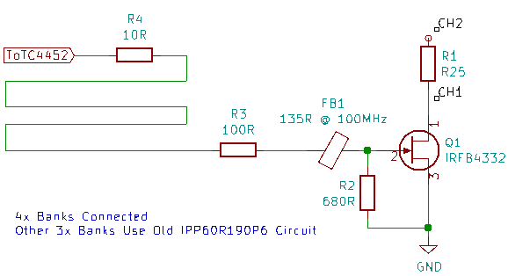

65 GATE: 12V CAP ANODE: 80V SERIES RESISTOR: R25 DURATION: 1us
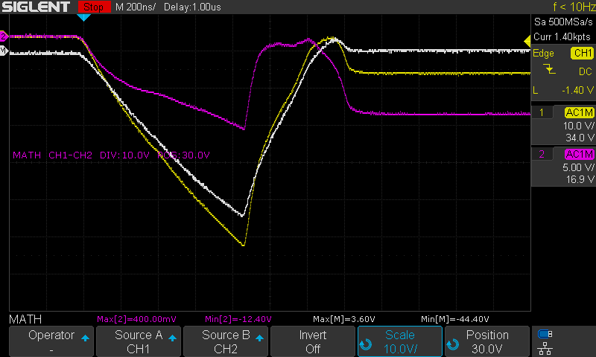
No Change
66, 67 (dup) GATE: 12V CAP ANODE: 100V SERIES RESISTOR: R25 DURATION: 1us
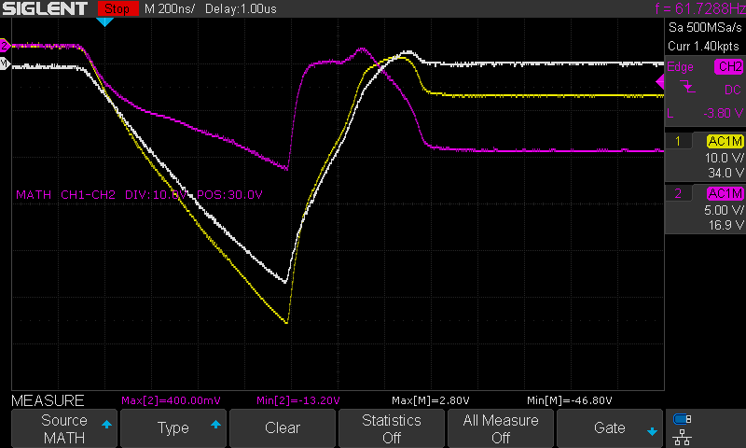
No Change
68 GATE: 12V CAP ANODE: 120V SERIES RESISTOR: R25 DURATION: 1us
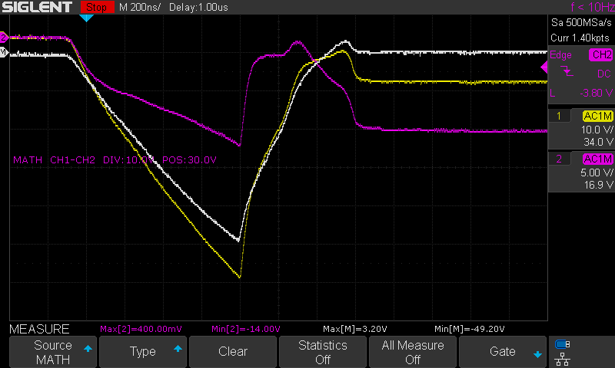
69 GATE: 12V CAP ANODE: 120V SERIES RESISTOR: R25 DURATION: 4us
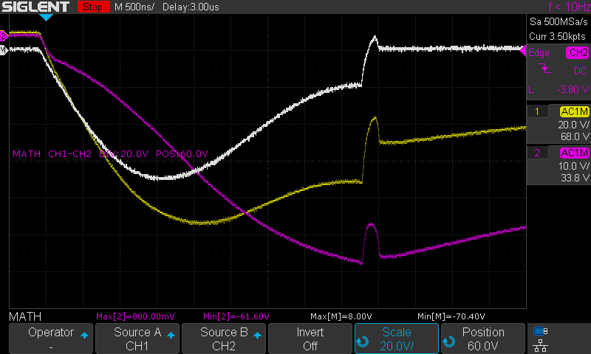
70 GATE: 12V CAP ANODE: 120V SERIES RESISTOR: R25 DURATION: 4us
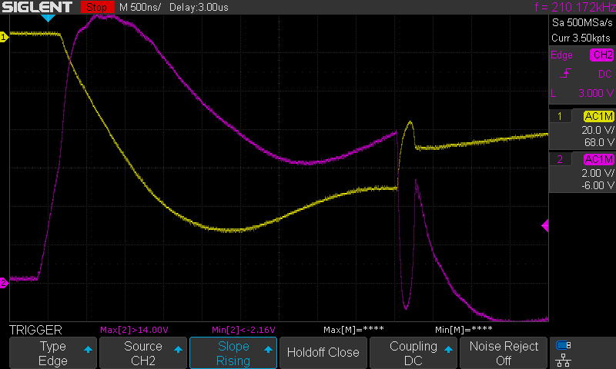
No change to circuit
CH2 – MOSFET Gate
71 GATE: 12V CAP ANODE: 120V SERIES RESISTOR: R25 DURATION: 4us
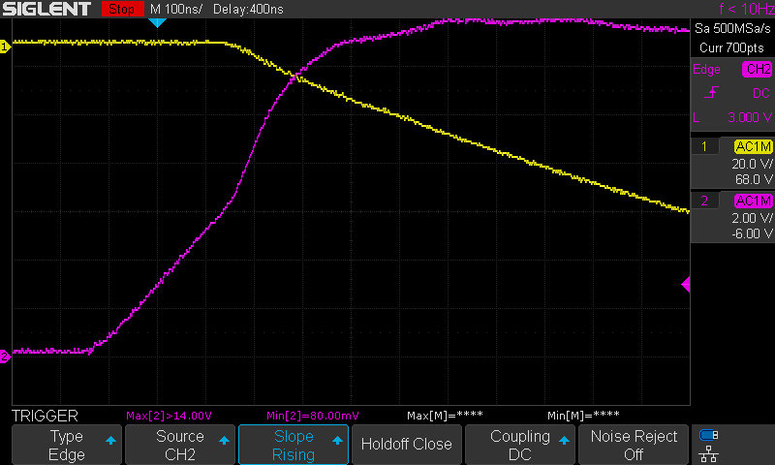
No Change
72 GATE: 12V CAP ANODE: 120V SERIES RESISTOR: R25 DURATION: 4us
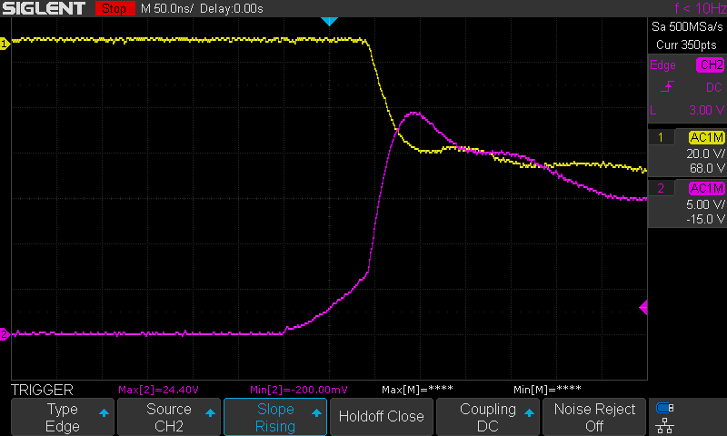
Changed 100R gate resistor to 4R7
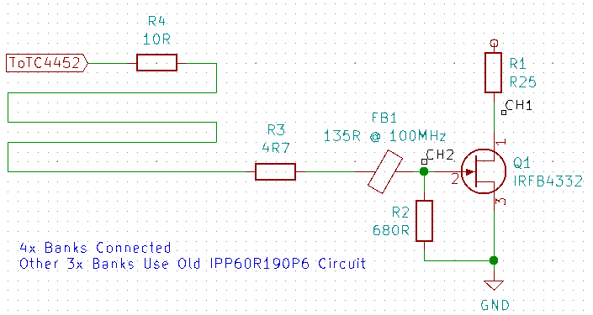

73 GATE: 12V CAP ANODE: 120V SERIES RESISTOR: R25 DURATION: 4us
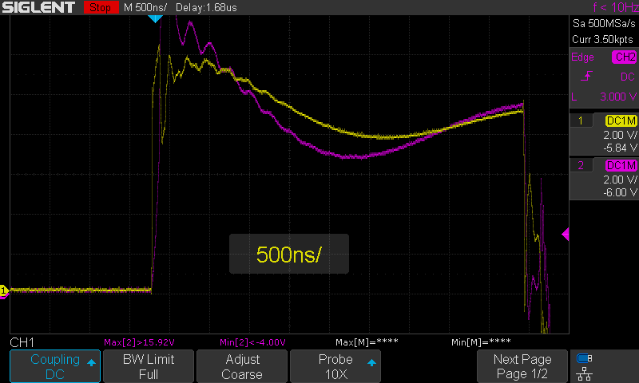
CH1 – R3
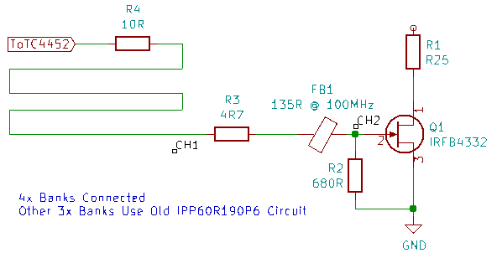

74, 75 (dup) GATE: 12V CAP ANODE: 120V SERIES RESISTOR: R25 DURATION: 4us
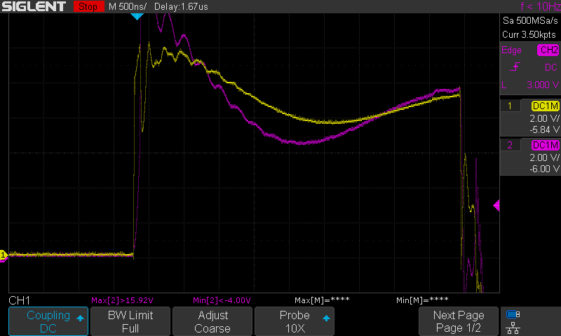
Removed Gate resistor
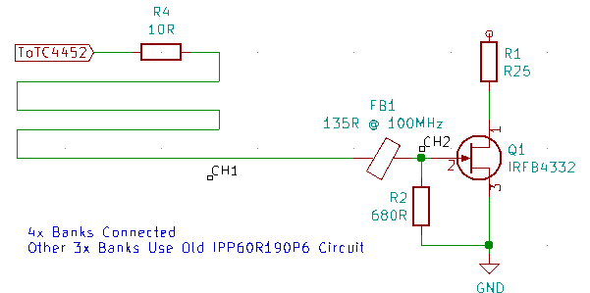

76 GATE: 8V CAP ANODE: 120V SERIES RESISTOR: R25 DURATION: 4us
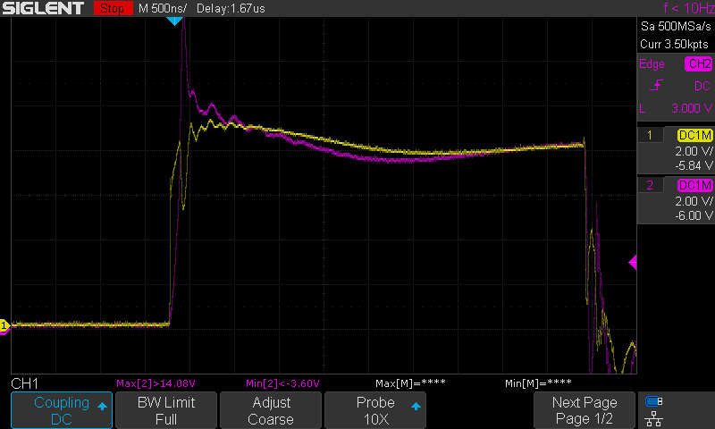
Lowered TC4452 voltage
77 GATE: 8V CAP ANODE: 120V SERIES RESISTOR: R25 DURATION: 4us
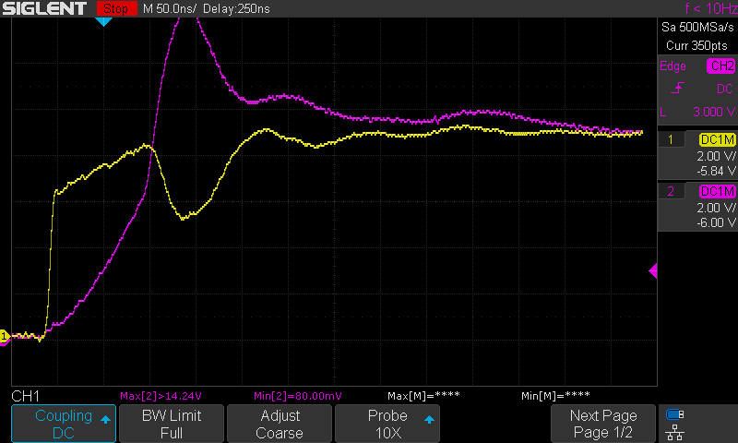
No change
78 GATE: 8V CAP ANODE: 120V SERIES RESISTOR: R25 DURATION: 4us
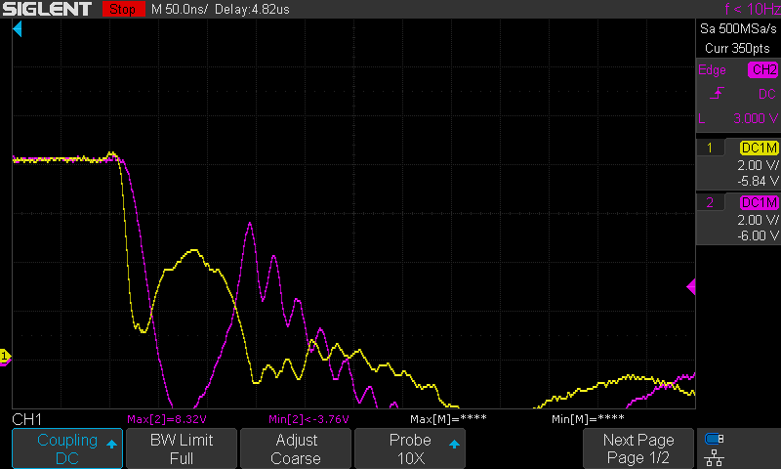
No Change
79 GATE: 8V CAP ANODE: 120V SERIES RESISTOR: R25 DURATION: 1us
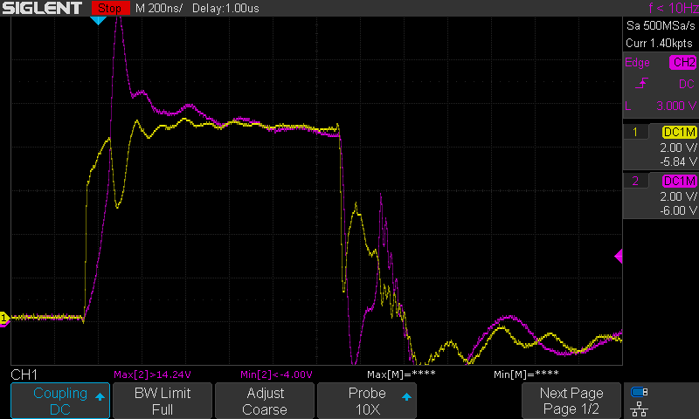
1us strobe
80 GARBAGE
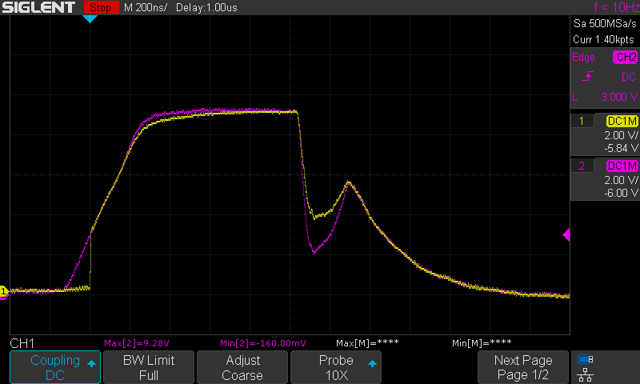
81 GATE: 8V CAP ANODE: 120V SERIES RESISTOR: R25 DURATION: 1us
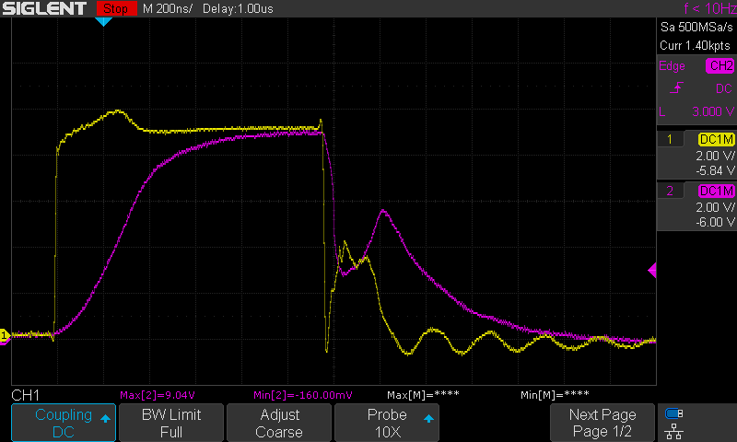
Re-installed 4R7 resistor to gate circuit
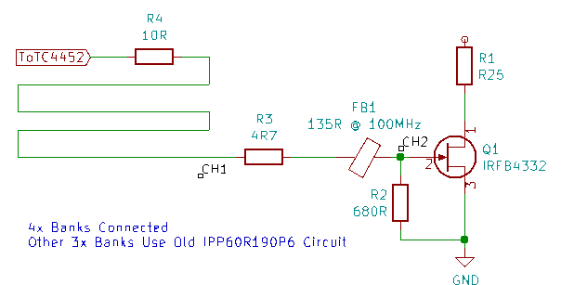

82, 83 (dup) GATE: 8V CAP ANODE: 120V SERIES RESISTOR: R25 DURATION: 1us
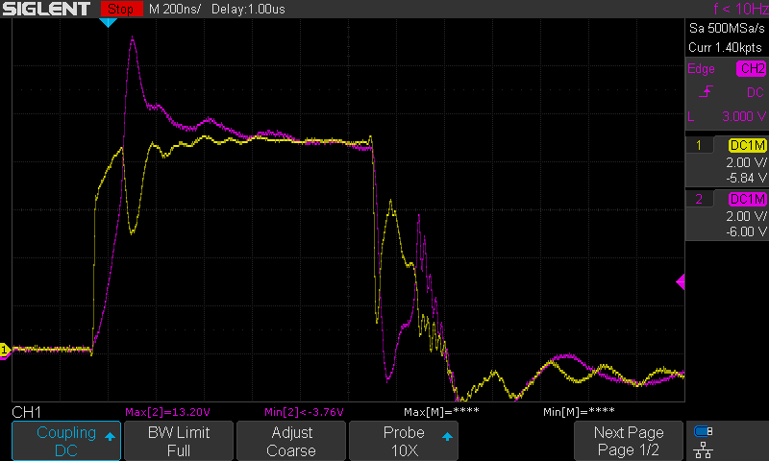
Replaced 4R7 gate resistor with 2R resistor
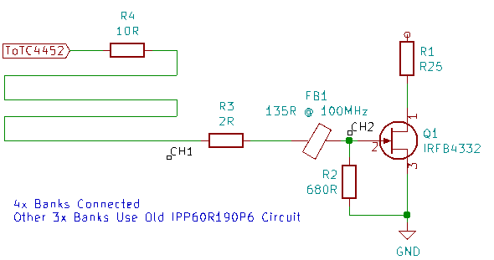

84 GATE: 8V CAP ANODE: 120V SERIES RESISTOR: R25 DURATION: 1us
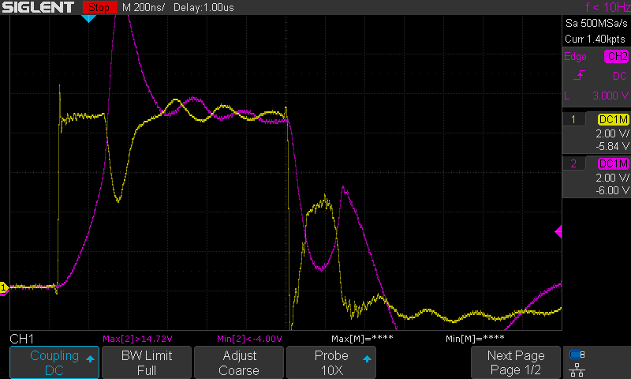
Added 800R @ 100MHz Ferrite Bead to gate circuit
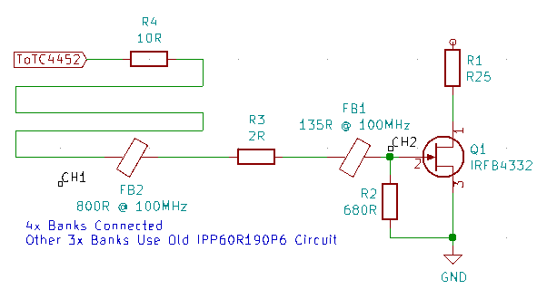

85 GATE: 8V CAP ANODE: 120V SERIES RESISTOR: R25 DURATION: 1us
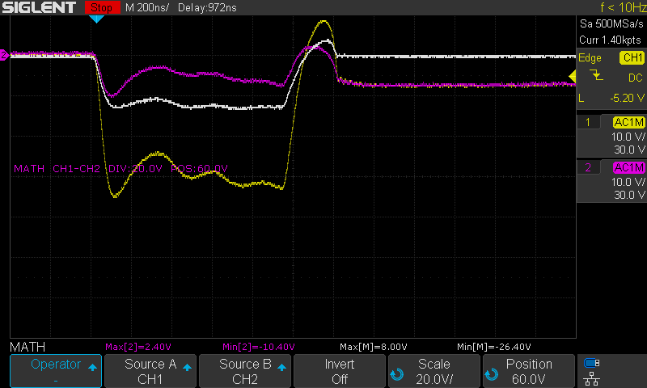
Current Test
86 GATE: 8.5V CAP ANODE: 120V SERIES RESISTOR: R25 DURATION: 1us
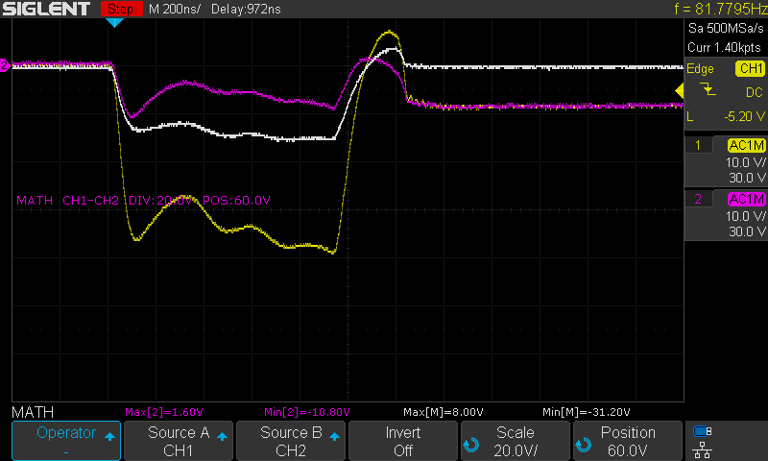
87 GATE: 9.1V CAP ANODE: 120V SERIES RESISTOR: R25 DURATION: 1us
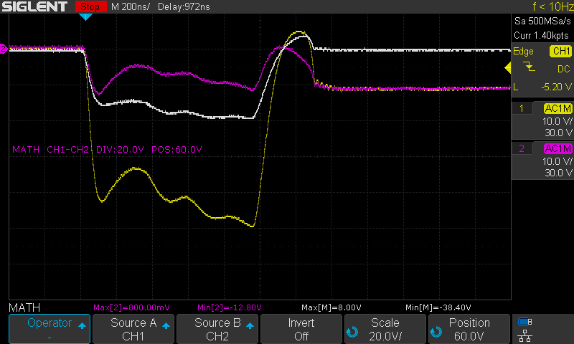
88, 89 (dup) GATE: 11V CAP ANODE: 120V SERIES RESISTOR: R25 DURATION: 1us
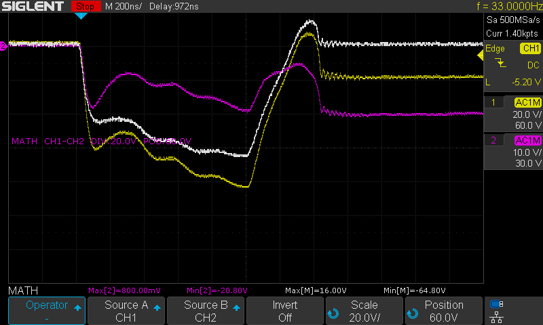
90, 91 (dup) GATE: 12.8V CAP ANODE: 120V SERIES RESISTOR: R25 DURATION: 1us
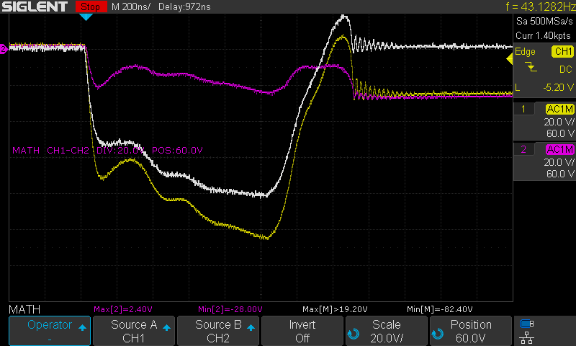

92 GATE: 12.8V CAP ANODE: 120V SERIES RESISTOR: R5 DURATION: 1us
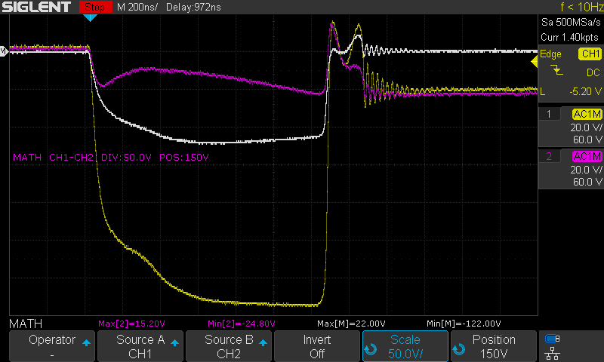
0R5 Current sense resistor

93, 94 (dup) GATE: 8V CAP ANODE: 120V SERIES RESISTOR: R5 DURATION: 1us
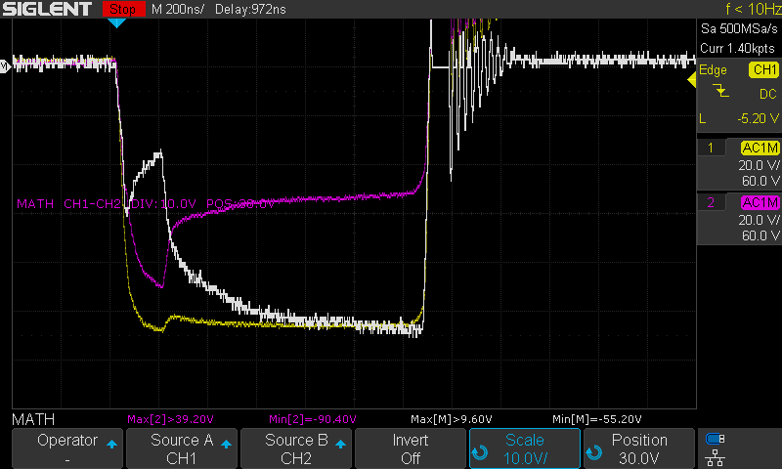
With single CXA2530 LED (T0) in series
Measuring current across R1
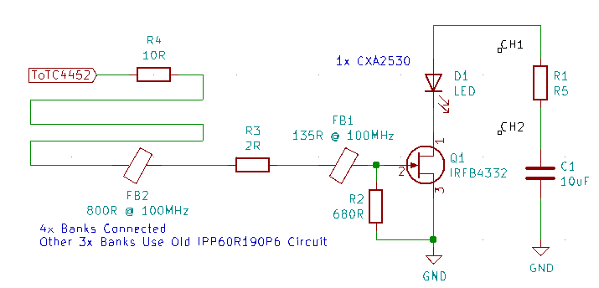
95 GATE: 8V CAP ANODE: 120V SERIES RESISTOR: R5 DURATION: 1us
No Change
96 GATE: 8V CAP ANODE: 120V SERIES RESISTOR: R5 DURATION: 1us
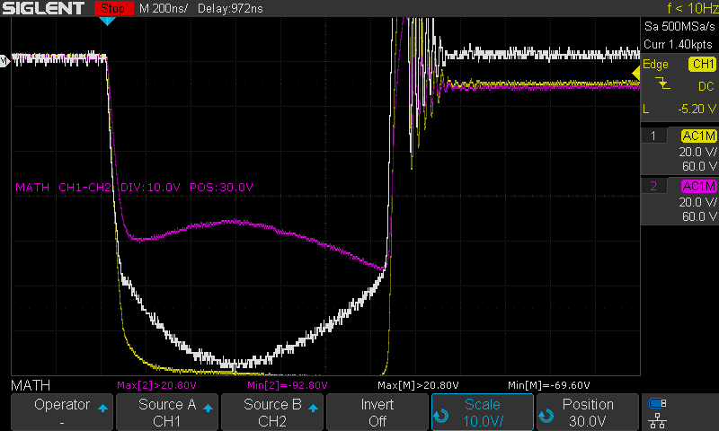
No Change

97 GATE: 8V CAP ANODE: 120V SERIES RESISTOR: R5 DURATION: 1us
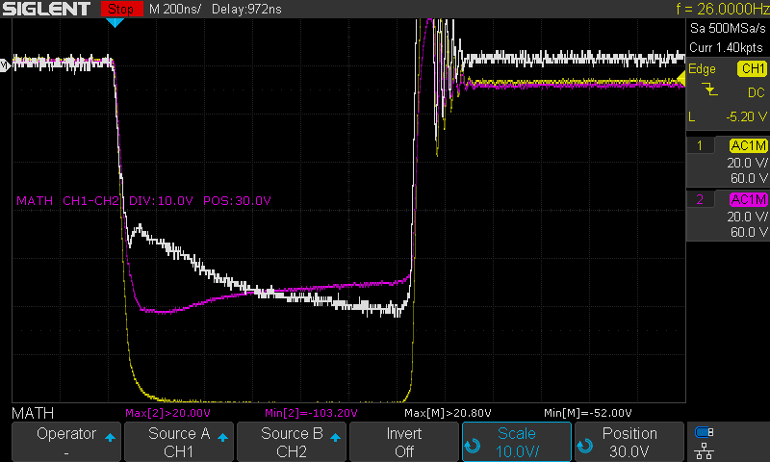
No Change
98 GATE: 8V CAP ANODE: 120V SERIES RESISTOR: R5 DURATION: 1us
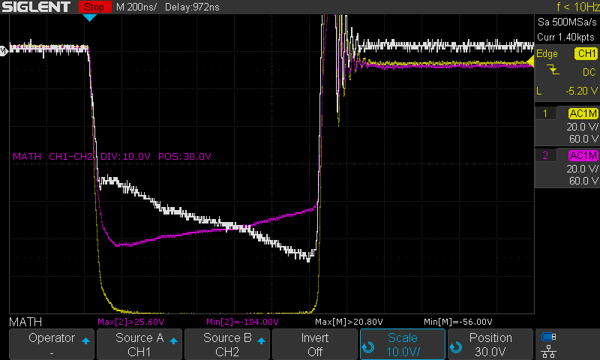
No Change
99 GATE: 8V CAP ANODE: 120V SERIES RESISTOR: R5 DURATION: 1us
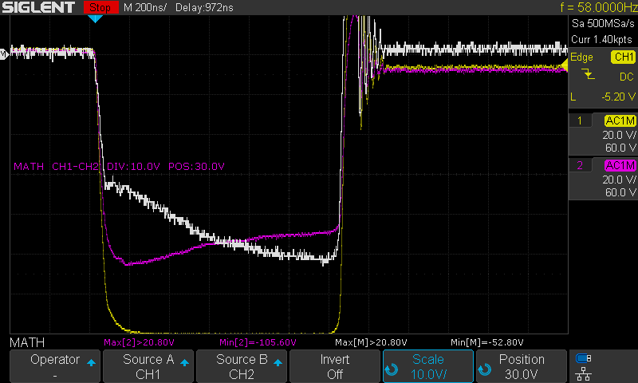
No Change
100 GATE: 8V CAP ANODE: 120V SERIES RESISTOR: R5 DURATION: 1us
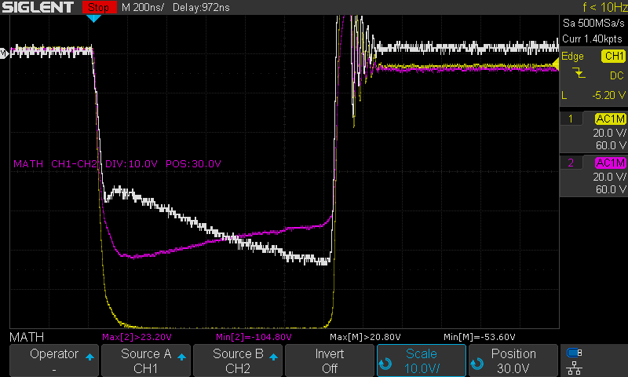
No Change
10? GATE: 8V CAP ANODE: 120V SERIES RESISTOR: R5 DURATION: 1us
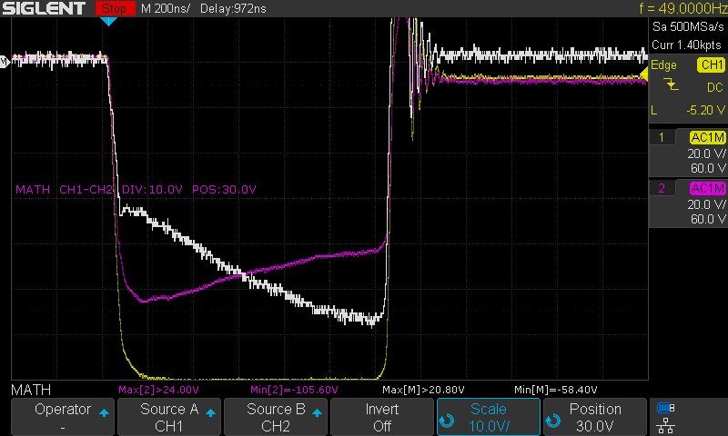

101 GATE: 8V CAP ANODE: 120V SERIES RESISTOR: R5 DURATION: 1us
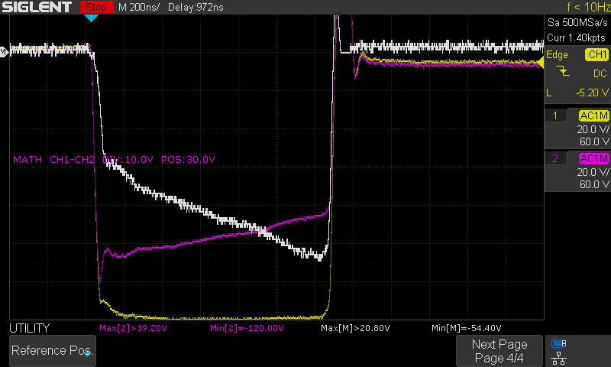
Added 85R @ 100MHz Ferrite Bead in series with LED
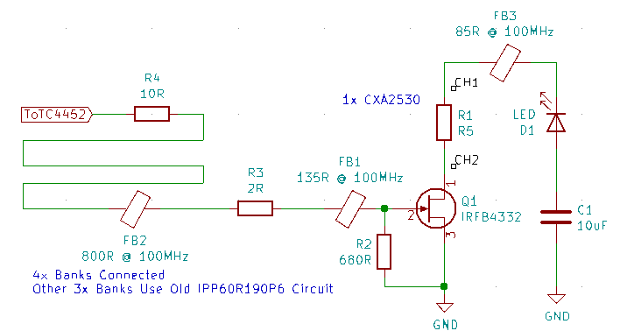
102 GATE: 8V CAP ANODE: 120V SERIES RESISTOR: R5 DURATION: 1us
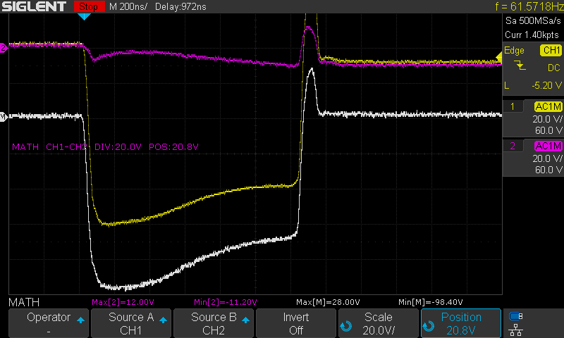
Measuring voltage drop across LED
103 GATE: 8V CAP ANODE: 120V SERIES RESISTOR: R5 DURATION: 1us
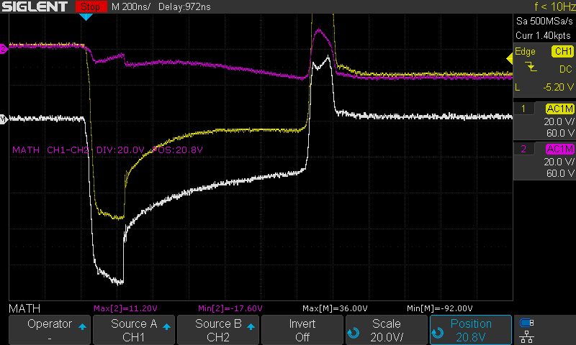
Added flyback diode across LED
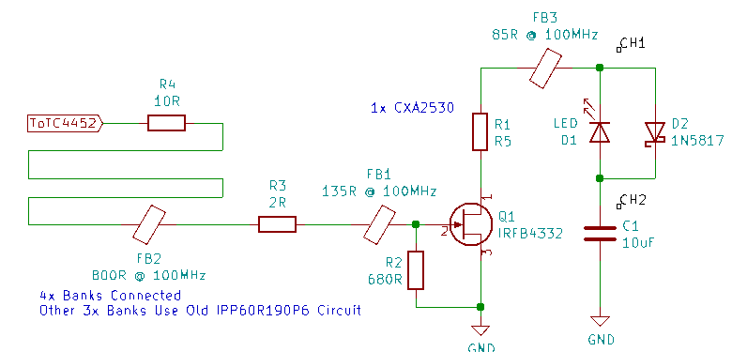

104 GATE: 8V CAP ANODE: 120V SERIES RESISTOR: R5 DURATION: 1us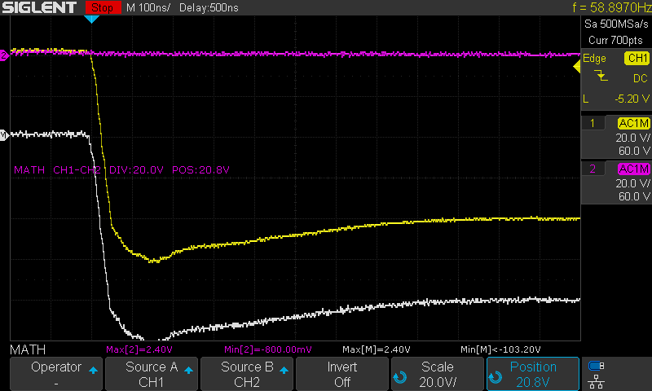
Removed flyback diode, added 2R gate resistor
105 GATE: 8V CAP ANODE: 120V SERIES RESISTOR: R5 DURATION: 1us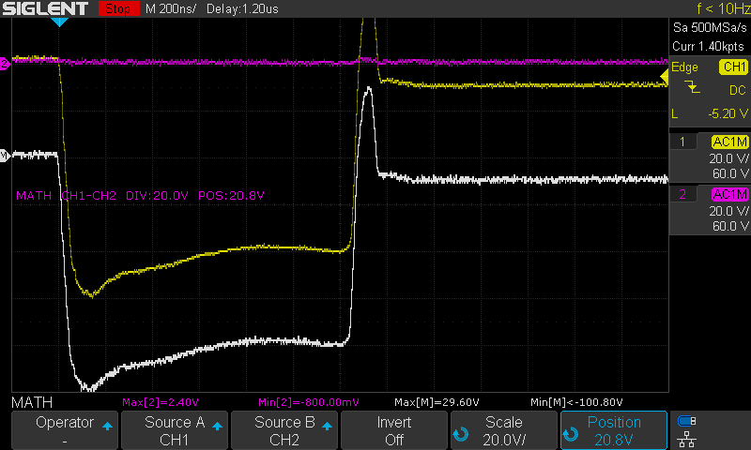
No Change
106 GATE: 8V CAP ANODE: 120V SERIES RESISTOR: R5 DURATION: 1us
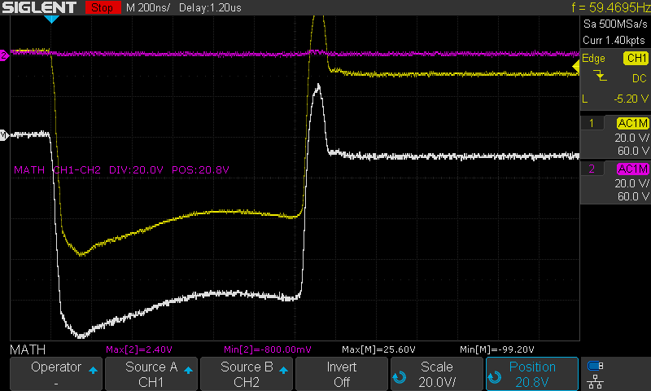
Removed gate wire, soldered ferrite bead directly to control board

Series 5 – LED Repetitive Strobe Testing #1

Overview:
Purpose:
- Testing the effect of repetitive high-voltage strobing on the Cree CXA2530 LED
Equipment:
- E2 Prototype with three banks of LED’s in various states of damage, anode voltage limited to 120V
- Single Cree LED switched with IRFB4332 MOSFET, no limit on anode voltage, TC4452 voltage at 12.8V
- Integrating sphere and active light probe measuring output of single LED
Procedure
- Firmware modified to execute 1,000 consecutive 1-microsecond strobes at 8Hz.
- Oscilloscope is not capable of recording data automatically at that rate, so the screen is recorded using a DSLR

Results:
- Because of a bug in the firmware (which was also present in all previous Edgerton firmware), occasionally the microcontroller will enter an interrupt routine while the LED is on, resulting in a long strobe. This occurs several times every 1,000 strobes.
- Strobe duration seems to be a significant factor in LED damage. The firmware issue was corrected following these test series.
- Damage to the LED occurred at 100V, which is unacceptably low. This damage was likely due to the long duration strobes. Testing continued as the LED’s damage seemed to be intermittent and functioned correctly, at times, at much higher voltages.
- MVI_9227_80V.mp4 – Firmware issue causes long pulses
- MVI_9229_100V.crop – Started off with signs of damage, after a long pulse it seems to have self-repaired, another long pulse didn’t cause damage, all subsequent tests start off with fluctuations but seem to normalize after several
- MVI_9230_110V.crop – Multiple long pulses
- MVI_9237_170V – Eventual decrease in power

Test Data:
- See Appendix A

Series 6 – LED Repetitive Strobe Testing #2

Overview:
Purpose:
- Testing the effect of repetitive high-voltage strobing on the Cree CXA2530 LED
Equipment:
- E2 Prototype with three banks of LED’s in various states of damage, anode voltage limited to 120V
- Single Cree LED switched with IRFB4332 MOSFET, no limit on anode voltage, TC4452 voltage at 12.8V
- Integrating sphere and active light probe measuring output of single LED
Procedure
- Firmware modified to execute 1,000 consecutive 4-microsecond strobes at 8Hz.
- Oscilloscope is not capable of recording data automatically at that rate, so the screen is recorded using a DSLR

Results:
- MVI_9245_143V.crop.mp4 – Noise in some frames, nothing wrong with LED strobing
- MVI_9246_161V.crop.mp4 – Slight decrease in power after several hundred strobes, Significant decrease after several more

Test Data:
- See Appendix B

Series 7 – LED Repetitive Strobe Testing #3

Overview:
Purpose:
- Testing the effect of repetitive high-voltage strobing on the Cree CXA2530 LED
Equipment:
- E2 Prototype with three banks of LED’s in various states of damage, anode voltage limited to 120V
- Single Cree LED switched with IRFB4332 MOSFET, no limit on anode voltage, TC4452 voltage at 12.8V
- Integrating sphere and active light probe measuring output of single LED
Procedure
- Firmware modified to execute 1,000 consecutive strobes at 10Hz.
- Oscilloscope is not capable of recording data automatically at that rate, so the screen is recorded using a DSLR
- 1000x cycles @ 10Hz, 4x strobes per cycle @ 50us between strobes, 4us strobe
- Each set increments 10V, starting at 80V and ending at partial failure at 150V
- Partial Failure @ 150V (MVI_9259.MOV)
- Frame 881 / 0:36.7
- tail ends of Strobes 3, 4 fall off rapidly

- Frame 1929 / 1:20.5
- Strobes 3, 4 drop
- Strobe 2 appears to drop faster?

- Frame 1945 / 1:21.1
- Strobe 4 doesn't start at full power

- After that, power drops here and there

- Starting voltage is consistent throughout run
- Ending voltage is higher at end of run

Test Data:
- See Appendix C

Series 8 – LED Current Testing

Overview:
Purpose:
- To measure the Current-Voltage relationship of the Cree CXA2530 LED
- To measure the Current-Light Output relationship of the Cree CXA2530 LED
Equipment:
- E2 Prototype with four banks of LED’s in various states of damage
  - IPPR60 MOSFET’s

Results:
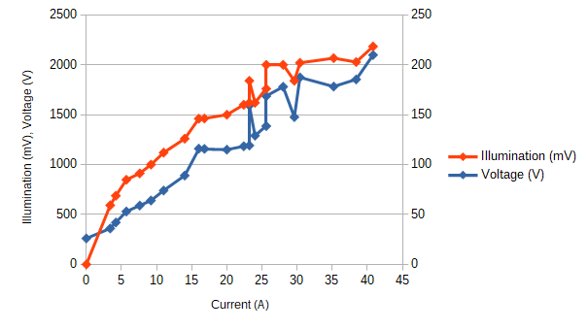

Test Data:

107, 108 (dup) GATE: 12.8V CAP ANODE: 124V SERIES RESISTOR: R5 DURATION: 1us
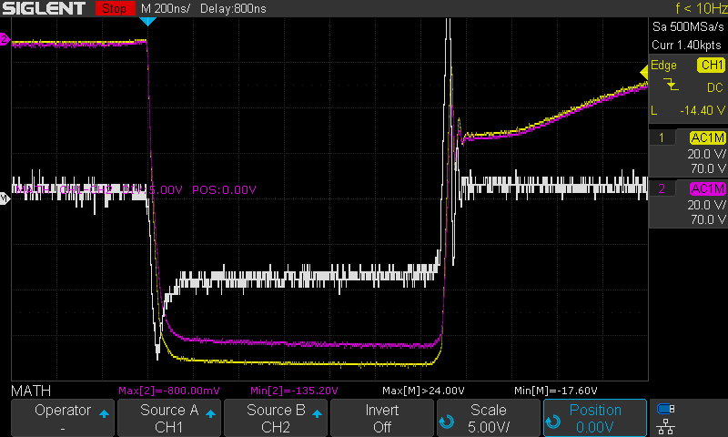
Current Test
109, 110 (dup) GATE: 12.8V CAP ANODE: 124V SERIES RESISTOR: 2R5 DURATION: 1us
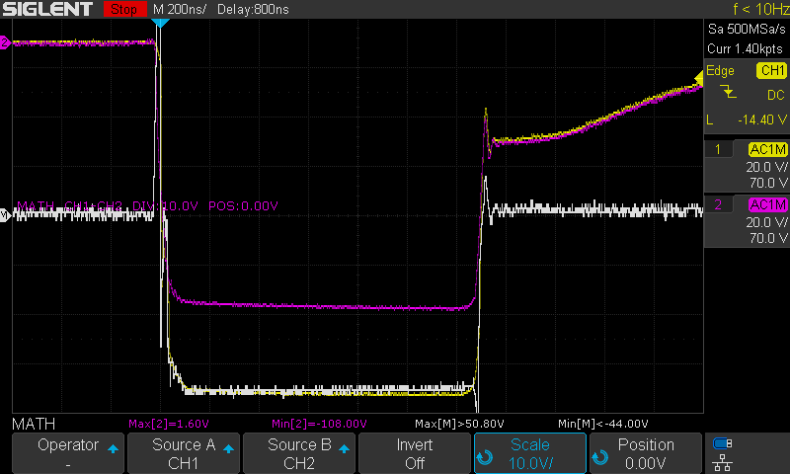
Current Test
111 GATE: 12.8V CAP ANODE: 124V SERIES RESISTOR: 4R5 DURATION: 1us
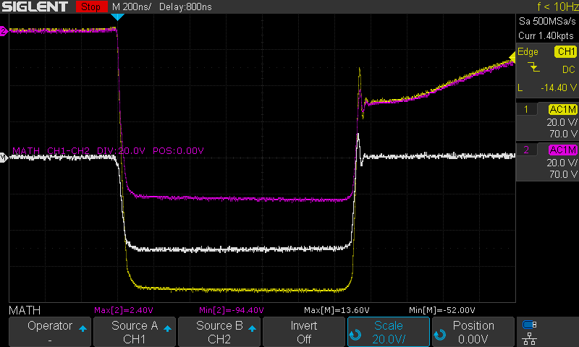
Current Test

112 GATE: 12.8V CAP ANODE: 124V SERIES RESISTOR: 6R5 DURATION: 1us
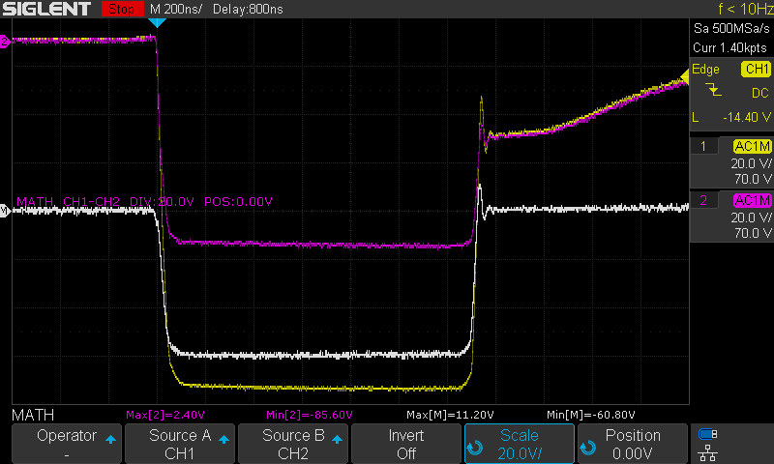
Current Test
113 GATE: 12.8V CAP ANODE: 124V SERIES RESISTOR: 8R5 DURATION: 1us
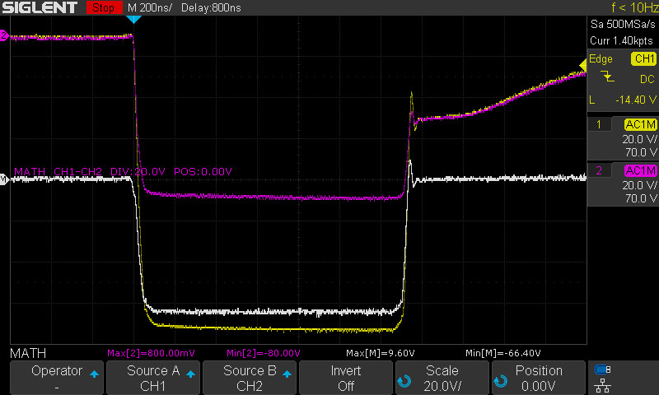
Current Test
114 GATE: 12.8V CAP ANODE: 124V SERIES RESISTOR: 10R5 DURATION: 1us
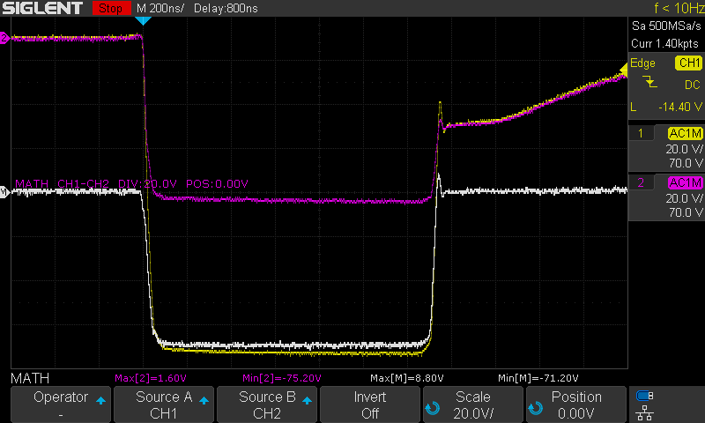
Current Test
115, 116 (dup) GATE: 12.8V CAP ANODE: 124V SERIES RESISTOR: 19R3 DURATION: 1us
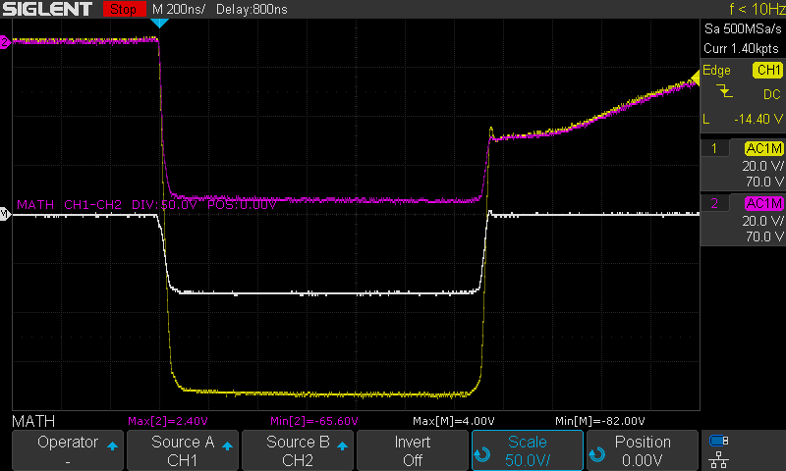
Current Test
117, 118 (dup) GATE: 12.8V CAP ANODE: 124V SERIES RESISTOR: 26R1 DURATION: 1us
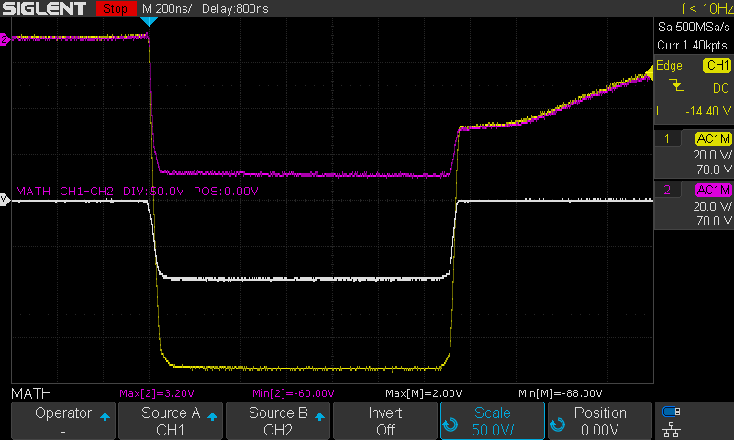
Current Test

119 GATE: 12.8V CAP ANODE: 124V SERIES RESISTOR: 26R1 DURATION: 1us
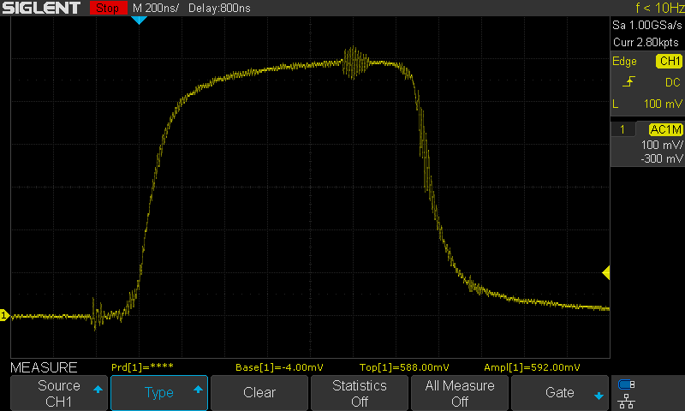
Light Output Test

120 GATE: 12.8V CAP ANODE: 124V SERIES RESISTOR: 26R1 DURATION: 1us
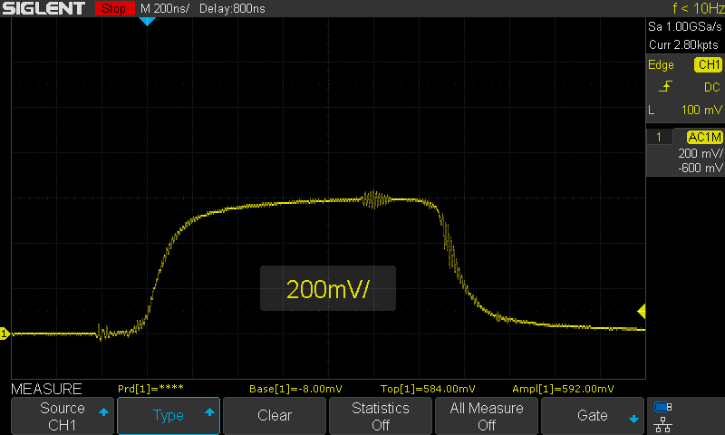
Light Output Test

121 GATE: 12.8V CAP ANODE: 124V SERIES RESISTOR: 19R3 DURATION: 1us
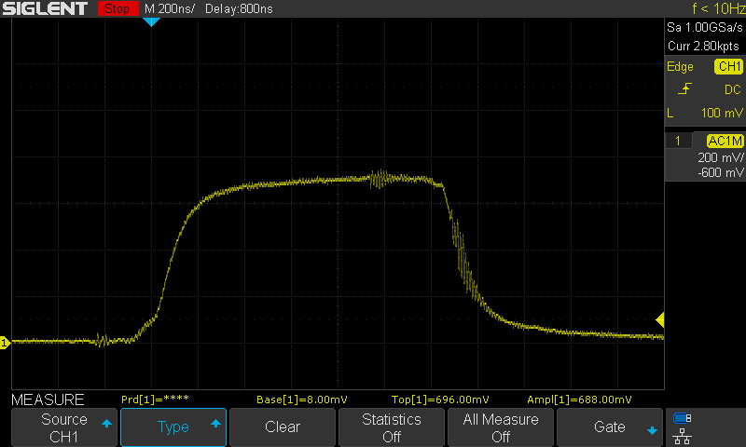
Light Output Test

122 GATE: 12.8V CAP ANODE: 124V SERIES RESISTOR: 12R5 DURATION: 1us
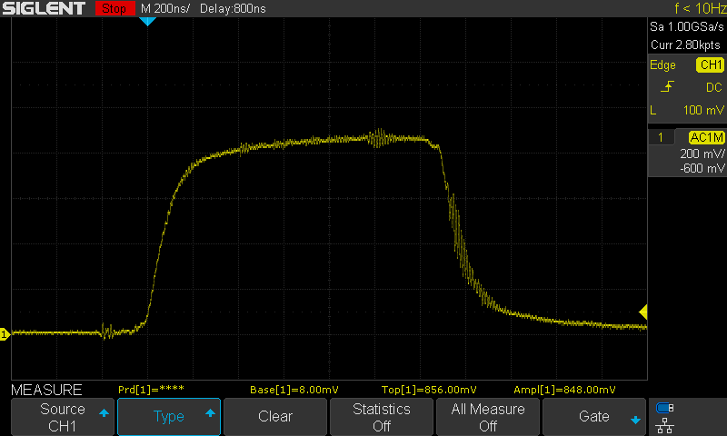
Light Output Test

123 GATE: 12.8V CAP ANODE: 124V SERIES RESISTOR: 8R5 DURATION: 1us
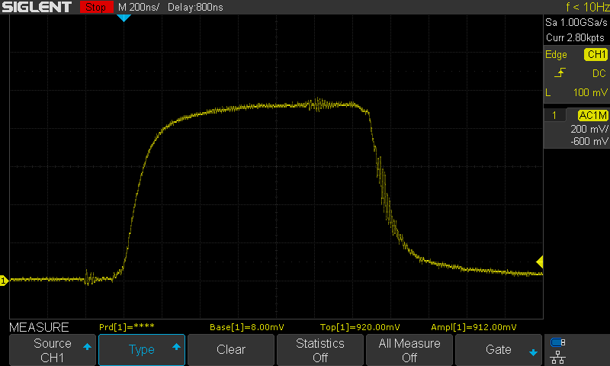
Light Output Test

124 GATE: 12.8V CAP ANODE: 124V SERIES RESISTOR: 6R5 DURATION: 1us
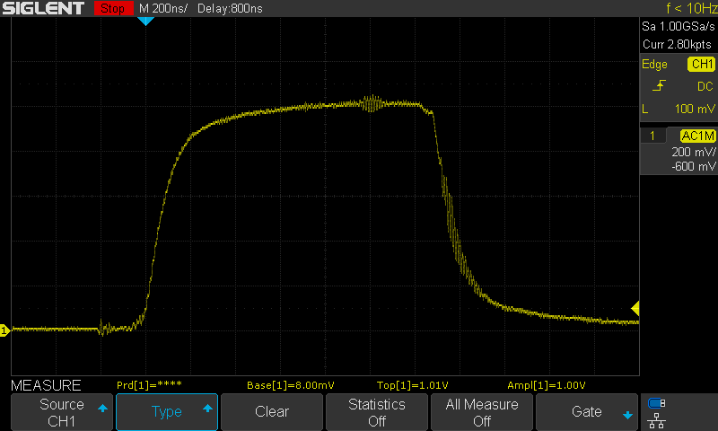
Light Output Test

125 GATE: 12.8V CAP ANODE: 124V SERIES RESISTOR: 4R5 DURATION: 1us
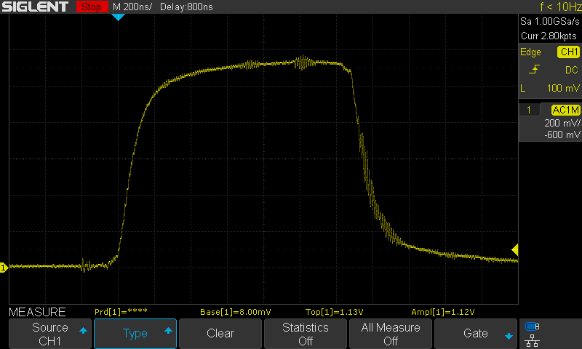
Light Output Test

126 GATE: 12.8V CAP ANODE: 124V SERIES RESISTOR: 2R5 DURATION: 1us
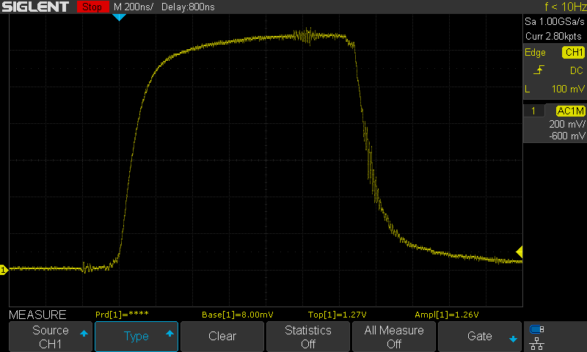
Light Output Test

127, 128 (dup) GATE: 12.8V CAP ANODE: 124V SERIES RESISTOR: 0R5 DURATION: 1us
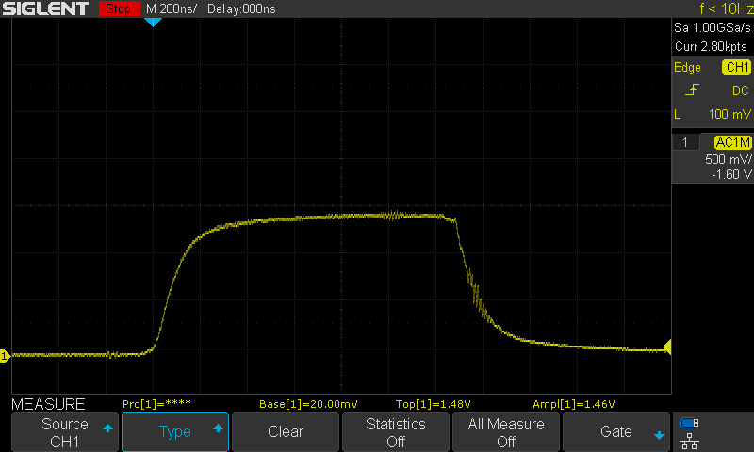
Light Output Test
129 GATE: 12.8V CAP ANODE: 124V SERIES RESISTOR: 0R25 DURATION: 1us
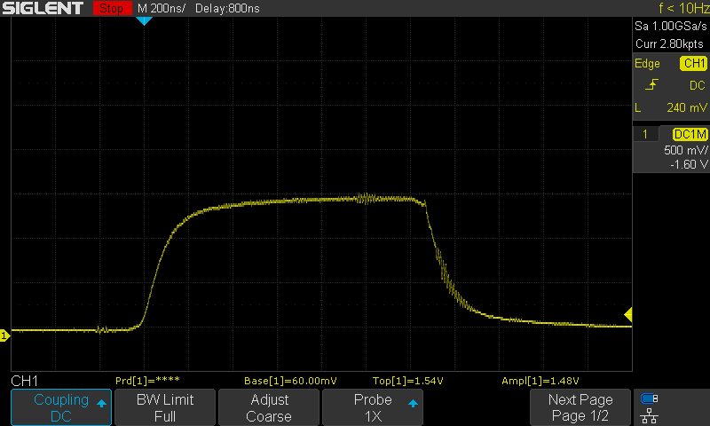
Light Output Test
130 GATE: 12.8V CAP ANODE: 120V? SERIES RESISTOR: R25 DURATION: 1us
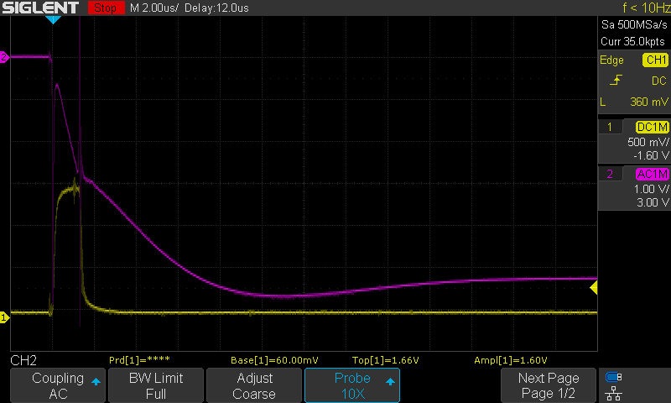
CH1 – Light Output
CH2 – Cap Anode

131 GATE: 12.8V CAP ANODE: 125V? SERIES RESISTOR: R25 DURATION: 1us
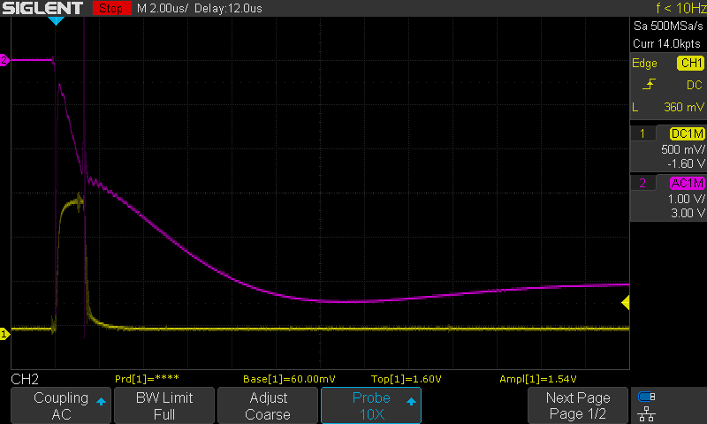

132 GATE: 12.8V CAP ANODE: 125V SERIES RESISTOR: R25 DURATION: 1us
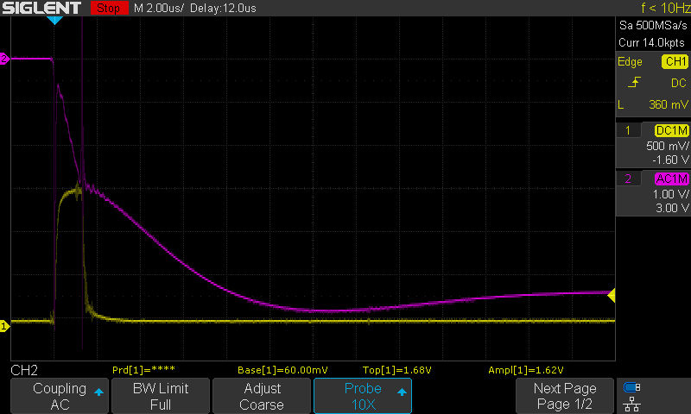

133 GATE: 12.8V CAP ANODE: 135V SERIES RESISTOR: R25 DURATION: 1us
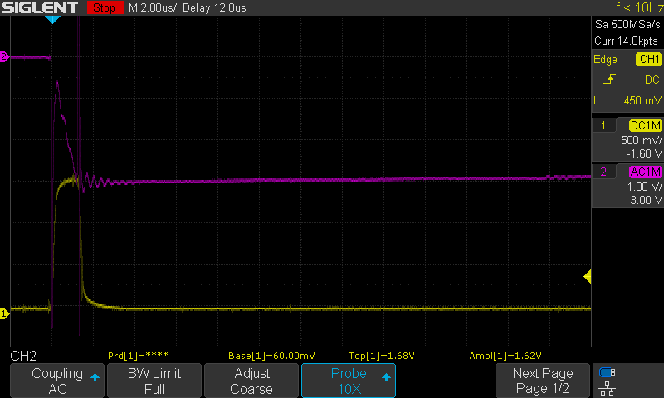

134 GATE: 12.8V CAP ANODE: 145V SERIES RESISTOR: R25 DURATION: 1us
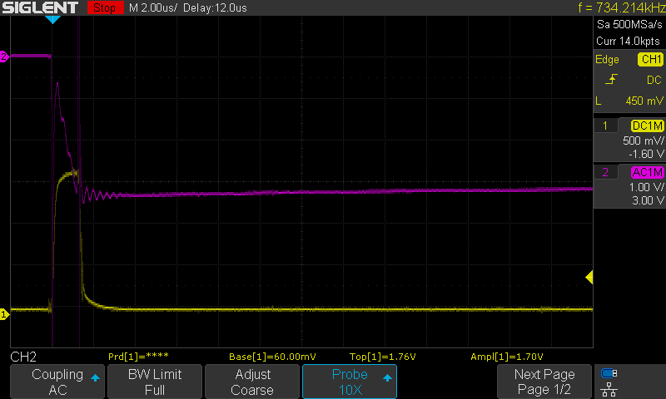

135 GATE: 12.8V CAP ANODE: 155V SERIES RESISTOR: R25 DURATION: 1us
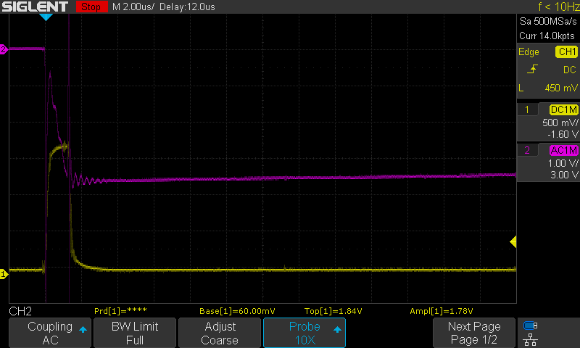

136 GATE: 12.8V CAP ANODE: 120V SERIES RESISTOR: R25 DURATION: 1us
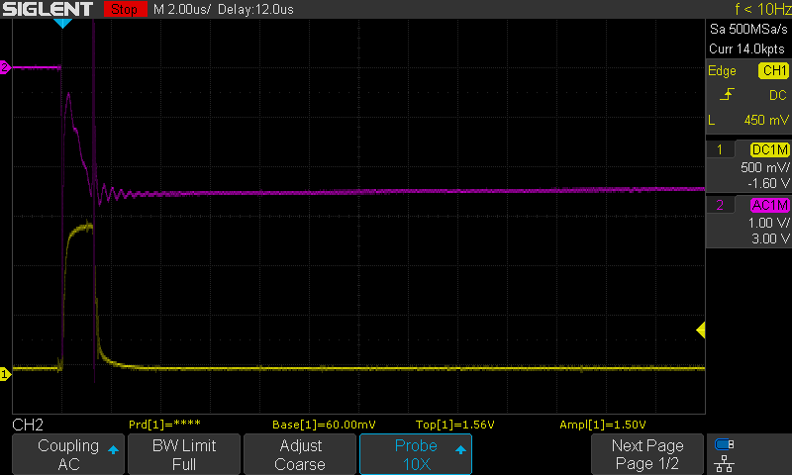

137 GATE: 12.8V CAP ANODE: 165V SERIES RESISTOR: R25 DURATION: 1us
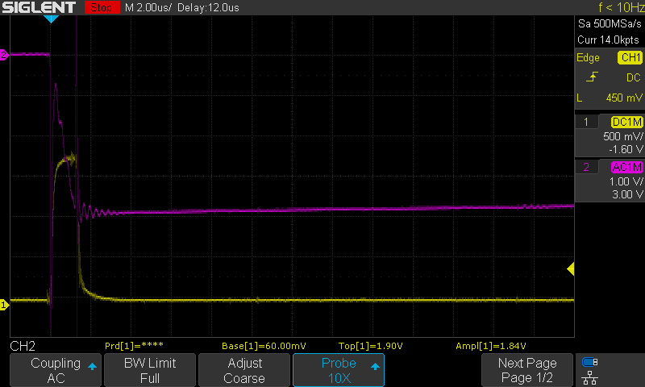

138 GATE: 12.8V CAP ANODE: 175V SERIES RESISTOR: R25 DURATION: 1us
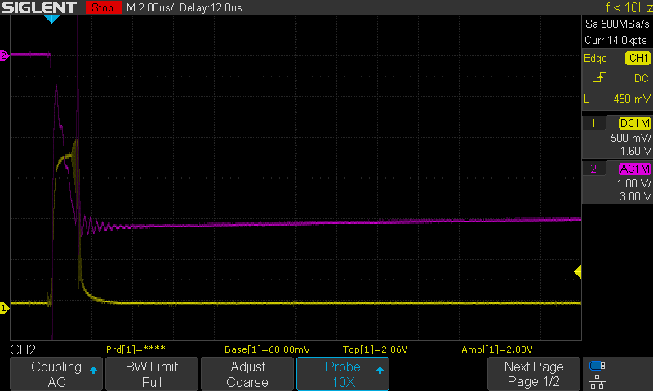

139 GATE: 12.8V CAP ANODE: 185V SERIES RESISTOR: R25 DURATION: 1us
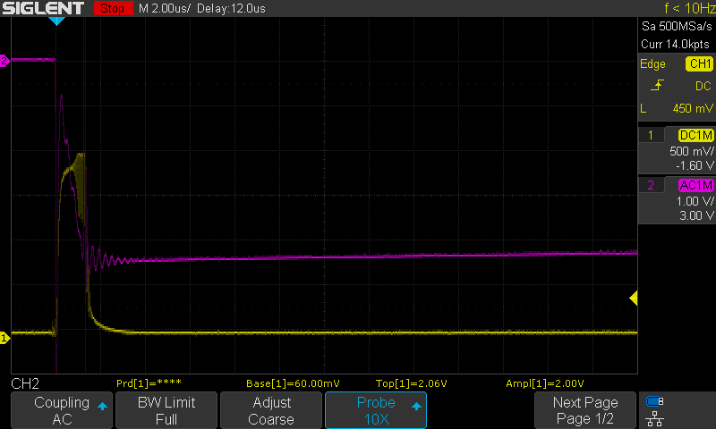

140 GATE: 12.8V CAP ANODE: 195V SERIES RESISTOR: R25 DURATION: 1us
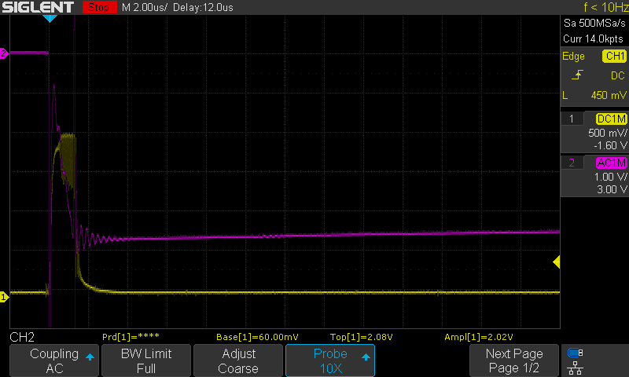

141 GARBAGE
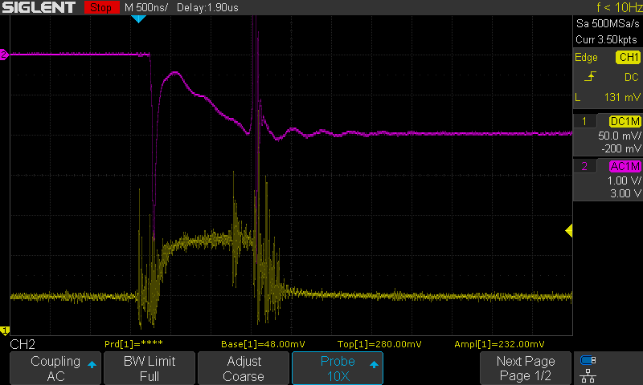

142 GARBAGE

143 GATE: 12.8V CAP ANODE: 120V SERIES RESISTOR: R25 DURATION: 1us
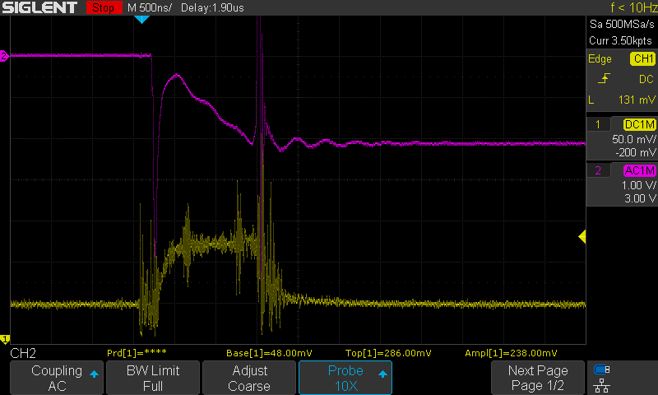
Added 6-stop ND Filter to optical train

144 GARBAGE
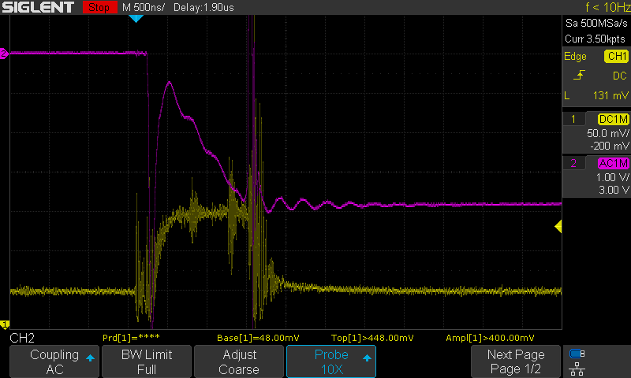

145 GATE: 12.8V CAP ANODE: 187V SERIES RESISTOR: R25 DURATION: 1us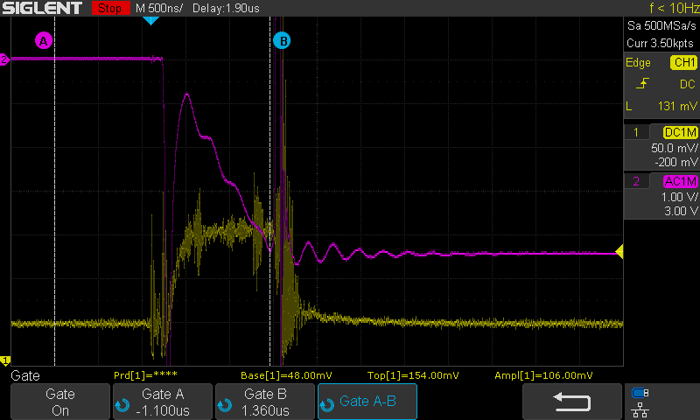

146 GATE: 12.8V CAP ANODE: 195V SERIES RESISTOR: R25 DURATION: 1us
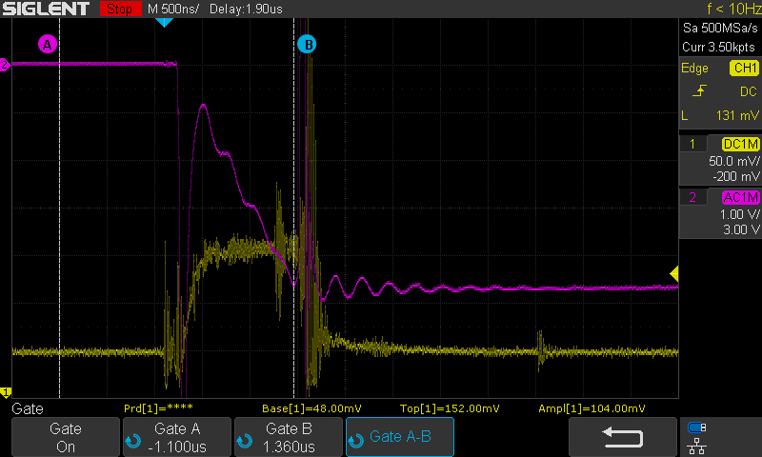

147 GATE: 12.8V CAP ANODE: 220V SERIES RESISTOR: R25 DURATION: 1us
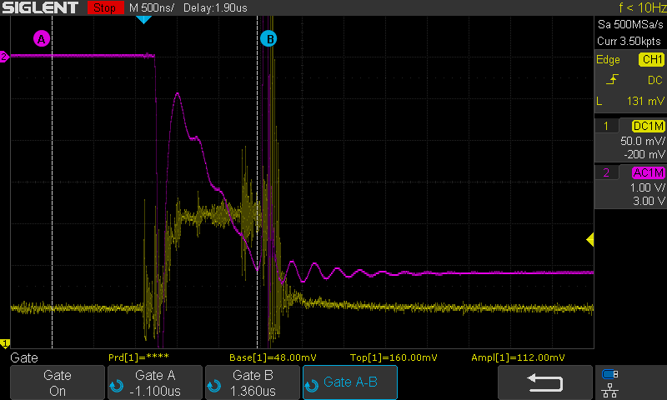

Series 9 – Multi-Strobe Testing

Overview:
Purpose: To test the effect of multi-strobing on the Cree CXA2530 LED and determine the safe limits of operation
Equipment:
- E2 Prototype with four banks of LED’s in various states of damage
  - IPPR60 MOSFET’s

Test Data:

Series 10 – IGBT Testing

Overview:
Purpose: To test the Ie / Vge relationship of two select IGBT transistors
Equipment:
- E2 Prototype with four banks of LED’s in various states of damage
  - STGP40V60F IGBT
  - FGAF40N60UFTU IGBT

Results:
- No advantage was found in using an IGBT over the established MOSFET transistors

Test Data:
1 GATE: 12.8V CAP ANODE: 80V SERIES RESISTOR: R25 DURATION: 1us
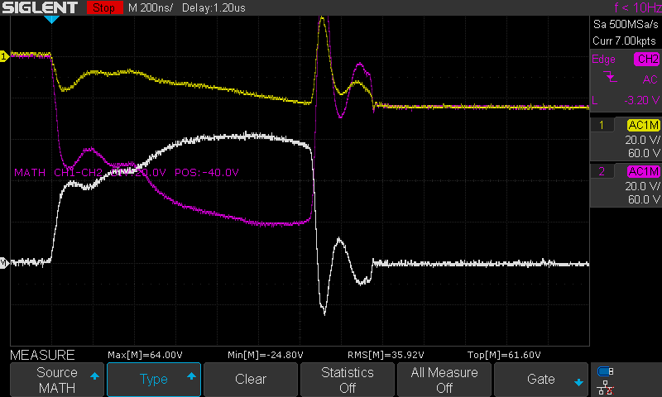
STGP40V60F
2 GATE: 12.8V CAP ANODE: 100V SERIES RESISTOR: R25 DURATION: 1us
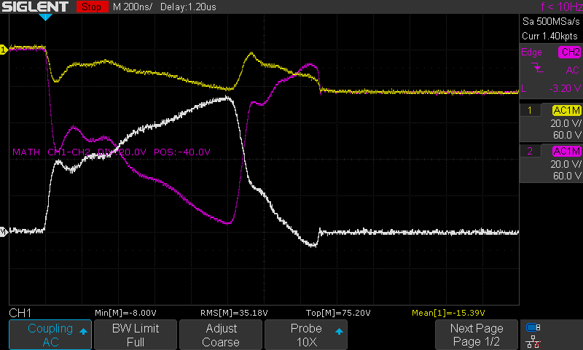
STGP40V60F
3 GATE: 12.8V CAP ANODE: 120V SERIES RESISTOR: R25 DURATION: 1us
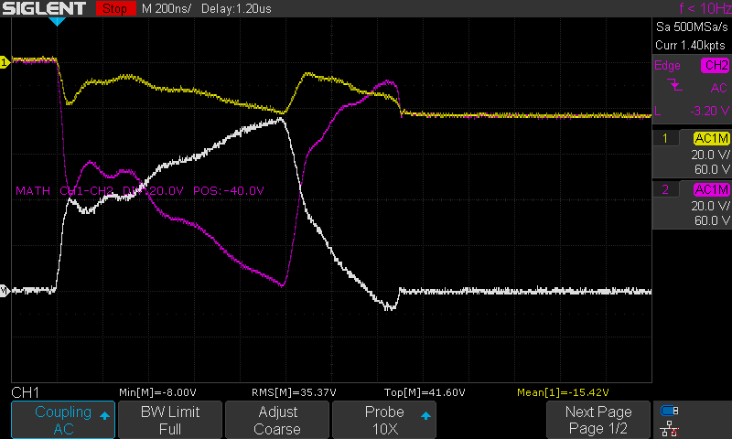
STGP40V60F
4 GATE: 12.8V CAP ANODE: 140V SERIES RESISTOR: R25 DURATION: 1us
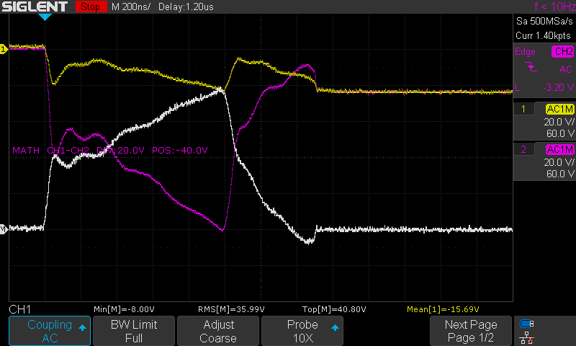
STGP40V60F
5 GATE: 12.8V CAP ANODE: 140V SERIES RESISTOR: R25 DURATION: 1us
STGP40V60F
Removed gate resistor
6 GATE: 12.8V CAP ANODE: 80V SERIES RESISTOR: R25 DURATION: 1us
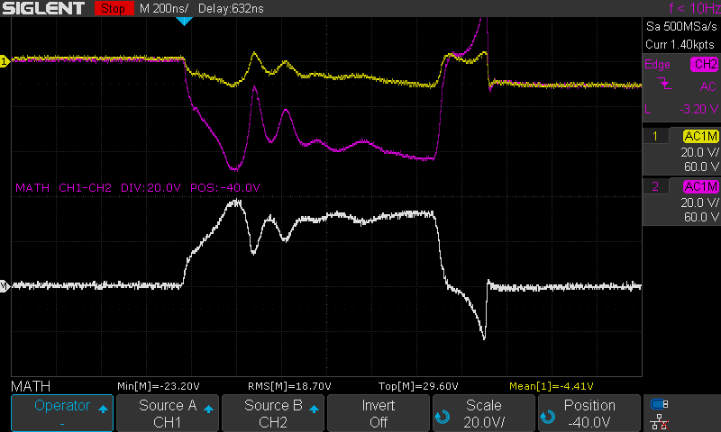
FGAF40N60UFTU
No gate resistor
7 GATE: 12.8V CAP ANODE: 100V SERIES RESISTOR: R25 DURATION: 1us
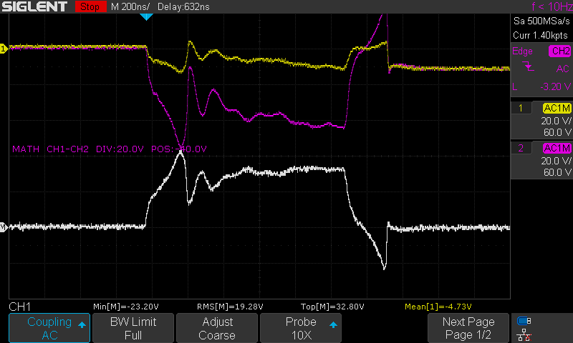
FGAF40N60UFTU
No gate resistor

8, 9 (dup) GATE: 18V CAP ANODE: 100V SERIES RESISTOR: R25 DURATION: 1us
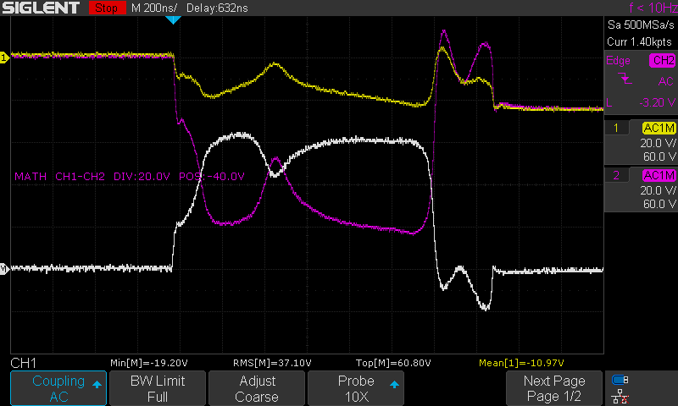
FGAF40N60UFTU
Increased TC4452 Voltage
No gate resistor

10 GATE: 12.8V CAP ANODE: 100V SERIES RESISTOR: R25 DURATION: 1us
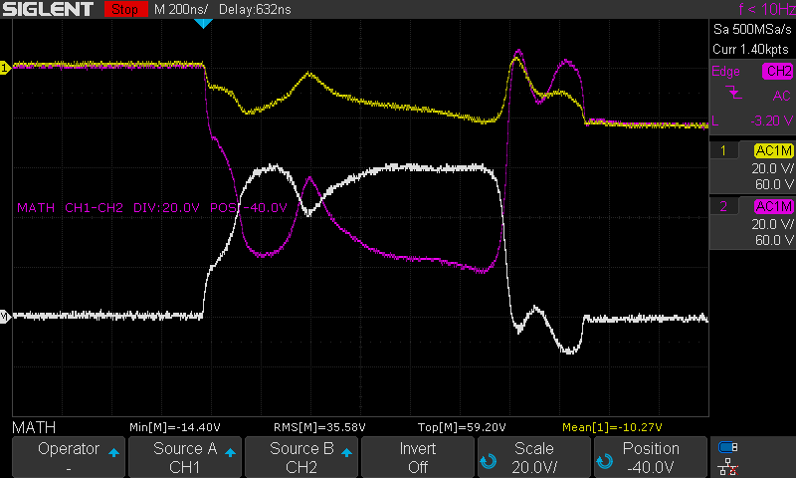
FGAF40N60UFTU
Added gate resistor

11, 12 (dup) GATE: 12.8V CAP ANODE: 120V SERIES RESISTOR: R25 DURATION: 1us
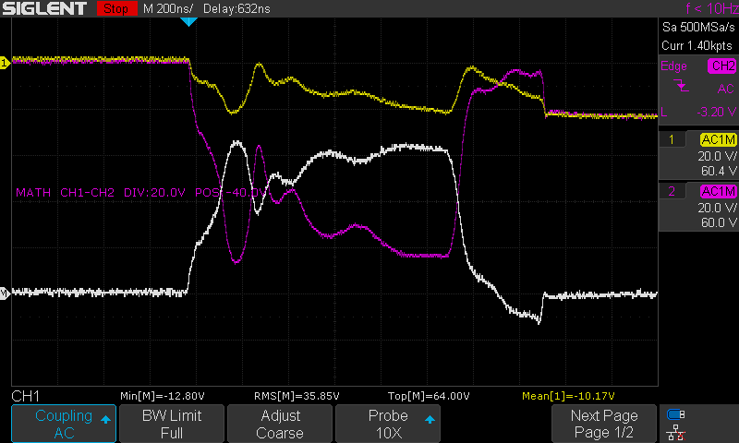
FGAF40N60UFTU

13 GATE: 12.8V CAP ANODE: 120V SERIES RESISTOR: R25 DURATION: 1us
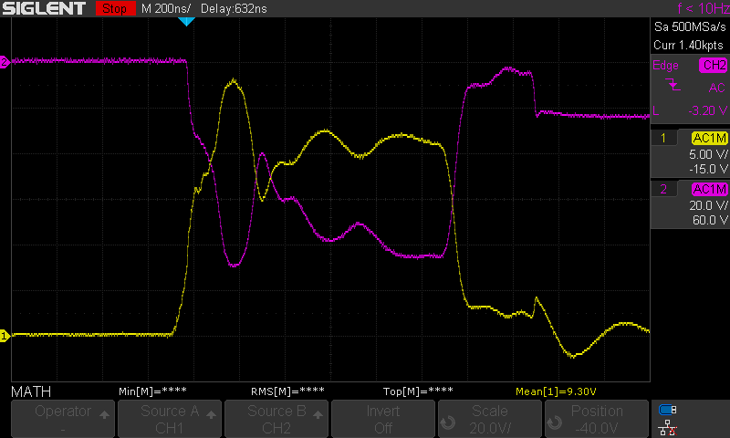
FGAF40N60UFTU
Ch1 – Gate Input

Series 11 – Flyback Converter Testing

Overview:
Purpose: To evaluate the MIC3172-based flyback converter
Equipment:
- E2 Prototype with four banks of LED’s in various states of damage
  - IRFB4332 MOSFET’s

Results:
- Order of gate filter components does not matter
- Gate overshoot is significant – 12.8V @ TC4452 = 18V max @ gate, 16.0V @ TC4452 = 24V max @ gate

Test Data:

Series 12 – Bank Testing

Overview:
Purpose: To test the effects of a full bank of LED’s on the circuit
Equipment:
- E2 Prototype with four banks of LED’s in various states of damage
  - IRFB4332 MOSFET’s

Results:
- Order of gate filter components does not matter
- Gate overshoot is significant – 12.8V @ TC4452 = 18V max @ gate, 16.0V @ TC4452 = 24V max @ gate

Test Data:

1 GATE: 12.8V CAP ANODE: 80V SERIES RESISTOR: R5 DURATION: 1us
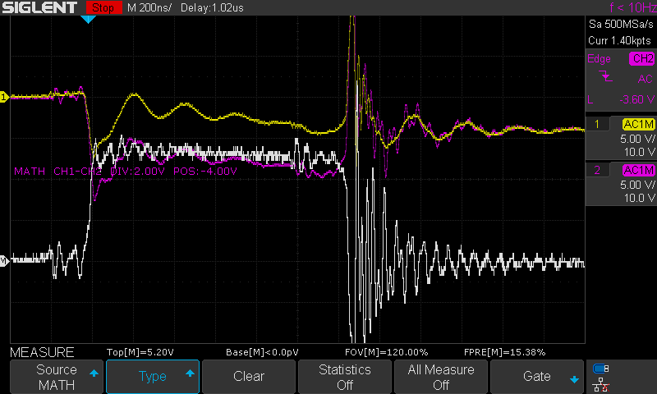
LED 1
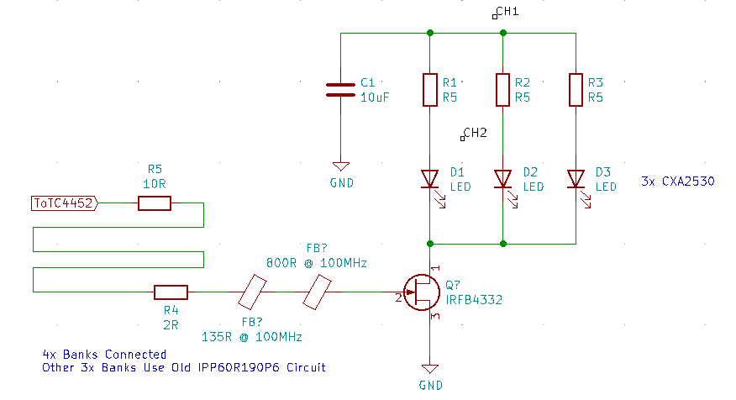
2 GATE: 12.8V CAP ANODE: 80V SERIES RESISTOR: R5 DURATION: 1us
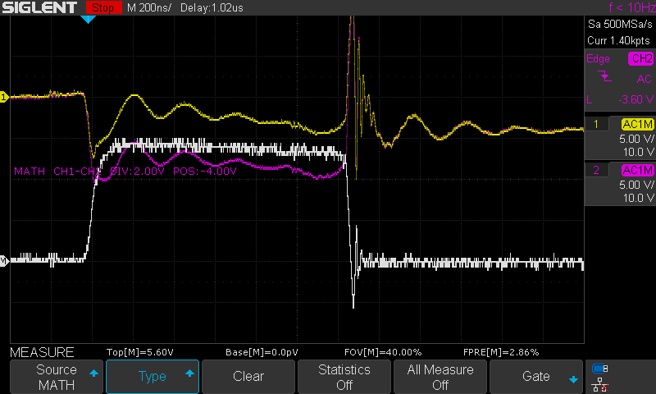
LED #3
3 GATE: 12.8V CAP ANODE: 80V SERIES RESISTOR: R5 DURATION: 1us
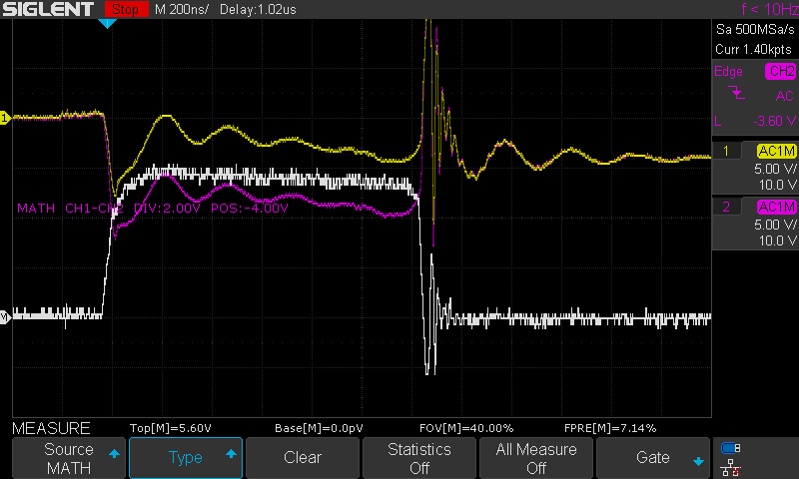
LED #2

4, 5 (dup) GATE: 12.8V CAP ANODE: 100V SERIES RESISTOR: R5 DURATION: 1us
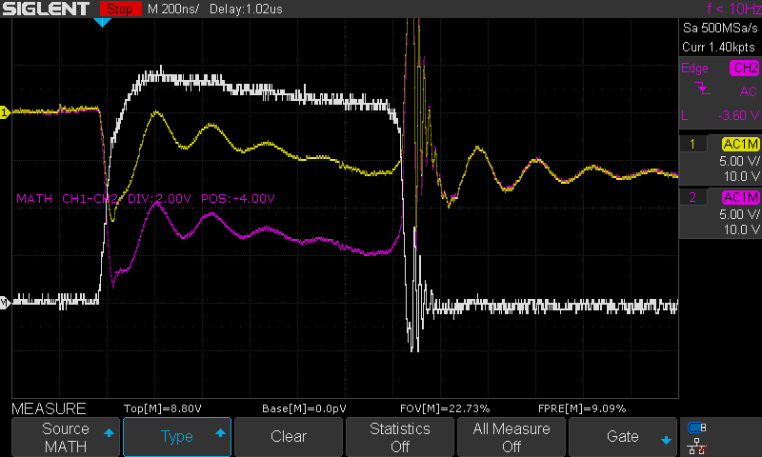
LED #2
6 GATE: 12.8V CAP ANODE: 100V SERIES RESISTOR: R5 DURATION: 1us
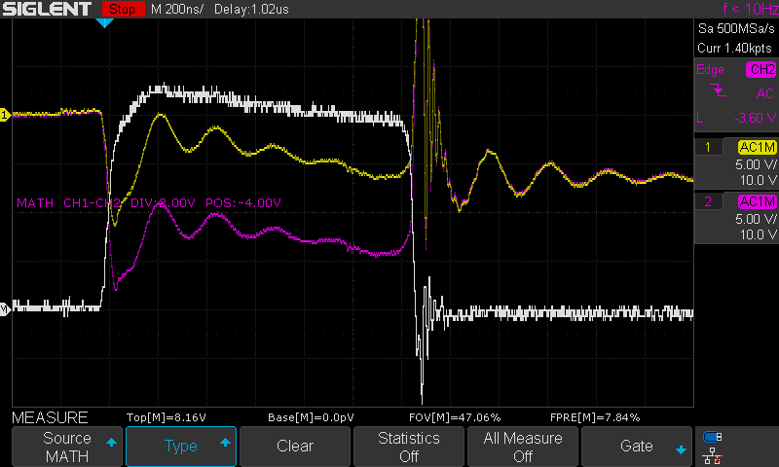
LED #1, CH2 near Resistor
7 GATE: 12.8V CAP ANODE: 100V SERIES RESISTOR: R5 DURATION: 1us
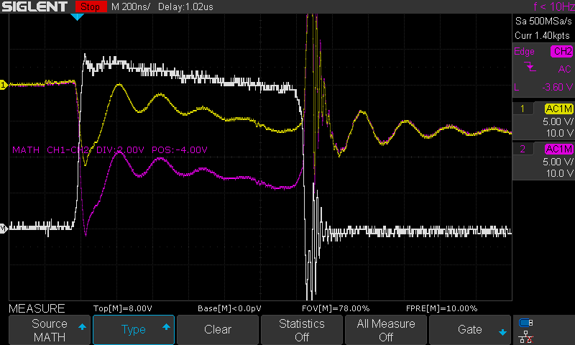
LED #1, CH2 near LED

8, 9 (dup) GATE: 12.8V CAP ANODE: 100V SERIES RESISTOR: R5 DURATION: 1us
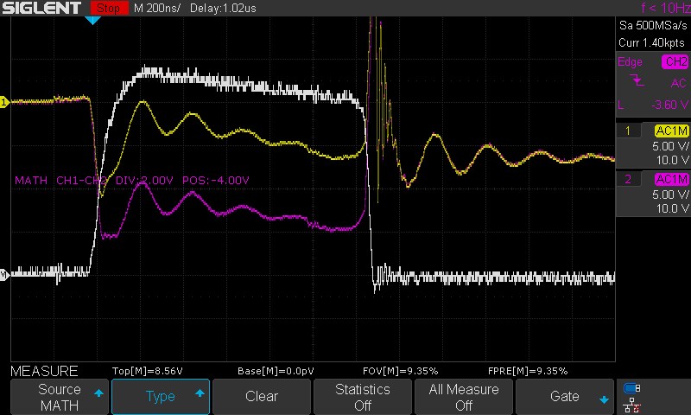
LED #3

10, 11 (dup) GATE: 12.8V CAP ANODE: 120V SERIES RESISTOR: R5 DURATION: 1us
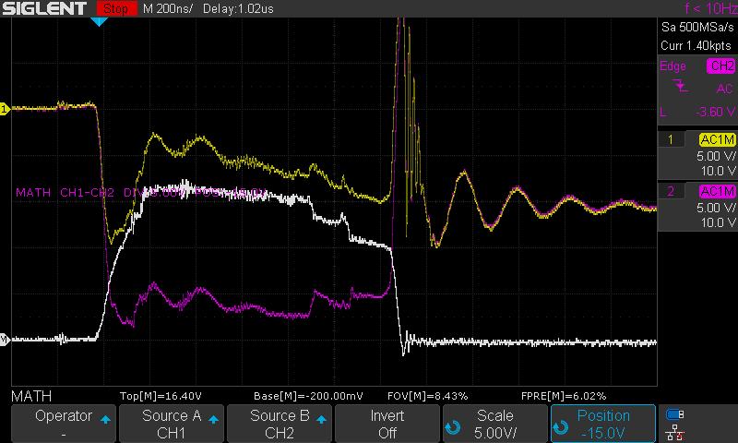
LED #3

12 GATE: 12.8V CAP ANODE: 120V SERIES RESISTOR: R5 DURATION: 1us
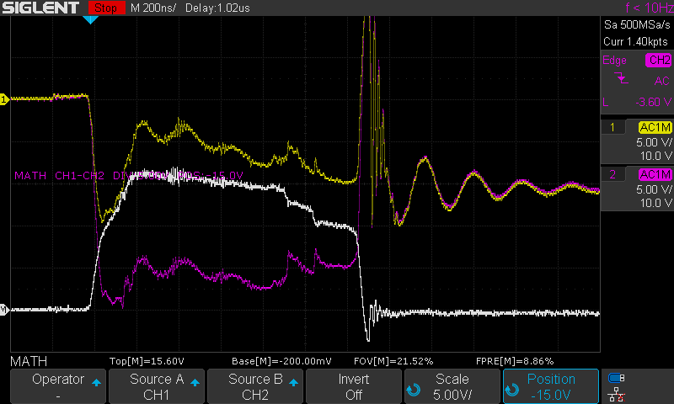
LED #1, CH2 near Resistor
13 GATE: 12.8V CAP ANODE: 120V SERIES RESISTOR: R5 DURATION: 1us
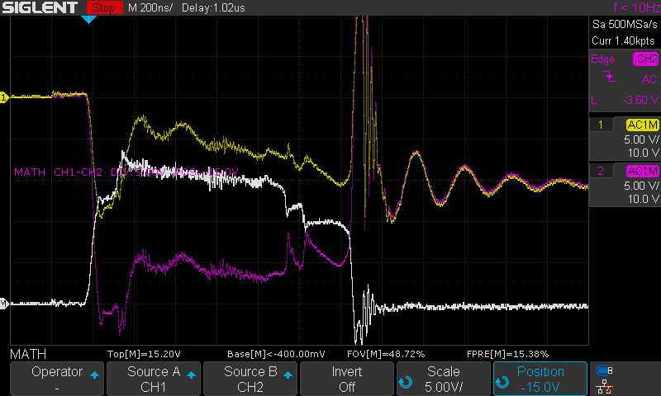
LED #1, CH2 near LED

14, 15 (dup) GATE: 12.8V CAP ANODE: 120V SERIES RESISTOR: R5 DURATION: 1us
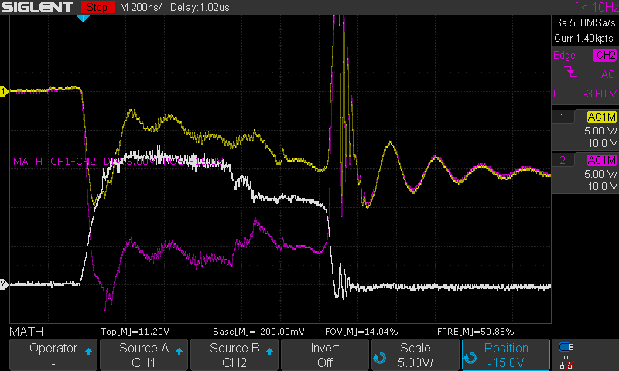
LED #2

16, 17 (dup) GATE: 12.8V CAP ANODE: 120V SERIES RESISTOR: R5 DURATION: 1us
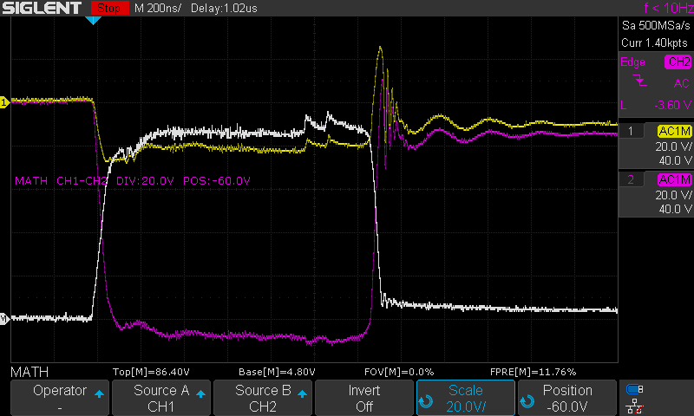
LED #1, Measuring across LED
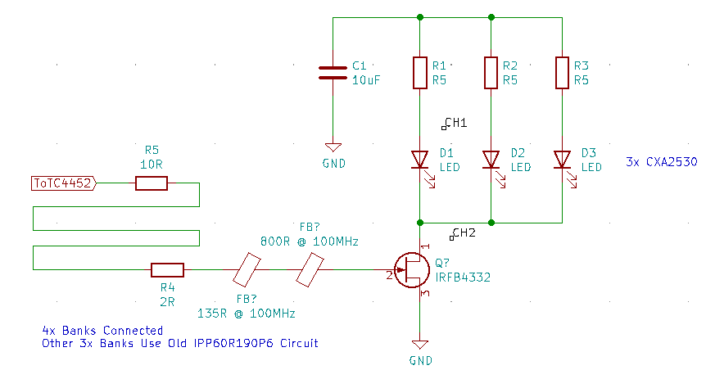
18, 19 (dup) GATE: 12.8V CAP ANODE: 120V SERIES RESISTOR: R5 DURATION: 1us
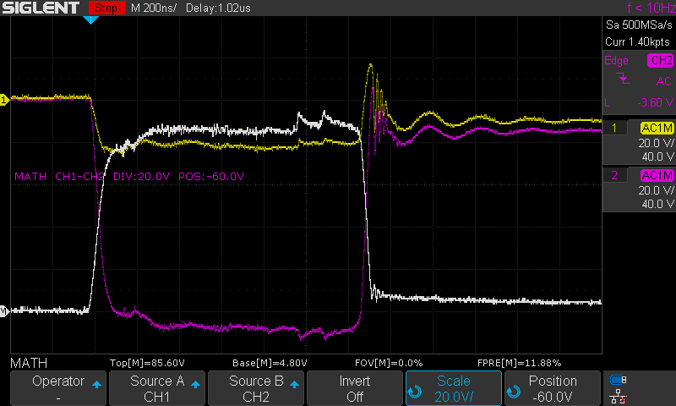
LED #3, Measuring across LED

20 GATE: 12.8V CAP ANODE: 120V SERIES RESISTOR: R5 DURATION: 1us
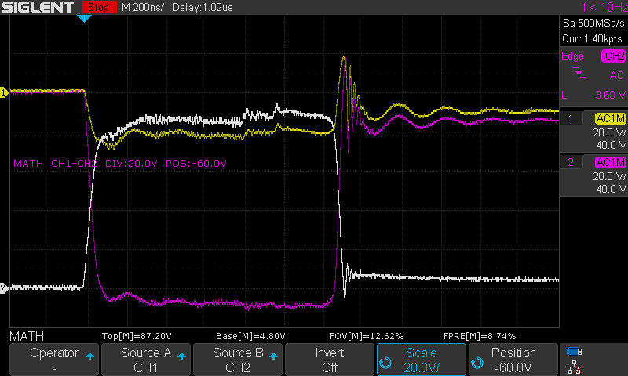
LED #2, Measuring across LED
21, 22 (dup) GATE: 12.8V CAP ANODE: 120V SERIES RESISTOR: R5 DURATION: 1us
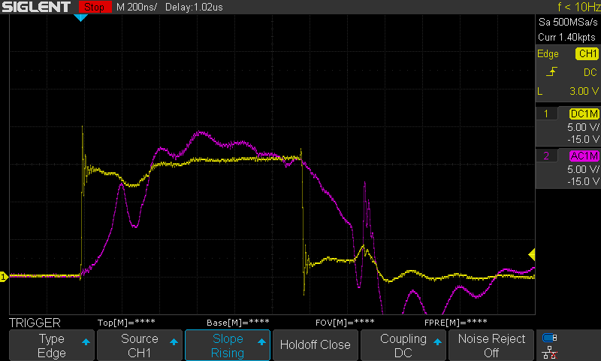
CH1 – Gate input, CH2 – FET Gate

23 GATE: 12.8V CAP ANODE: 80V SERIES RESISTOR: R5 DURATION: 1us
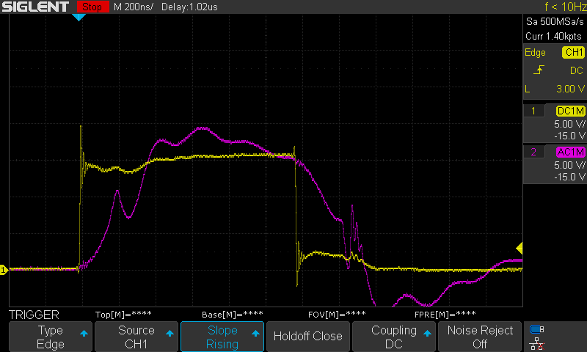
Reversed gate filter circuit
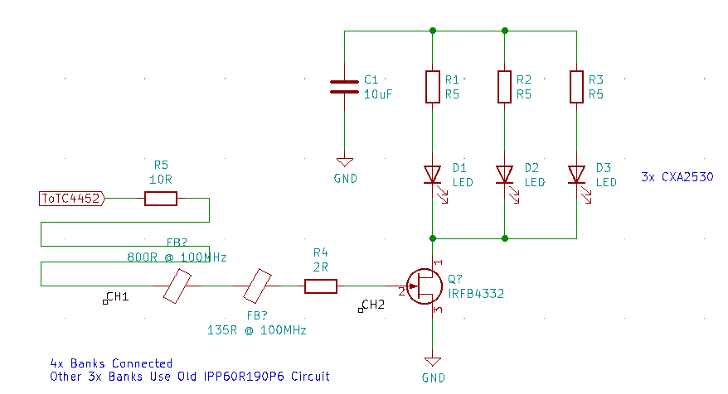

24 GATE: 12.8V CAP ANODE: 120V SERIES RESISTOR: R5 DURATION: 1us
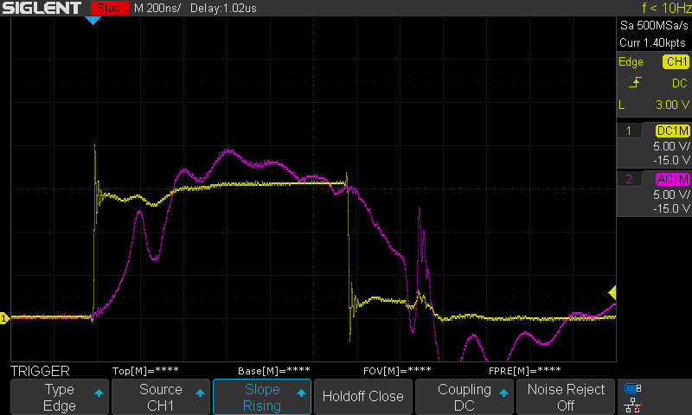
Increased Cap Anode voltage

25 GATE: 12.8V CAP ANODE: 120V SERIES RESISTOR: R5 DURATION: 1us
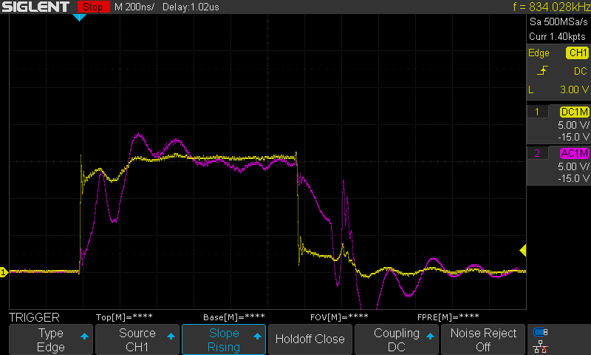
Removed 800R @ 100MHz FB
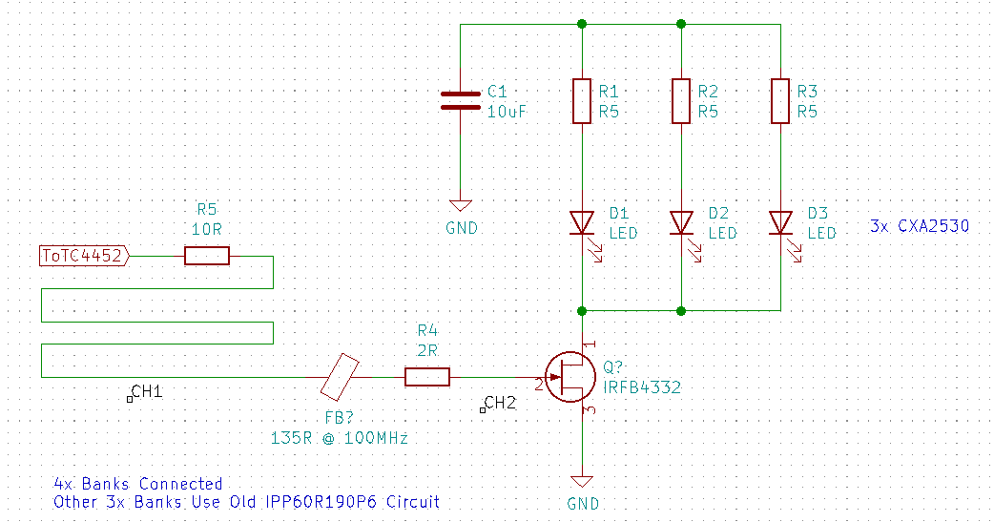

26 GATE: 16.0V CAP ANODE: 120V SERIES RESISTOR: R5 DURATION: 1us
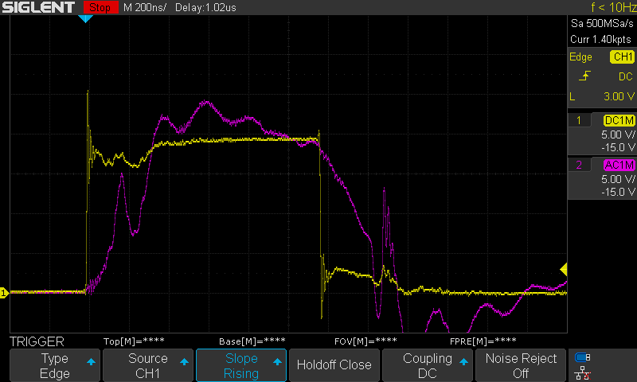
Added FB again
Increased TC4452 voltage to 16V
27, 28 (dup) GATE: 16.0V CAP ANODE: 120V SERIES RESISTOR: R5 DURATION: 1us
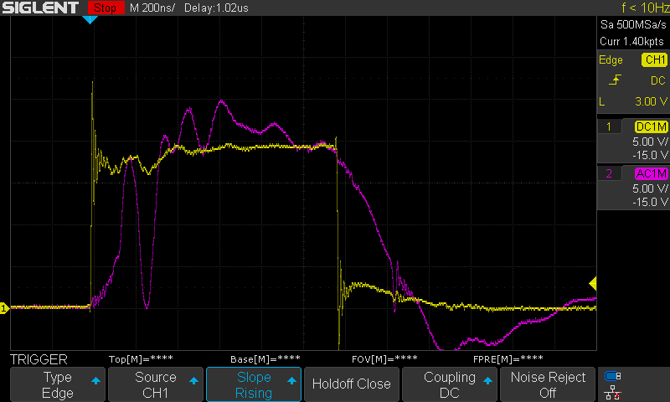
Added 100nF Ceramic Cap to Drain

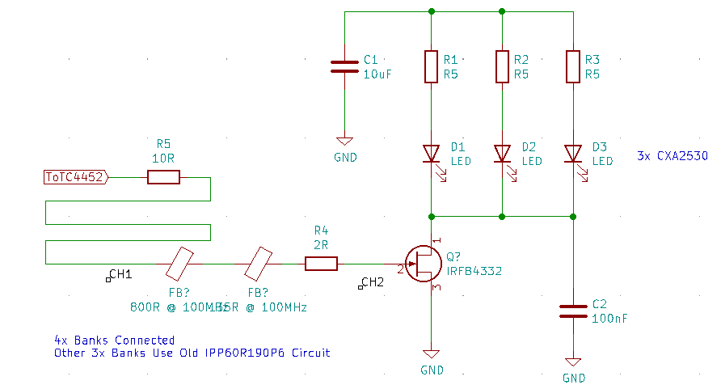
29, 30 (dup) GATE: 16.0V CAP ANODE: 120V SERIES RESISTOR: R5 DURATION: 1us
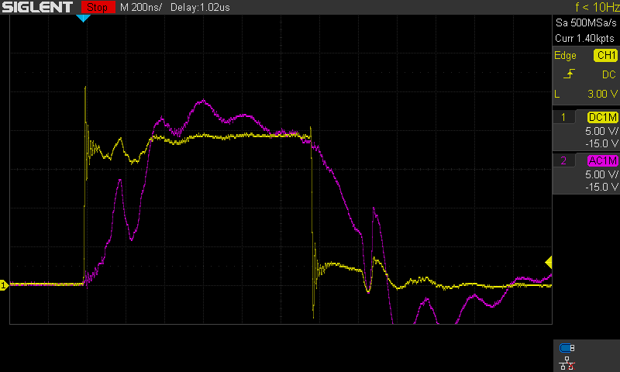
Added 10R resistor in series with cap
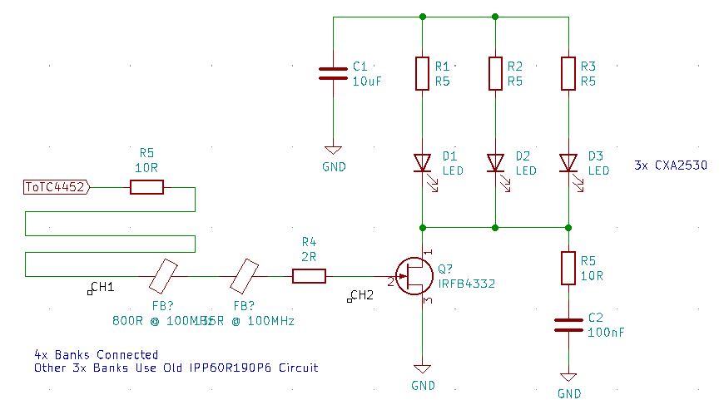

31 GATE: 16.0V CAP ANODE: 120V SERIES RESISTOR: R5 DURATION: 1us
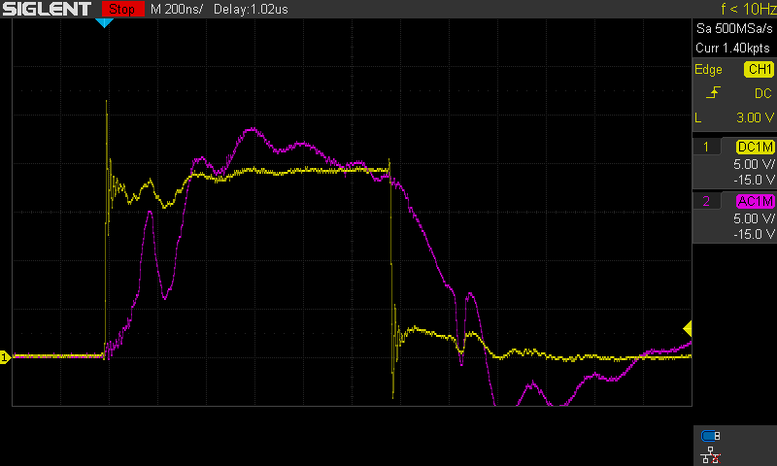
Changed R5 to 2R
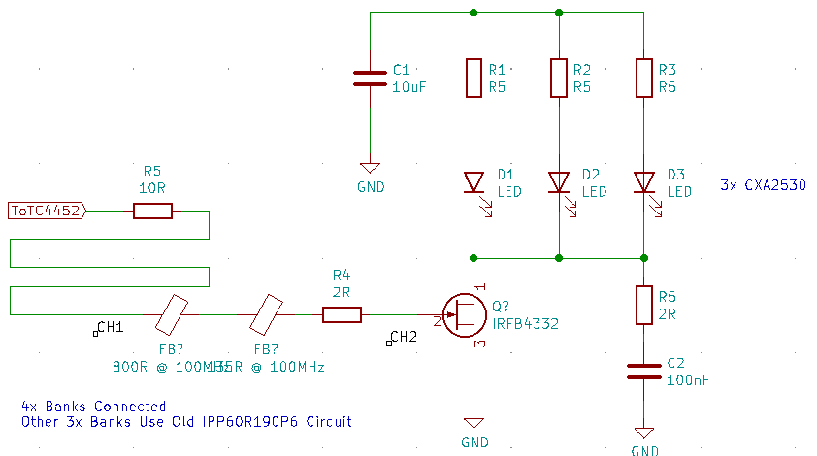
32 GATE: 16.0V CAP ANODE: 120V SERIES RESISTOR: R5 DURATION: 1us
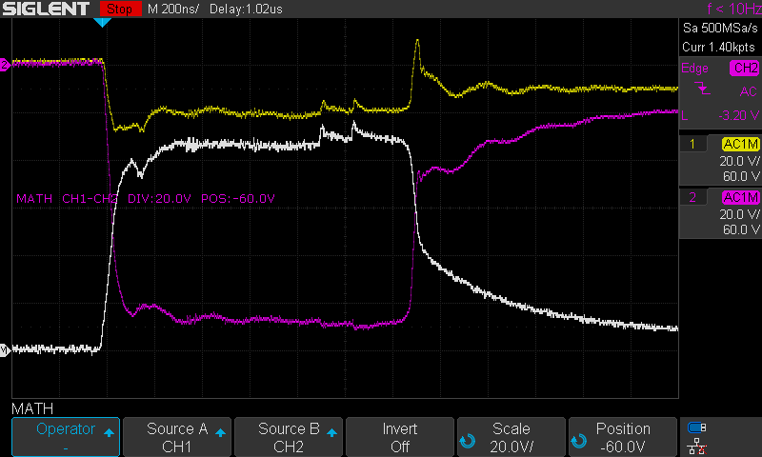
Measuring across LED #1
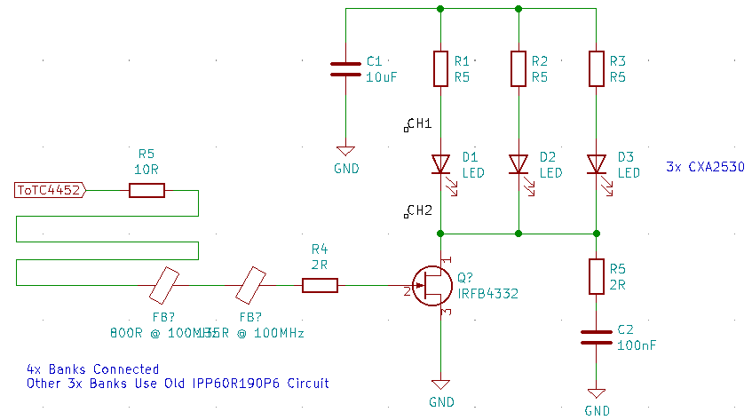
33 GATE: 16.0V CAP ANODE: 120V SERIES RESISTOR: R5 DURATION: 1us
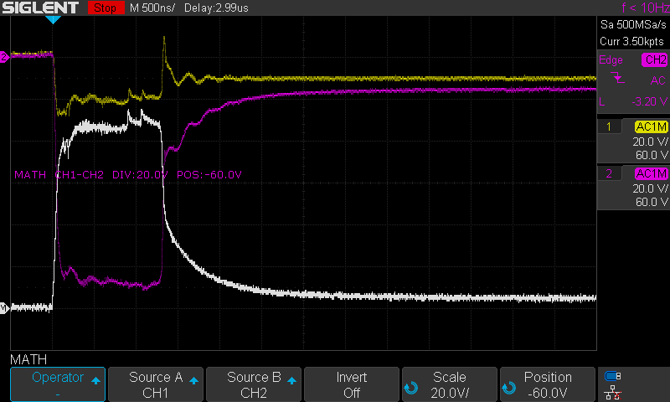
No Change – Timebase changed
34 GATE: 16.0V CAP ANODE: 120V SERIES RESISTOR: R5 DURATION: 1us
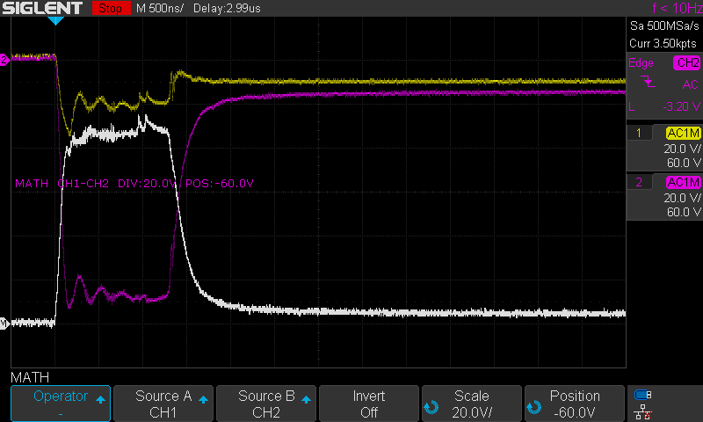
Changed R5 to 0.1R
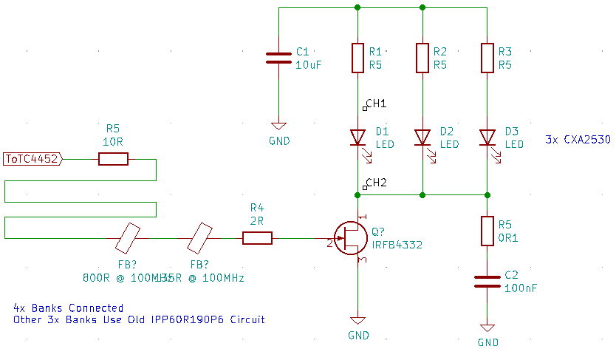
35 GATE: 16.0V CAP ANODE: 120V SERIES RESISTOR: R5 DURATION: 1us
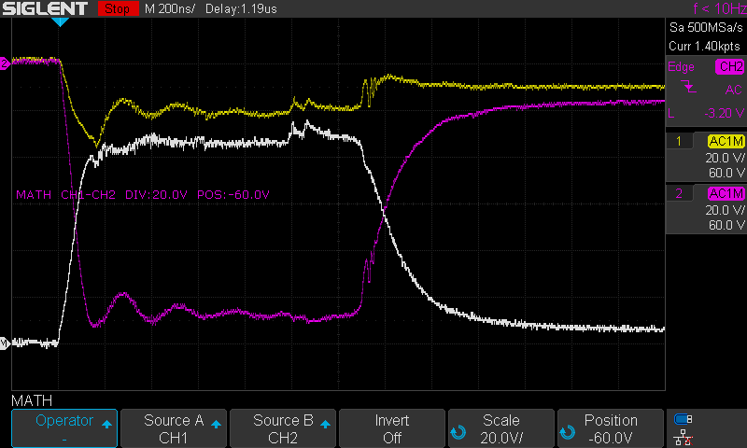
No Change – Timebase changed
36, 37 (dup) GATE: 16.0V CAP ANODE: 120V SERIES RESISTOR: R5 DURATION: 1us
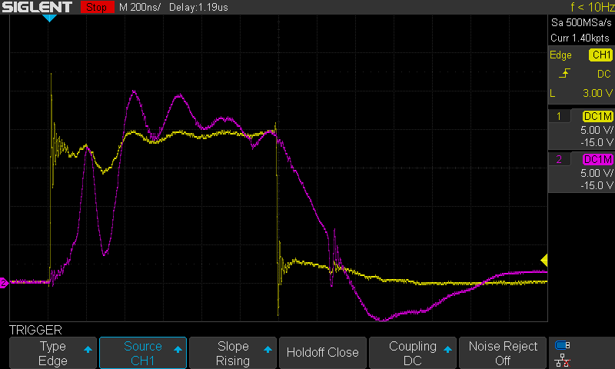
Measuring gate voltage
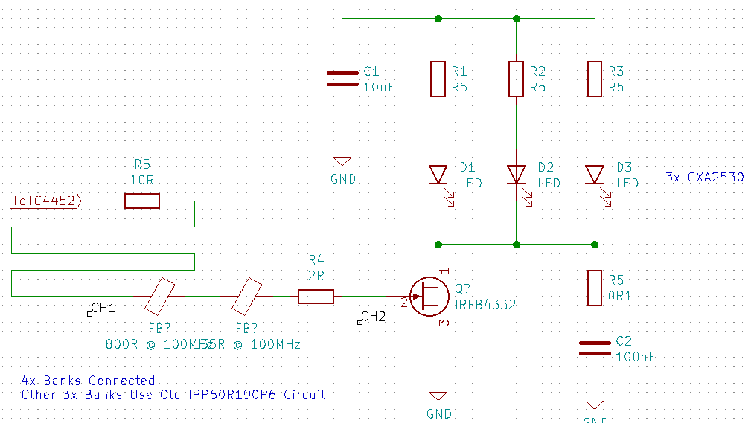
38 GATE: 16.0V CAP ANODE: 120V SERIES RESISTOR: R5 DURATION: 1us
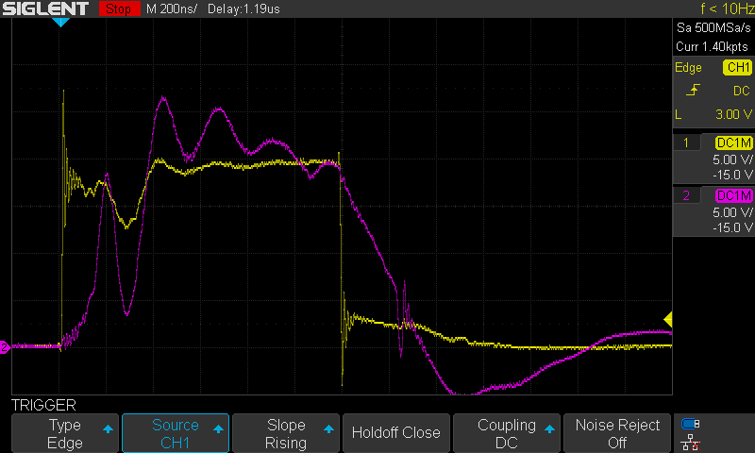
Changed gate resistor to 1R
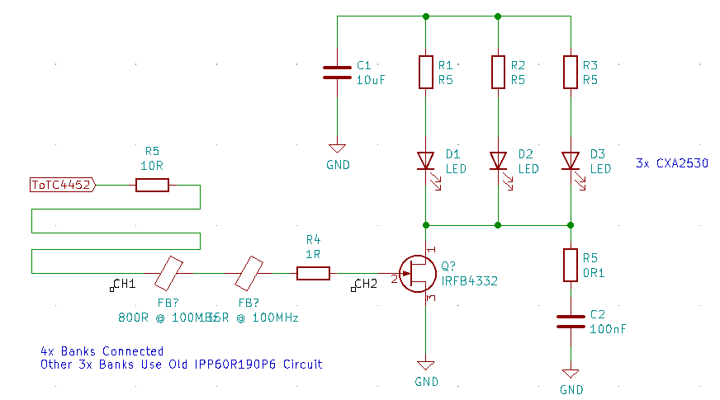

39 GATE: 16.0V CAP ANODE: 120V SERIES RESISTOR: R5 DURATION: 1us
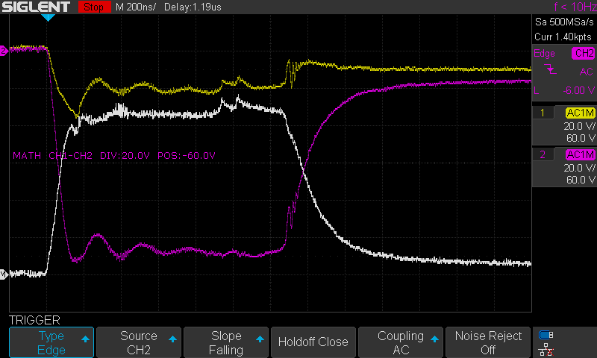
Measuring LED #1


